Lawrence William Towner-1921–1992

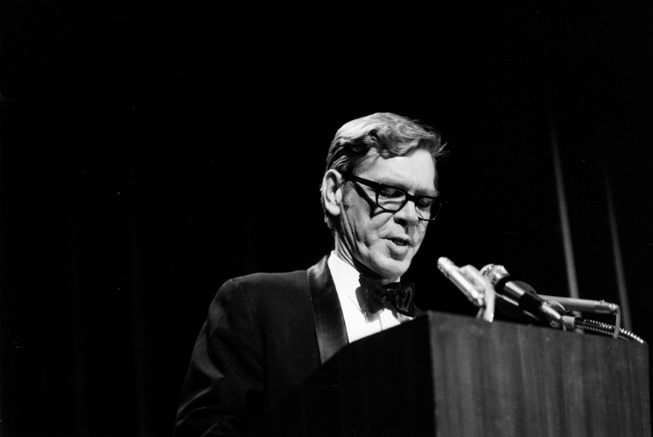

Lawrence William Towner (1921–1992) was an American historian, editor, and librarian who served as director/president and librarian of the Newberry Library in Chicago from 1962 to 1986.
From 1943 to 1946 he served as a pilot in the U.S. Army Air Corps in the China-Burma-India Theater of World War II.
Lawrence William Towner was born on September 10, 1921, in St. Paul, Minnesota. He graduated from Cornell College in Mount Vernon, Iowa, in 1942, with concentrations in history and literature.
As a pilot in the U.S. Army Air Corps in the China-Burma-India Theater of World War II (1943-1946) he flew in the China-Burma-India Theater. This involved some of the most hazardous flying of World War II. After the Japanese closed the Burma Road in 1942, the primary means of supplying Chinese and Allied forces was the famous “Hump” airlift—transport aircraft flying over the eastern Himalayas between bases in India (Assam) and China. These missions faced extreme weather, high altitudes, poor navigation aids, mechanical failures, and Japanese fighters.
After the war, the Towner settled in Chicago. Towner pursued graduate studies in American history at Northwestern University while teaching at the Latin School of Chicago. He earned an M.A. and a Ph.D. in 1955. His dissertation, A Good Master Well Served: A Social History of Servitude in Massachusetts, 1620–1750, examined the lives of servants, apprentices, and the enslaved in colonial New England, drawing primarily on public records. This work aligned with emerging approaches in social history focused on ordinary people.
In the mid-1950s he taught as an instructor and assistant professor at the Massachusetts Institute of Technology. In 1955 he and his family moved to Williamsburg, Virginia, where he served as editor of The William and Mary Quarterly (Institute of Early American History and Culture) until 1962. Working with Lester Cappon, he helped establish the journal’s reputation as a leading publication in early American history.
He was elected to the American Antiquarian Society in 1963.

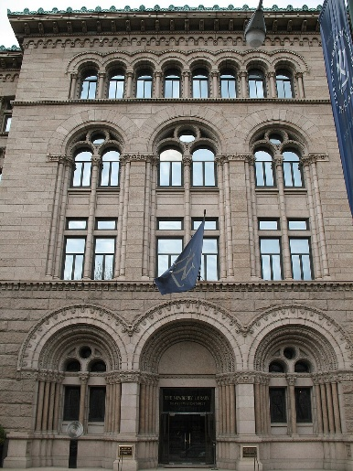
In 1962 Dr. Towner became director and librarian (later titled president and librarian) of the Newberry Library, the private research library in the humanities founded in 1887. Over 24 years he oversaw major growth and modernization: collection expansion through purchases and gifts;(building renovations; and construction of climate-controlled storage. By his retirement the holdings were valued at roughly $300 million and included about 1.4 million books, 5 million manuscripts, and 60,000 maps, photographs, paintings, and related materials (examples included signed scores by Mozart and Chopin, a first edition of Alice’s Adventures in Wonderland, Sherwood Anderson manuscripts, and extensive railroad, Native American, and early printed materials).
He pioneered conservation by establishing a laboratory for book and manuscript preservation that also trained conservators for other institutions. He created research centers tied to collection strengths, including the Hermon Dunlap Smith Center for the History of Cartography (associated with the Atlas of Early American History), the D’Arcy McNickle Center for the History of the American Indian, the Family and Community History Center, and programs supporting Renaissance studies.
These initiatives advanced social and other understudied aspects of history while encouraging use by independent scholars, Associated Colleges of the Midwest seminars, Chicago school history fairs, genealogists, and the broader public. Towner described the library’s primary purpose as preserving the records of the past so that research could make knowledge of literature, history, music, and philosophy “less imperfect.”
Nationally, he advocated for the humanities. He helped establish the National Endowment for the Humanities matching-grant program for libraries, chaired the Illinois Humanities Council (which later named an award in his honor), co-founded the Independent Research Libraries Association (serving as chairman in 1975–77), and advised on the papers of George Washington, Benjamin Franklin, James Madison, and Thomas Jefferson.
Dr. Towner served on the panel assembled by Jacqueline Kennedy to select books for the White House Library and held roles with the Modern Poetry Association.
Towner retired in 1986 at age 65 and was named president emeritus and a life trustee. Under his leadership, the independent research library significantly expanded its collections and facilities, pioneered conservation practices, established specialized research centers, and strengthened its role as a center for humanities scholarship open to scholars, students, and the public.
Dr. Lawrence William Towner died June 12, 1992, at Northwestern Memorial Hospital in Chicago. Survivors included his wife of 49 years, Rachel (Bauman) Towner; sons Peter and Michael; daughters Wendy Yanikoski, Kristin Moses, and Elizabeth Jackson.

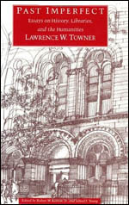
A posthumous collection of his essays, speeches, memoranda, and writings, Past Imperfect: Essays on History, Libraries, and the Humanities (edited by Robert W. Karrow Jr. and Alfred F. Young), was published by the University of Chicago Press in 1993 and articulates his views on research libraries, conservation, collection development, social history, and the role of the humanities.

Selected Publications

Towner, Lawrence W. A Good Master Well Served: Masters and Servants in Colonial Massachusetts, 1620–1750. 1954/1955 Northwestern University Ph.D. dissertation.
Towner, Lawrence W. “‘A Fondness for Freedom’: Servant Protest in Puritan Society.” William and Mary Quarterly, 3rd ser., 19, no. 2 (April 1962): 201–19.
Towner, Lawrence W. “The Sewall-Saffin Dialogue on Slavery.” William and Mary Quarterly, 3rd ser., 21, no. 1 (January 1964): 40–52.
Towner, Lawrence W. “The Indentures of Boston’s Poor Apprentices, 1734–1805.” Publications of the Colonial Society of Massachusetts 43 (1966): 417–68.
Towner, Lawrence W. An Uncommon Collection of Uncommon Collections: The Newberry Library. Chicago: Newberry Library, 1970 (revised/later editions, including 1976 and 1986). (Newberry Library Associates publication surveying the library’s collections.)
Towner, Lawrence W. The Newberry Library: A Brief History. Chicago: Newberry Library, 1977.
Munby, A. N. L., and Lawrence W. Towner. The Flow of Books and Manuscripts: Papers Read at a Clark Library Seminar, March 30, 1968. With a foreword by James Thorpe. Los Angeles: William Andrews Clark Memorial Library, University of California, 1969. (Includes Towner’s essay “Every Silver Lining Has a Cloud: The Recent Shaping of the Newberry Library’s Collections.”)
Harley, J. B., Barbara Bartz Petchenik, and Lawrence W. Towner. Mapping the American Revolutionary War. Chicago: University of Chicago Press, 1978. (The Kenneth Nebenzahl, Jr., Lectures in the History of Cartography at the Newberry Library.)
Towner, Lawrence W. Past Imperfect: Essays on History, Libraries, and the Humanities. Edited by Robert W. Karrow, Jr., and Alfred F. Young. Chicago: University of Chicago Press, 1993. (Includes an introductory essay by Alfred F. Young, “Dissertations and Gatekeepers: Why It Took 45 Years for a Ph.D. Thesis to Be Published.” Later reprints by Routledge.)
Statements and talks on the humanities, including “Independent Research Libraries: ‘Truly National Libraries,’” “On ‘Pure Scholarship’ and ‘Public Programs,’” and pieces defending or discussing the National Endowment for the Humanities and funding priorities.
Other Contributions
Editor of The William and Mary Quarterly (1956–1962; earlier associate editor), during which he elevated the journal’s standing in early American history (he also held an associate professorship at the College of William and Mary).
Contributor to editions and related works (e.g., connected with Mercy Otis Warren’s Observations on the New Constitution, and on the Federal and State Conventions).
Forewords, book reviews, internal Newberry reports/memoranda, speeches before Congress and other bodies, and institutional publications tied to the library’s research centers and programs.
Involvement with projects such as the Northwestern-Newberry edition of Herman Melville and the Atlas of Early American History.
Primary sources for a complete list include the bibliography in Past Imperfect and the Newberry Library’s archival holdings of his papers.

Sources
Lambert, Bruce. “Lawrence W. Towner Dies at 70; Historian Led Research Library.” New York Times, June 15, 1992, B10.
Litke, Ronald. “In Print: The Last Cultural Commissar.” Chicago Reader, October 14, 1993.
McCorison, Marcus A. “Lawrence William Towner.” Proceedings of the American Antiquarian Society 102, pt. 2 (October 1992): 283–89.
Plating, John D. (2011). The Hump: America's Strategy for Keeping China in World War II. College Station: Texas A&M University Press.
Towner, Lawrence W. (Lawrence William), 1921–1992. Lawrence W. Towner Papers, 1948–1989 (bulk 1962–1986). Newberry Library Archives, Subgroup 06. Newberry Library, Chicago.
Towner, Lawrence W. Past Imperfect: Essays on History, Libraries, and the Humanities. Edited by Robert W. Karrow Jr. and Alfred F. Young. Chicago: University of Chicago Press, 1993.

Submitted by Kathleen de la Peña McCook

