Gordon Roland Williams -1914–1996

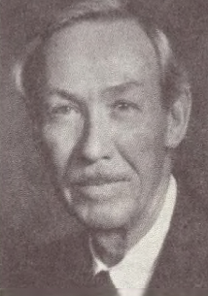

Gordon Roland Williams (1914–1996) was an American librarian best known as the longtime director of the Center for Research Libraries (CRL) in Chicago and as the driving force behind the publication of the monumental National Union Catalog: Pre-1956 Imprints.
Gordon Roland Williams was born July 26, 1914 in Ontario, Oregon. He attended Stanford University (A.B.), the University of Oregon, and the University of Chicago Graduate Library School, from which he received his library degree (M.A.). Bookselling and a lifelong interest in books shaped his early path.
During the Second World War Gordon Williams served in the U.S. Navy in the Pacific, becoming an expert navigator; proximity to heavy naval artillery left him with tinnitus that persisted later in life.
After the war he returned to California as vice-president of the international bookselling firm Brentano’s, managing its Los Angeles shop. He also spent time in Sacramento, where his interest in the theater led him to produce and stage-manage plays after hours.
Williams entered professional librarianship in 1950 as executive assistant to the librarian at the John Crerar Library in Chicago. In 1952 he became chief assistant (or assistant) librarian at the University of California, Los Angeles (UCLA) Library, joining the team built by the influential Lawrence Clark Powell. This experience prepared him for his most significant role: in 1959 he was appointed director of the Midwest Inter-Library Center (which became the Center for Research Libraries). He held the position until his retirement in1980.
Under Williams’s leadership the organization transitioned in 1965 from a regional cooperative to an international consortium. Membership and collections expanded substantially (reaching more than three million volumes by the end of his tenure), new programs such as the Journals Access Service (1975) were launched, and initiatives exploring a national lending facility were pursued. He was an early advocate of systematic conservation policy and a founder member of the International Institute of Conservation. He also served on the board of the Association of Research Libraries (1965–1968).

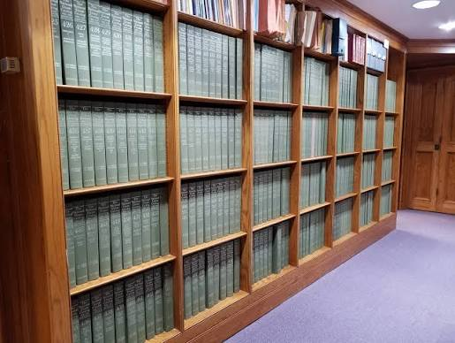
Williams’s most visible achievement was his work as chair of the American Library Association Resources and Technical Services Division Resources Committee’s Subcommittee on the National Union Catalog.
Although the project was formally the responsibility of an ALA committee, Williams oversaw its practical realization. The resulting National Union Catalog: Pre-1956 Imprints (often called the Mansell catalog after its publisher) appeared in 754 volumes between 1968 and 1981.
Drawing on records from hundreds of North American research libraries, the National Union Catalog: Pre-1956 Imprints provided location information for millions of pre-1956 imprints and fulfilled a long-standing vision, articulated as early as 1901 by Librarian of Congress Herbert Putnam, of a comprehensive national union catalog.
Gordan Williams managed the enormous administrative, editorial, and collaborative challenges—including coordination with the British publisher Mansell and the Library of Congress—with characteristic calm efficiency. By the time of his retirement the set was virtually complete. It remains a foundational reference tool in major libraries worldwide.
Beyond administration, Williams wrote and edited works reflecting his bibliographical and printing interests, including Ravens and Crows (1966) and the first edition of Thomas Bewick’s letters to John Dovaston (1968). He also produced Fantasy in a Wood-Block (Caxton Club, 1972), a narrative about a supposed 1827 encounter between John James Audubon and Thomas Bewick.
After retiring to Napa, California, Williams printed small books on a hand-press (including a treatise by his friend Will Cheney on pocket-knives) and took an active interest in local wine culture as a founding member of the board of the Napa Valley Wine Library.
Colleagues remembered him for quiet seriousness, devotion to the printing arts, and a modest, practical approach to large-scale library cooperation. He once observed that library cooperation suffered from its good name: “if it were regarded as just a bit sinful, librarians might indulge in it more than they do.”
Williams died in Napa 15 September 15, 1996. He was survived by his wife, Jane (married 1942), and their daughter, Megan.
His career exemplified mid-twentieth-century efforts to build cooperative research-library infrastructure, and the National Union Catalog stands as his principal monument.

Selected Publications
Center for Research Libraries (U.S.), and Gordon R. Williams. 1960. Report of a Trip to the Soviet Union,. [Chicago].
Williams, Gordon Roland, and G. R. Williams. 1963. “Medical Deposits in the Midwest Inter-Library Center.” Bulletin of the Medical Library Association 51 (April): 41–43.
Williams, Gordon. “The Librarian’s Role in the Development of Library Book Collections.” The Library Quarterly 34, no. 4 (October 1964): 308–17.
Association of Research Libraries. 1964. The Preservation of Deteriorating Books : An Examination of the Problem with Recommendations for a Solution : Report. Edited by Gordon R. Williams. [Washington? D.C.].
Williams, Gordon Roland, and G. R. Williams. 1965. “Library Cooperation: Key to Greater Resources.” Special Libraries 56 (December): 565–70.
Williams, Gordon R. Ravens and Crows. [Place of publication and publisher not identified], 1966.
Williams, Gordon R. 1968. Library Cost Models : Owning versus Borrowing Serial Publications. Springfield, Va.: Clearinghouse for Federal Scientific & Technical Information.
Bewick, Thomas. Bewick to Dovaston: Letters 1824–1828. Edited by Gordon Williams, with an introduction by Montague Weekley. London: Nattali & Maurice, 1968.
Williams, Gordon R. “History of the National Union Catalog, Pre-1956 Imprints.” In National Union Catalog, Pre-1956 Imprints, vol. 1, vii–x. London: Mansell, 1968.
Williams, Gordon R. “Physical Access to Library Materials.” PMLA 86, no. 4 (September 1971): 590–93.
Williams, Gordon R. Fantasy in a Wood-Block; or, What Occurred When John James Audubon, the Naturalist, Visited with Thomas Bewick, the Wood-Engraver, in the Year 1827: Being a Narrative by Gordon R. Williams, Together with a Print Taken by R. Hunter Middleton from the Wood-Block Which Mr. Bewick Was Engraving at the Time. Chicago: Caxton Club, 1972.
Williams, Gordon R. 1975. “Library Subscription Decisions.” IEEE Transactions on Professional Communication 18 (3): 207–9.
Williams, Gordon R. 1980. “The Function and Methods of Libraries in the Diffusion of Knowledge.” The Library Quarterly: Information, Community, Policy 50 (1): 58–75.
Williams, Gordon R. “The National Union Catalog and Research Libraries.” In In Celebration: The National Union Catalog, Pre-1956 Imprints, edited by John Y. Cole, 14–20. Washington, DC: Library of Congress, 1981.
- Additional short writings and privately printed pieces (including a hand-press edition related to Will Cheney’s treatise On Pocket-knives) are mentioned in obituaries but lack full bibliographic details in public sources.

Sources
Barker, Nicolas. “Obituary: Gordon Williams.” The Independent, January 3, 1997.
“Gordon R. Williams.” College & Research Libraries News 41, no. 5 (1980).
Center for Research Libraries. “Gordon Roland Williams.” Focus 16, nos. 4–6 (July–December 1996).
Williams, Gordon R. “History of the National Union Catalog, Pre-1956 Imprints.” In National Union Catalog, Pre-1956 Imprints, vol. 1, vii–x. London: Mansell, 1968.
Williams, Gordon R. “The National Union Catalog and Research Libraries.” In In Celebration: The National Union Catalog, Pre-1956 Imprints, edited by John Y. Cole, 14–20. Washington, DC: Library of Congress, 1981.

Submitted by Kathleen de la Peña McCook

