Bennett Harvie Branscomb-1894-1998

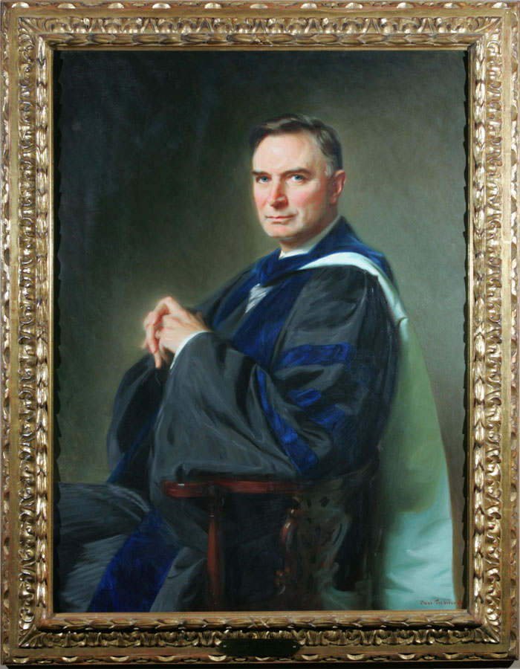
National Society of Colonial Dames of America in Tennessee. “Bennett Harvie Branscomb 1894–1998.” Tennessee Portrait Project.

Bennett Harvie Branscomb (December 25, 1894 – July 23, 1998) was an American New Testament scholar, theologian, academic administrator, and library leader. Best known as the fourth chancellor of Vanderbilt University (1946–1963), he earlier made lasting contributions to academic librarianship, most notably as director of the Duke University Libraries and as the author of the influential study Teaching with Books.
Branscomb was born in Huntsville, Alabama and graduated from Birmingham-Southern College with a B.A. in 1914) and, as a Rhodes Scholar, attended Wadham College, Oxford. There he earned a B.A. (1917), a distinguished M.A. in biblical studies, the Greek Prize, and First Honors in Theology.
During World War I, while at Oxford, he volunteered with Herbert Hoover’s Commission for Relief in Belgium. With fellow student Oliver Carmichael (later Vanderbilt’s third chancellor), he helped smuggle a letter from Cardinal Mercier past German lines; it was published in The Times of London. Belgium awarded both men the Médaille du Roi Albert and the Médaille de la Reine Élisabeth. He later served briefly in the U.S. Army.
After the war he taught at Southern Methodist University (from 1919), earned a Ph.D. from Columbia University / Union Theological Seminary (1924), and joined the Duke University faculty in 1925 as professor of New Testament literature. He held a Guggenheim Fellowship for study in Berlin and Marburg (1930–1931).
Library Leadership and Contributions
Although primarily a biblical scholar and administrator, Branscomb made significant contributions to library practice and theory. At Duke he served on the Library Council from 1928 and as Director of the University Libraries from approximately 1933- 1941. He promoted the unfettered use of library materials in undergraduate study and early cooperative resource-sharing efforts that anticipated the National Union Catalog. A 1975 master’s thesis later characterized him as “the reluctant librarian,” noting that a religion professor had stepped into the role, yet he became an effective advocate for service-oriented rather than purely collection-building approaches.
His most important library work was directing a major study for the Association of American Colleges (funded by the Carnegie Corporation), which resulted in Teaching with Books: A Study of College Libraries (Chicago: Association of American Colleges / American Library Association, 1940). The study found undergraduate library use “astonishingly” low; Branscomb argued that college libraries had been treated mainly as research repositories rather than integral teaching tools. He advocated greater physical accessibility (including open shelves), closer faculty-library collaboration so that instructors would actively direct students to books, and a primary focus on supporting the instructional program. The book became widely cited in library literature and helped shape mid-century thinking about the role of the undergraduate library.
In 1945 he chaired an American Library Association mission to Brazil that assisted in reorganizing that country’s National Library. For this work he received the Order of the Southern Cross. He was a member of the American Library Association and also wrote a short piece, How Should We Develop the Kenyon Libraries? (1942). These activities demonstrate that his library engagement extended beyond institutional administration into national and international professional service.
Later Career
Dr. Branscomb served as dean of the Duke Divinity School (1944–1946) before moving to Vanderbilt.
He was appointed Vanderbilt’s fourth chancellor in 1946. He oversaw substantial growth: the number of buildings roughly doubled, full-time faculty doubled and the endowment grew from about $38 million to $88 million. The university was elected to the Association of American Universities in 1949. He strengthened the board, raised academic standards, and guided the gradual desegregation of the university amid Southern resistance, though the process included controversies such as the 1960 expulsion of divinity student and civil-rights organizer James Lawson (an action Branscomb later regretted).
After retirement he remained active in international education: first chairman of the U.S. Advisory Commission for Education Exchange (1947–1951), educational consultant to the World Bank (1963–1964), chairman of the U.S. Commission for UNESCO (1963–1965), and participant in related conferences on literacy and education. He maintained an office at Vanderbilt as chancellor emeritus until near the end of his life and published an autobiography, Purely Academic (1978).
Dr. Branscomb died in Nashville on July 23, 1998. While his longest-lasting public reputation is as the chancellor who helped move Vanderbilt toward national prominence, his library work—especially Teaching with Books and his practical leadership at Duke and on the Brazilian mission—remain a notable contribution to the development of academic librarianship in the mid-twentieth century.

Selected Publications

Library-related
Branscomb, Harvie. Teaching with Books: A Study of College Libraries. Chicago: Association of American Colleges / American Library Association, 1940. (Later reprints, including Shoe String Press, 1964 and 1974.) Available via Internet Archive and HathiTrust.
Branscomb, Harvie. How Should We Develop the Kenyon Libraries? N.p., 1942.

Other
Branscomb, Harvie. The Message of Jesus: A Survey of the Teaching of Jesus Contained in the Synoptic Gospels. Nashville, TN: Cokesbury Press, 1926.
Branscomb, Bennett Harvie. Jesus and the Law of Moses. London: Hodder and Stoughton, 1930. (Also issued New York: R. R. Smith, 1930; based on his Columbia University doctoral work.)
Branscomb, Harvie. The Teachings of Jesus: A Textbook for College and Individual Use. Nashville, TN: Cokesbury Press, 1931. (Later reprints by Abingdon Press / Abingdon-Cokesbury Press.)
Branscomb, B. Harvie. The Gospel of Mark. The Moffatt New Testament Commentary. London: Hodder and Stoughton, 1937. (Subsequent American and reprint editions exist.)
Branscomb, Harvie. Vanderbilt University: The Commodore’s Best Investment. Newcomen Address, 1950. New York: Newcomen Society in North America, 1950.
Branscomb, Harvie. The Contribution of Moral and Spiritual Ideas to the Making of the American Way of Life. Madison, WI, 1952.
Branscomb, Harvie. The Competent College Student. Nashville, TN: Tennessee Higher Education Commission, 1977.
Branscomb, Harvie. Purely Academic: An Autobiography. Nashville, TN: Vanderbilt University Press, 1978.
He also published journal articles (notably in the Journal of Biblical Literature), but those are not included here.

Sources
Alabama Authors. “Branscomb, Bennett Harvie, 1894–1998.” University of Alabama Libraries. Accessed November 3, 2026.
“B. Harvie Branscomb Papers, 1922–1952.” Duke University Archives, David M. Rubenstein Rare Book & Manuscript Library. Collection UA.29.02.0148.
“Harvie Branscomb.” Bham Wiki..
“Harvie Branscomb.” Wikipedia. Last modified October 15, 2026.
Honan, William H. “Harvie Branscomb, a Shaper of Vanderbilt U., Dies at 103.” New York Times, August 1, 1998.
Martz, David. “Dr. Harvie Branscomb, the Reluctant Librarian.” M.A. thesis, 1975. Vanderbilt University Special Collections (referenced in collection guides).
National Society of Colonial Dames of America in Tennessee. “Bennett Harvie Branscomb 1894–1998.” Tennessee Portrait Project. Accessed November 3, 2026.
Tucker, John Mark (2003) "B(ennett) Harvie Branscomb (1894–1998)" in Donald G. Davis, ed. Dictionary of American Library Biography. Vol. 3: 35-39. Libraries Unlimited.
Vanderbilt University Library. “Chancellor Harvie Branscomb.” Dare to Grow: 1945–2025 exhibition.
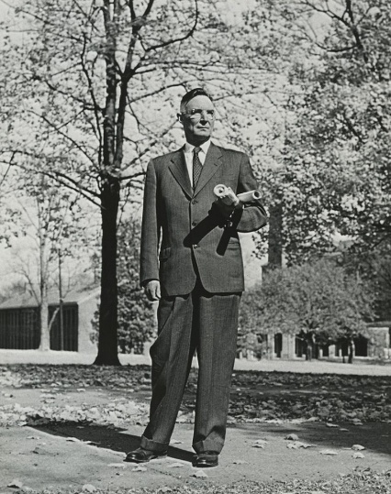

Submitted by LHRT Member

