Emily Stewart Boyce – 1934- 2014

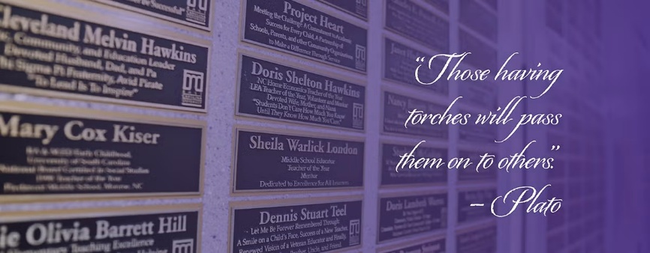
Emily Stewart Boyce was inducted in 2000 to the Educators Hall of Fame at East Carolina University.

Emily Stewart Boyce (c. 1934–April 22, 2014) was a North Carolina librarian, library educator, advocate for school libraries, and community volunteer.
Emily Boyce earned a bachelor’s degree in library science and history and a master’s degree in counseling from East Carolina University (then East Carolina College). She earned a Master of Library Science from the University of North Carolina at Chapel Hill.
Early in her career, Boyce worked as a school librarian and as a children’s librarian in a public library. She also served in the North Carolina Department of Public Instruction in Raleigh, where she supervised school libraries statewide. In 1966 she joined the newly created Department of Library Science at East Carolina University. She served as department chair beginning in 1980 and retired in 1992 as Professor Emeritus.
During her academic career she spent roughly twenty years as a member of evaluation teams for the Southern Association of Colleges and Schools, visiting public schools.
After retirement, Boyce remained active in library and civic affairs. She was appointed by the governor as chair of the North Carolina State Library Commission (2001–2003) and chaired the Library Services and Technology Act Advisory Committee for the State Library (1997–1999). From 2004 -2006 she chaired the board of directors of the Asheville-Buncombe (Buncombe County Library System).
In the Asheville area Emily Boyce volunteered extensively, serving on boards including those of the Botanical Gardens, the Mediation Center, the Buncombe County Nursing Home Advisory Committee, the Learning Resource Center Advisory Committee at Asheville-Buncombe Technical Community College, the Asheville YMCA, the Literacy Council (where she served as president of the board), and the Asheville Branch of the American Association of University Women. She was instrumental in a capital campaign that helped save the Asheville YWCA.

Boyce received numerous honors:
- North Carolina Association of School Librarians- Mary Peacock Douglas Award
- Achievement Award and life membership from the North Carolina Community College Learning Resources Association ;
- life membership in the North Carolina Library Association (1993) for contributions to librarianship at local, state, and national levels, and
- recognition in the East Carolina University Educators Hall of Fame (inducted 2000; plaque inscription: “Teacher, Counselor, Mentor / Leader and Friend / Pioneer In Library Education”).
- She received ECU’s Outstanding Educators Award (1994)
- Named one of the “100 Incredible ECU Women: A Legacy of Leadership” during the university’s centennial celebration (2007).
- Bahá’ís of Asheville Human Rights Award.

Upon retirement, former students, colleagues, and friends established the Emily S. Boyce Fellowship (also referred to as the Emily S. Boyce Fellowship Fund) at East Carolina University College of Education to support graduate students in library/information studies, particularly those showing leadership potential and commitment to library administration. The university and department also granted her the title of Professor Emeritus at that time.

Emily Stewart Boyce died on April 22, 2014 in Pittsboro, North Carolina.

Sources
American Library Association. “Resolution Honoring Emily Stewart Boyce.” ALA Council, July 1, 2014.
East Carolina University, College of Education. “Educators Hall of Fame Inductees.” Accessed via education.ecu.edu. Entry for Emily S. Boyce (induction year 2000).
“Emily Boyce Obituary.” The News & Observer (Raleigh, NC), via Legacy.com, April 27, 2014.

Submitted by LHRT Member

