Wyllis Eaton Wright -1903–1979

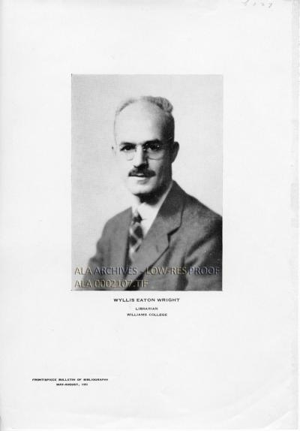

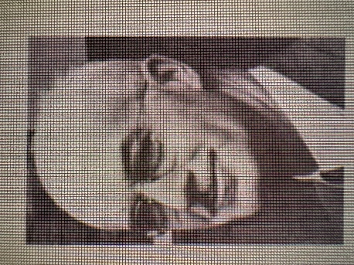

Wyllis Eaton Wright (1903–1979) was an American librarian, cataloging specialist, and professional leader known for his long service at the New York Public Library, the U.S. Army Medical Library, and Williams College. He was president of the Association of College and Research libraries (1949-1950) and received the Melvil Dewey Medal in 1957.
Wyllis Eaton Wright was born December 13, 1903, in Jacksonville, Florida, He graduated from Williams College (B.A. 1925, philosophy; Phi Beta Kappa) and received an M.A. from Williams in 1926 (philosophy and Greek).
He earned a B.S. in library science from Columbia University in 1928. His early library work included serving as a page in Lowell, Massachusetts (1916–1920), student assistant and library assistant at Williams (1921–1927), and then positions at the New York Public Library (cataloger 1927–1930; chief classifier 1933–1936; chief cataloger 1936–1945). He also served as librarian of the American Academy in Rome (1930–1933) and held an association with Columbia University (1939–1945).
In 1945 he was appointed librarian of the U.S. Army Medical Library (predecessor of the National Library of Medicine) in Washington, D.C., where he focused on modernizing operations after World War II; he held the post 1946-1947.
In 1947 he returned to Williams College as librarian, serving until 1968.
He began a second career in September 1969 as a rare books cataloger in the Department of Special Collections at Stanford University Libraries. He cataloged sixteenth-century imprints, American almanacs, early American materials, and difficult monographs and serials in classical and modern languages; reduced to part-time work in 1974; served as chief of Special Collections in 1973–74; and continued until shortly before his death, notably clearing long-standing backlogs.
Wright was a leader in the American Library Association and related organizations. He served as president of ACRL (1949–1950) and of the Cataloging and Classification Association (or Division). He received the Melvil Dewey Medal in 1957.
He chaired the Catalog Code Revision Committee (1954–1967) and the Joint Committee on the Union List of Serials (with service spanning the late 1930s/1940s into the 1960s), and held other roles such as chair of the ALA Aid to Libraries in War Areas Committee and involvement with the American Book Center for War Devastated Libraries. He was also a trustee in Williamstown, Massachusetts, from 1951.
His editorial and bibliographic work included editing the English translation of the Vatican Library’s Rules for the Catalog of Printed Books (American Library Association, 1948); contributing the section on the history of the catalogues to the Guide to the Reference Collections of the New York Public Library (1941); and editing or serving as consulting editor for successive volumes of the American Library Annual, American Library & Book Trade Annual, and the Bowker Annual of Library and Book Trade Information (sponsored by the Council of National Library Associations). He also contributed to the Catalogers’ and Classifiers Yearbook.
Wright died October 2, 1979, in Portola Valley, California.

Selected Publications

Wright, Wyllis E. “Report of the informal conference on union catalogs, Library of Congress, April 17th and 18th, 1936. (1937).” Library Quarterly, 7, 290–291.
Wright, Wyllis E. “History of the Catalogues.” In Guide to the Reference Collections of the New York Public Library. New York: New York Public Library, 1941.
Wright, Wyllis E., co-editor. Catalogers’ and Classifiers Yearbook. 1937–1939.
Beach, Leonard B., Theodore Hornberger, and Wyllis E. Wright, eds. Peter Irving’s Journals. Edited from manuscripts in the Sterling Memorial Library, Yale University, the Miriam Lutcher Stark Library, University of Texas, and the New York Public Library. New York: New York Public Library, 1943. (Reprinted from the Bulletin of the New York Public Library, August–December 1940.)
Wright, Wyllis Eaton. 1946. “Reorganization of the Army Medical Library.” Bulletin of the Medical Library Association 34 (January): 221–23.
Wright, Wyllis E., ed. Rules for the Catalog of Printed Books. Translated from the second Italian edition by Thomas J. Shanahan, Victor A. Schaefer, and Constantin T. Vesselowsky. Chicago: American Library Association, 1948.
Wright, Wyllis E. Review of Subject Headings; a Practical Guide. College & Research Libraries 13, no. 3 (1952).
Wright, Wyllis E. “Some Aspects of Technical Processes.” Library Trends 1, no. 1 (Summer 1952).
Wright, Wyllis Eaton. 1956. “Report of Progress on Catalog Code Revision in the United States.” Library Quarterly 26 (April): 331–36
Wright, W. E., & Wright, W. E. (1961). Probl‘emes courants du catalogage aux États-Unis. Bulletin Des Bibliotheques de France, 6, 431–435.
Wright, Wyllis E., ed. American Library Annual (and related titles including American Library Annual for …, American Library Annual and Book Trade Almanac, and American Library & Book Trade Annual). Sponsored by the Council of National Library Associations and the Library Journal. New York: R.R. Bowker, primarily late 1950s.
Wright, Wyllis E., consulting editor. The Bowker Annual of Library and Book Trade Information. New York: R.R. Bowker, various editions from the 1960s onward.
Wright, Wyllis Eaton. Colonel Ephraim Williams, a Documentary Life. Pittsfield, Mass.: Berkshire County Historical Society, 1970.

Sources
American Library Association Archives. “Wyllis Eaton Wright (1).” Photograph, circa 1945. Library Photographic Vertical File, 1892–1985 (RS 18/1/57, Box 30, Folder: WO-WY). Accessed October 17, 2026.
American Library Association Archives. “Wyllis Eaton Wright (2).” Photograph, 1951. Library Photographic Vertical File, 1892–1985 (RS 18/1/57, Box 30, Folder: WO-WY). Accessed October 17, 2026.
Cole, Dorothy Ethlyn, ed. Who’s Who in Library Service: A Biographical Directory of Professional Librarians of the United States and Canada. [Edition containing the Wyllis E. Wright entry; mid-20th century]. Available via Internet Archive digitization of the volume.
“Willis Wright Dies.” College & Research Libraries News (1979), reprinted from the Stanford Library Bulletin, October 12, 1979 (tribute by David C. Weber).

Submitted by ALA Member

