Paul N. Banks – 1934-2000

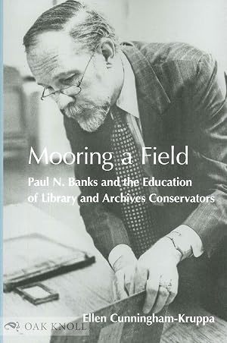

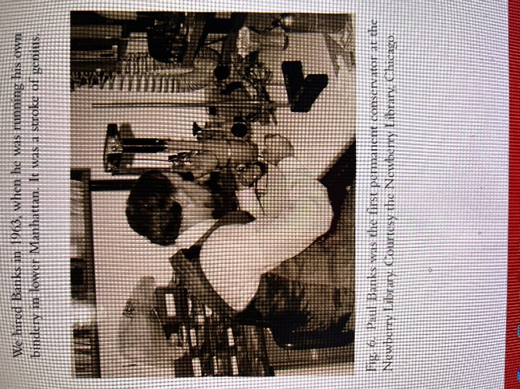
Source: Russick, Susan, and Giselle Simón. “One Hundred Years of Conservation Documentation at the Newberry Library.” The Book and Paper Group Annual 24 (2005): 89–95.

Paul Noble Banks (April 15, 1934–May 10, 2000) was an American book conservator and educator who helped turn library and archives conservation from a workshop craft into a graduate profession.
Paul N. Banks was born in California. He studied at the Carnegie Institute of Technology in Pittsburgh, then worked in New York from 1956 to 1960 as a typographer and production assistant for Viking Press and Clark & Way, while taking evening courses in book-related subjects at Columbia University.
After leaving commercial printing he spent several years in part-time work: assisting the binder Carolyn Horton, teaching bookbinding (including at Riverside Church), writing for the Journal of the Guild of Book Workers, and attending early conservation seminars at Cooperstown.
In 1964 he became conservator and head of conservation at the Newberry Library in Chicago, one of the first such appointments in an American research library. There he reformed binding and repair practice, began systematic monitoring of temperature, humidity, and other environmental conditions, and trained apprentices and staff.
The Newberry conservation laboratory, which he directed, became a training ground for later conservators. In 1969 he gave the first paper on book conservation at a meeting of the American Institute for Conservation of Historic and Artistic Works (AIC), on the treatment of the first British edition of Melville’s The Whale.
He served as the American Institute for Conservation of Historic and Artistic Works president from 1978 to 1980, the first professional book conservator to hold the office, and published steadily on binding, paper conservation, environmental standards, and training.
By the late 1970s his main concern was education. With National Endowment for the Humanities support he left the Newberry in 1981 to found and direct the Conservation Education Programs at Columbia University’s School of Library Service—the first degree-granting program in the United States for library and archives conservators and preservation administrators.
Classes began on August 1, 1981. When Columbia closed the school in 1992, the program moved to the University of Texas at Austin; Banks taught there for the first three years and retired in 1996, then returned to New York
After retirement he continued as a consultant, including work for the Library of Congress and the National Archives on storage and display of the Declaration of Independence, the Constitution, and the Bill of Rights.
Paul N. Banks died in New York on May 10, 2000.
The Paul Banks and Carolyn Harris Preservation Award, given by the Association for Library Collections and Technical Services, is named in part for him. His papers are held at the University of Texas at Austin.

Selected Publications
Banks, Paul N. “The Treatment of the First British Edition of Melville’s The Whale.” Paper presented at the annual meeting of the American Institute for Conservation of Historic and Artistic Works, 1969.
Banks, Paul N. “Environmental Standards for Storage of Books and Manuscripts.” Library Journal 99, no. 3 (1974): 339–43.
Banks, Paul N. “Books in Peril: Cooperative Approaches to Conservation.” Library Journal 101, no. 20 (1976): 2348–51.
Banks, Paul N. “Education for Conservators.” Library Journal 104, no. 9 (1979): 1013–17.
Banks, Paul N. A Selective Bibliography on the Conservation of Research Library Materials. Chicago: Newberry Library, 1981. (An earlier, nine-page version dates to 1965.)
Banks, Paul N. “Education in Library Conservation.” Library Trends 30, no. 2 (1981): 189–201.
Banks, Paul N. Preservation of Library Materials. Chicago: Newberry Library, 1987.
Banks, Paul N. “Preservation, Library Collections, and the Concept of Cultural Property.” In Libraries and Scholarly Communication in the United States: The Historical Dimension, edited by Phyllis Dain and John Y. Cole. New York: Greenwood Press, 1990.
Banks, Paul N. “ISR/ASTM Workshop on Paper Aging.” Conservation Administration News, no. 60 (1995): 22.
Banks, Paul N. “Environment and Building Design for Preservation of Library Materials.” In Preservation: Issues and Planning, edited by Paul N. Banks and Roberta Pilette, 114–44. Chicago: American Library Association, 2000. (Page span not confirmed in the sources used.)
Banks, Paul N., and Roberta Pilette, eds. Preservation: Issues and Planning. Chicago: American Library Association, 2000.
Stewart, Eleanore, and Paul N. Banks. “Preservation of Information in Nonpaper Formats.” In Preservation: Issues and Planning, edited by Paul N. Banks and Roberta Pilette. Chicago: American Library Association, 2000.

Sources
American Institute for Conservation. “About Us.” Accessed October 5, 2026.
Banks-Harris Preservation Award.
Cunningham-Kruppa, Ellen. Mooring a Field: Paul N. Banks and the Education of Library and Archives Conservators. Ann Arbor, MI: Legacy Press, 2019.
Dong, Lorrie, Elspeth Healey, Samantha Mueller, and Sarah Ticer. “Paul N. Banks’ Electronic Records.” Poster presented at the Society of American Archivists Research Forum, Austin, TX, 2009.
Frost, Gary. “Founding Futurist of the Book: Paul Banks, 2000.” In writings associated with Future of the Book, 2003.
Hunt, J. (2025). Mooring a Field: Paul N. Banks and the Education of Library and Archives Conservators: by Ellen Cunningham-Kruppa, Ann Arbor, MI: The Legacy Press, 2019, 294 pp., $65 (softcover), ISBN 9781940965284. Available from Oak Knoll Books. (review).
McCrady, Ellen. “In Memoriam: Paul N. Banks, 1934–2000.” Abbey Newsletter 24, no. 1 (2000).
Murphy, Edwina A. Review of Mooring a Field: Paul N. Banks and the Education of Library and Archives Conservators, by Ellen Cunningham-Kruppa. RBM: A Journal of Rare Books, Manuscripts, and Cultural Heritage. Accessed October 5, 2026.
Pavelka, Karen L. “A Death.” Conservation DistList, May 19, 2000.
“Paul N. Banks.” Wikipedia.
Russick, Susan, and Giselle Simón. “One Hundred Years of Conservation Documentation at the Newberry Library.” The Book and Paper Group Annual 24 (2005): 89–95.

Submitted by Kathleen de la Peña McCook

