Margaret Cross Norton-1891–1984

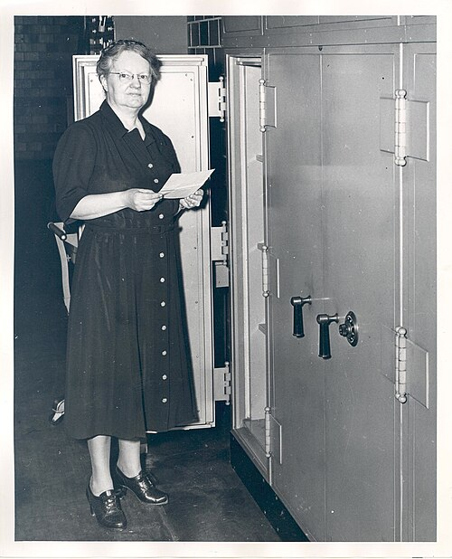

Margaret Cross Norton (1891–1984) was an American librarian and pioneering archivist who served as the first State Archivist (superintendent) of the Illinois State Archives from 1922 to 1957. She co-founded the Society of American Archivists (SAA).
She was named 100 of the most important leaders in librarianship in the 20th century.
Margaret Cross Norton was born on July 7, 1891, in Rockford, Illinois, to Samuel Norton, a deputy county clerk, and Jennie (Adams) Norton, who had been deputy county treasurer for Winnebago County. She grew up in a household focused on records and official duties. As a child, she often accompanied her father to the county courthouse, where she played among the vaults and observed attorneys consulting official records. This early exposure shaped her lifelong emphasis on the practical, legal, and administrative importance of public records rather than viewing them solely as historical materials.
She earned a bachelor’s degree in history from the University of Chicago in 1913 and a master’s degree in history there in 1914. In 1915 she received a Bachelor of Library Science from the New York State Library School in Albany. She attended an American Historical Association meeting in 1915 at which Waldo Gifford Leland discussed the poor condition of national archives.
Norton’s first professional position was as a cataloger at Vassar College Library in Poughkeepsie, New York (1915–1918). She subsequently worked briefly as a manuscripts assistant at the Indiana State Library (1918), held a fellowship at the University of Chicago (around 1919–1920), and served as a cataloger at the Missouri State Historical Society in Columbia (1920–1921).

Illinois State Archives

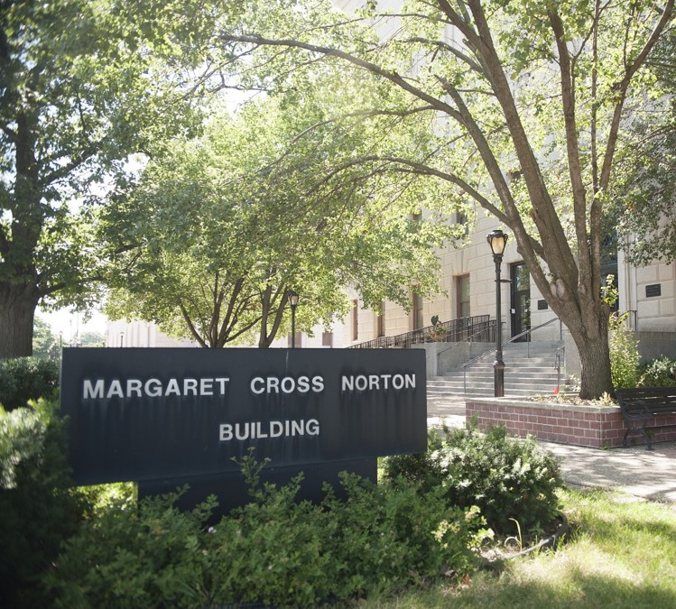

Norton was hired in 1922 by Illinois Secretary of State Louis Emmerson. She began work with minimal staff and resources, reporting initially as head of the Archives Division within the Illinois State Library. She systematically searched basements, attics, and other storage areas in the Capitol complex, recovering neglected or discarded records. Notable early finds included an 1823 governor’s letterbook that provided evidence useful in a major land-claim lawsuit (potentially saving the state substantial funds), the 1818 census under which Illinois entered the Union, and General Assembly papers from the era when Abraham Lincoln and Stephen A. Douglas served.
Influenced by childhood experience with county records, her meeting with Iowa archivist Cassius Stiles (who arranged records by provenance and prepared administrative histories), and Hilary Jenkinson’s Manual of Archive Administration, Norton emphasized arrangement by provenance, the creation of administrative histories of state agencies, and the primary value of records for current government administration and legal purposes. She prepared a multi-volume compilation of the history of Illinois state departments and laws affecting them. Her approach helped establish the Archives as an integral, practical part of state government rather than a purely scholarly repository.
Storage and preservation problems led Norton to advocate for a purpose-built facility. A 1934 fire that destroyed the Illinois State Arsenal and many military records strengthened her case.
The legislature appropriated $500,000 in 1935; additional federal Public Works Administration funding brought the total higher. Ground was broken in 1936 and the building was dedicated in 1938 during the second annual meeting of the Society of American Archivists, held in Springfield.
Designed largely to Norton’s specifications, it featured strong security and fire protection, stack capacity for tens of thousands of cubic feet of records, and departmental vaults that allowed agencies controlled access to semi-current records while maintaining proper custody. It was one of the earliest U.S. public buildings constructed specifically for archival purposes and was regarded as a national model.
During World War II, the National Archives considered it a potential contingency site for its most valuable materials if Washington had to be evacuated.
In 1995 the building was renamed the Margaret Cross Norton Building—the first structure on the Illinois Capitol complex named for a woman.
Later in her tenure Norton advanced records management. She chaired the State Records Commission; legislation in 1951 gave the commission authority over destruction of state records, and in 1956 records management was formally designated a function of the State Archives. By her retirement she had helped create an integrated program combining archival preservation with active records administration.
Professional Leadership and Writings
Norton was a founding member of the Society of American Archivists (established 1936). She served as its first vice president (1936–1937), a Council member, president (1943–1945), and editor of The American Archivist (primarily 1946–1949).
Norton was one of the few women in prominent leadership roles in the early profession. She was also active in the American Historical Association (including its Public Records Commission, which supported creation of the National Archives).
Margaret Cross Norton was an active member of the American Library Association. She used the organization to promote archival interests and to distinguish archival techniques and purposes from those of traditional librarianship and historical scholarship.
Her principal involvement centered on the ALA’s Archives and Libraries Committee. Through this committee she helped educate librarians about the unique principles of archival work—such as provenance, the legal and administrative value of government records, and the differences between archival series and library materials. She also contributed to programming for ALA meetings, including efforts to organize sessions on archives.
In 1940 she taught “American Archival Technique” at Columbia University, one of the first formal archival courses offered in a U.S. library school.
Norton was also active in the related National Association of State Libraries (NASL) and its Archives Committee, where she delivered addresses and published materials advancing the same ideas. She published regularly in library journals, including Illinois Libraries.
Norton leveraged her dual background as a trained librarian and practicing archivist to advocate within the ALA for recognition of archives as a distinct professional field focused on the practical needs of government rather than solely on scholarly or bibliographic functions.

Her writings stressed the utilitarian and legal character of archives, the distinction between archives and historical manuscripts collections or libraries, provenance, and practical administration. Key publications include numerous articles in Illinois Libraries and The American Archivist, a 1947 pamphlet What Does an Archivist Do?, and the posthumously influential compilation Norton on Archives: The Writings of Margaret Cross Norton on Archival and Records Management (1975). She argued that archivists sit at the heart of government machinery and that records serve both administrative needs and secondary historical research.

Later Life and Legacy
Norton retired on April 15, 1957. She died on May 21, 1984, in Springfield, Illinois and left her estate to the SAA. A framed photograph of the Archives Building was found beside her bed.
Her legacy includes the model Illinois program and building, the Margaret Cross Norton Award (established by the Midwest Archives Conference), the Margaret Cross Norton Fund at the SAA (supporting educational activities), and lasting influence on American archival theory and practice.
Scholars have reassessed her as a pragmatic advocate who adapted European principles such as provenance to American governmental needs while insisting on both administrative integrity and historical usefulness of records. She is recognized as a trailblazer for women in the profession and for defining archives as essential to effective government rather than solely as historical resources.
She helped establish archives as a distinct profession in the United States, emphasized the legal and administrative value of government records, oversaw construction of a model archives building, co-founded the Society of American Archivists (SAA), and influenced archival theory and practice through her writings and teaching.

Selected Publications
Norton, Margaret Cross. Catalog Rules: Series for Archives Material. Springfield: Illinois State Library, Archives Division, 1938.
Norton, Margaret C. “Establishing Priorities for State Records: Illinois Experience.” The American Archivist 5, no. 1 (January 1942): 6–14.
Norton, Margaret Cross, ed. Illinois Census Returns, 1810, 1818. Collections of the Illinois State Historical Library, vol. 24. Springfield: Illinois State Historical Library.
Norton, Margaret Cross, ed. Illinois Census Returns, 1820. Collections of the Illinois State Historical Library, vol. 26. Springfield: Illinois State Historical Library.
Norton, Margaret Cross. Norton on Archives: The Writings of Margaret Cross Norton on Archival and Records Management. Edited by Thornton W. Mitchell. Foreword by Ernst Posner. Carbondale: Southern Illinois University Press, 1975. Reprint, with a new introduction by Randall C. Jimerson, Chicago: Society of American Archivists, 2003.
Norton, Margaret C. “Some Legal Aspects of Archives.” The American Archivist 8, no. 1 (January 1945): 1–11.
Norton, Margaret Cross. What Does an Archivist Do? Springfield: Illinois State Library, 1947.
Norton, Margaret C. “Archives in Illinois: The Pioneer Period.” Illinois Libraries 63 (March 1981).
Additional Notes
Norton regularly contributed practical and theoretical pieces on archival administration, cataloging, records management, legal aspects of records, and the role of state archives to Illinois Libraries (roughly 1939–1947) and other library and archival periodicals. She also edited the Proceedings of the National Association of State Libraries (1933–1938) and served as editor of The American Archivist (primarily 1946–1949). Many of her addresses and shorter writings were later collected or referenced in Norton on Archives. Her working papers, reports, and related materials (bulk 1924–1958) are available on microfilm as The Margaret Cross Norton Working Papers (Springfield: Illinois State Archives, 1993).

Sources
Campbell, Ann Morgan (1984). "The Society of American Archivists". The American Archivist. 47 (4): 469–474.
Illinois Office of the Secretary of State. “Margaret Cross Norton: A Biographical Sketch.” Illinois State Archives.
International Council on Archives. “Norton, Margaret Cross (1891, Rockford, Illinois, U.S. – 1984.” Who’s Who in Archives Globally. 2013.
Illinois General Assembly, Office of the Architect of the Capitol. “Norton Building.” Accessed October 21, 2026.
Jimerson, Randall C. “Margaret C. Norton Reconsidered.” Archival Issues 26, no. 1 (2001): 41–62.
Kniffel, L., Sullivan, P., McCormick, E. (1999, December). "100 of the most important leaders we had in the 20th century". American Libraries, 30(11), 38.
Lawrimore, Erin. “Margaret Cross Norton: Defining and Redefining Archives and the Archival Profession.” Libraries & the Cultural Record 44, no. 2 (2009): 183–200.
“Margaret Cross Norton.” Wikipedia.
Norton, Margaret Cross. Interview by Georgia Rountree. Margaret Cross Norton Memoir. Oral History Collection, University of Illinois at Springfield, November 10, 1972. Illinois Digital Archives.
Norton, Margaret Cross. Norton on Archives: The Writings of Margaret Cross Norton on Archival and Records Management. Edited by Thornton W. Mitchell. Carbondale: Southern Illinois University Press, 1975. Reprinted, Chicago: Society of American Archivists, 2003.
“Margaret Cross Norton.” SangamonLink. Sangamon County Historical Society, October 14, 2013.
“Trailblazing Record Holder.” Illinois Times, March 25, 2021.

Submitted by Kathleen de la Peña McCook

