James David Hart-1911-1980

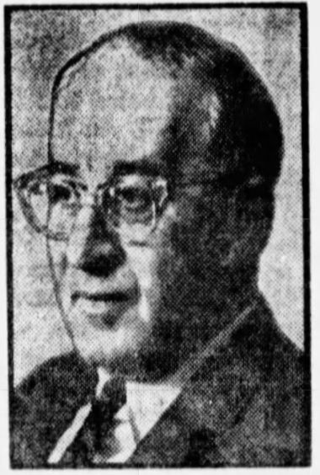

James David Hart (April 18, 1911 – July 23, 1990) was an American literary scholar, professor of English, university administrator, author, and library director. He spent 54 years at the University of California, Berkeley, where he served as chair of the English Department, vice chancellor, and longtime director of the Bancroft Library.
James David Hart was born in San Francisco in 1911. He developed an early passion for books and fine printing. While at the Menlo School in Menlo Park, he persuaded the Grabhorn Press in San Francisco to design and print the school’s yearbook, The Menlo Musketeer, during his senior year in 1928.
Hart earned his A.B. from Stanford University in 1932, then an M.A. (1933) and Ph.D. (1936) in English from Harvard University.
In 1936 Dr. Hart joined the English Department at UC Berkeley as an instructor and remained there for the rest of his career, becoming a full professor in 1951.
As a doctoral student in 1934, Hart conceived the idea for an American counterpart to The Oxford Companion to English Literature while browsing secondhand bookstores in Manhattan. On impulse he walked into the Oxford University Press offices on Fifth Avenue, proposed the project, and—after producing sample entries overnight—secured a contract. Working largely alone, he produced the first edition of The Oxford Companion to American Literature (published 1941). Critic Alfred Kazin later called it “the most valuable handbook I know on our literature.” It reached its fifth edition during Hart’s lifetime and remained a widely used reference containing biographies of authors, summaries of major works, and related literary and historical information.
Dr. Hart also wrote The Popular Book: A History of America’s Literary Taste (1950), A Companion to California (1978; later revised), works on Frank Norris and Robert Louis Stevenson, and Fine Printing: The San Francisco Tradition (1985, Library of Congress). He operated a private press at home and distributed finely printed literary keepsakes.
At Berkeley he taught undergraduates and graduate students; his course on the literature of the American West drew large enrollments. He chaired the English Department twice, served as vice chancellor from 1957 to 1960, and was active on library committees.
From 1959 to 1963 he chaired the Marshall Scholarship Committee for the western United States; for this work promoting Anglo-American educational ties he was appointed a Commander of the Order of the British Empire (CBE) in 1963. He also held visiting appointments (including at Uppsala and Harvard) and lectured in Europe.

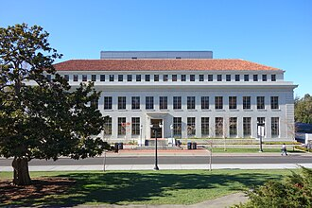
Dr. Hart served as acting director of the Bancroft Library in 1961–62 and became its permanent director in 1969 holding the post until his death. Under his leadership the Bancroft—already strong in Hispanic and Western American materials—expanded its collections of British and American materials, California documents, rare books, and papers of figures such as William Saroyan and Henry J. Kaiser.
Hart was a fellow of the American Academy of Arts and Sciences and the American Antiquarian Society.
Dr Hart died in Berkeley on July 23, 1990.His papers (professional correspondence, writings, speeches, and related materials) are held at the Bancroft Library.

Selected Publications
Editions of The Oxford Companion to American Literature
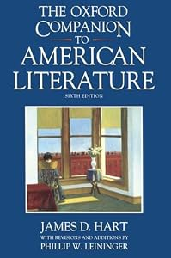
Hart, James D. The Oxford Companion to American Literature. New York: Oxford University Press, 1941.
———. The Oxford Companion to American Literature. 2nd ed. New York: Oxford University Press, 1948.
———. The Oxford Companion to American Literature. 3rd ed. New York: Oxford University Press, 1956.
———. The Oxford Companion to American Literature. 4th ed. New York: Oxford University Press, 1965.
———. The Oxford Companion to American Literature. 5th ed. New York: Oxford University Press, 1983.
———. The Concise Oxford Companion to American Literature. New York: Oxford University Press, 1986.
Hart, James D., and Phillip W. Leininger. The Oxford Companion to American Literature. 6th ed. New York: Oxford University Press, 1995.
----
Hart, James D. The Popular Book: A History of America’s Literary Taste. New York: Oxford University Press, 1950. Reprint, Westport, CT: Greenwood Press, 1976.
Hart, James D., and Clarence Gohdes, eds. America’s Literature. New York: Henry Holt, 1955. (Also issued under Holt, Rinehart and Winston imprints in later printings.)
Hart, James D. “Search and Research: The Librarian and the Scholar.” College & Research Libraries 19, no. 5 (1958): 365–74.
Hart, James D. Fine Printing in California. Berkeley: Tamalpais Press, 1960. (Address delivered at the California Library Association conference, October 23, 1959; limited edition.)
Hart, James D., ed. My First Publication: Eleven California Authors Describe Their Earliest Appearances in Print. San Francisco: Book Club of California, 1961.
Hart, James D. The Private Press Ventures of Samuel Lloyd Osbourne and R. L. S., with Facsimiles of Their Publications. San Francisco: Book Club of California, 1966.
Hart, James D. A Tribute to Edwin Grabhorn and the Grabhorn Press. San Francisco: Friends of the San Francisco Public Library, 1969.
Hart, James D., and Ward Ritchie. Influences on California Printing: Papers Read at a Clark Library Seminar, April 11, 1970. With an introduction by Andrew H. Horn and a bibliography of the Primavera Press by J. M. Edelstein. Los Angeles: William Andrews Clark Memorial Library, University of California, 1970.
Hart, James D. A Companion to California. New York: Oxford University Press, 1978.
———. A Companion to California. Rev. and expanded ed. Berkeley: University of California Press, 1987.
Hart, James D. “A Note on the California Edition.” In Moby-Dick, by Herman Melville. Berkeley: University of California Press, 1981.
Hart, James D. Fine Printing: The San Francisco Tradition. Washington, DC: Library of Congress, 1985.
Additional shorter contributions, introductions, and privately printed items (including works related to Frank Norris, Robert Louis Stevenson, and California printing history) appear in scholarly journals and in limited editions associated with the Book Club of California and the Hart Press. For the most complete record, consult the James D. Hart Papers (1928–1991) at the Bancroft Library, UC Berkeley.

Sources
Fowler, Glenn. “Prof. James D. Hart Is Dead at 79; Chronicled America’s Literature.” New York Times, July 24, 1990.
“James D. Hart.” Wikipedia.
“James David Hart (1911–1990).” Find a Grave.
“James D. Hart Papers, 1928–1991.” Online Archive of California.
McMillan, Penelope. “James Hart; Wrote Literary ‘Companion.’” Los Angeles Times, July 24, 1990.
Middlekauff, Robert. “James David Hart.” Proceedings of the American Antiquarian Society.
Pagni, Michelle M. “Hart, James D. (1911–1990).” American National Biography. Oxford University Press, 1999.

Submitted by ALA Member

