Mollie Ernestine Dunlap- 1898 – 1977
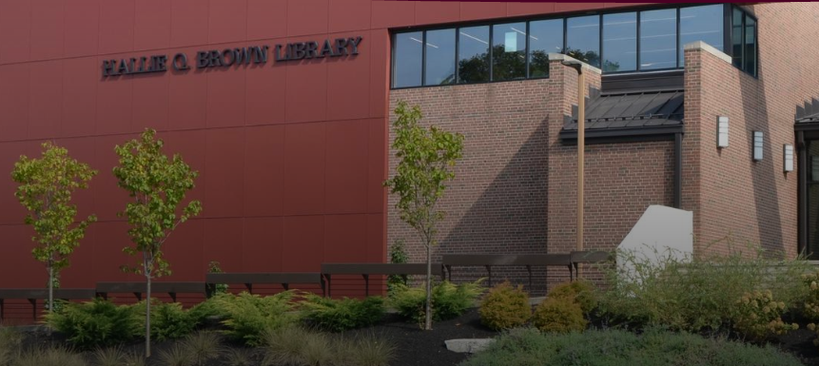
Mollie Ernestine Dunlap (September 2, 1898 – July 7, 1977) was an American librarian, bibliographer, and educator whose career centered on historically Black colleges and universities. She built collections documenting African American scholarship and higher education, published bibliographic studies that aided research in the field, and worked to expand professional opportunities for Black librarians under segregation.
Mollie Dunlap was born in Paducah, Kentucky. She studied English and elementary education at Wilberforce University in Ohio and later earned a bachelor’s degree from Ohio State University in 1928. With support from a Rosenwald Fund scholarship, she studied librarianship at the University of Michigan, receiving a second bachelor’s degree in 1931 and a Master of Library Science in 1932. From 1918 to 1923 she worked as an instructor at Wilberforce.
In 1925 she became librarian at Winston-Salem Teachers College (now Winston-Salem State University) in North Carolina, remaining until 1934. That year she returned to Wilberforce as university librarian. When Central State College (now Central State University) was established in 1947, she became library director, guided construction of the Hallie Q. Brown Memorial Library, organized its African American collection, and in 1968 was named university archivist. Her papers are held at the Hallie Q. Brown Library.
Dunlap was a founding member and the first vice president of the North Carolina Negro Library Association, organized at Shaw University in April 1934. It was the first African American library association in the United States, formed because Black librarians were excluded from full participation in the white state association. She later engaged the American Library Association over racial discrimination. After the 1936 ALA conference in Richmond, Virginia, barred African American attendees from hotel rooms and meal functions, she joined others in pressing the association to uphold equal treatment; she served on the Special Committee on Racial Discrimination and helped draft a 1936 resolution calling for equal treatment of Black librarians.
Her scholarship included an early study of the recreational reading habits of Black college students (published in the Journal of Negro Education in 1933) and a 1935 survey of special collections of Negro literature in the United States. From 1944 to 1947 she was assistant editor of the Negro College Quarterly, contributing bibliographic studies.
In 1976 the University of Michigan awarded her its Distinguished Alumnus Award.
Mollie Ernestine Dunlap died on July 7, 1977, in Ann Arbor, Michigan. Paducah later named a local educational project in her honor.

Selected Publications
Dunlap was assistant editor of the Negro College Quarterly (1944–1947). The Hallie Q. Brown Library index associated with her work also appears in later library serials under related titles.
Dunlap, Mollie E. “Recreational Reading of Negro College Students.” Journal of Negro Education 2, no. 4 (October 1933): 448–59.
Dunlap, Mollie E. “Special Collections of Negro Literature in the United States.” Journal of Negro Education 4, no. 4 (October 1935): 482–89.
Dunlap, Mollie. Review of Rural America Reads: A Study of Rural Library Service, by Marion Humble. Journal of Negro Education 8, no. 2 (April 1939): 217.
Dunlap, Mollie E. Bibliographic studies of Negro literature. Negro College Quarterly, 1944–1947. (Specific article titles not separately cataloged in the sources consulted.)
Dunlap, Mollie E., and Anne O’H. Williamson. “Institutions of Higher Learning among Negroes in the United States of America: A Compendium.” 1947.
Dunlap, Mollie E. Despite Discrimination: Some Aspects of Negro Life in the United States. 1949.
Dunlap, Mollie E. Index to Selected Negro Publications Received in the Hallie Q. Brown Library. Wilberforce, OH: Hallie Q. Brown Library. (Described in biographical accounts as her principal reference work; the library’s related serial Index to Selected Negro Periodicals began in 1950.)

Sources
“Dunlap, Mollie E.” Notable Kentucky African Americans Database. University of Kentucky. Accessed October 1, 2026.
“The Dunlap Project – Jetton Schoolhouse.” City of Paducah. Accessed October 1, 2026.
Jordan, Casper L. “Mollie Ernestine Dunlap (1898–1977): Librarian, Bibliographer, Editor.” In Notable Black American Women, Book II, edited by Jessie Carney Smith, 194–196. Detroit: Gale Research, 1991.
“Mollie E. Dunlap.” Wikipedia.
Walters, Deborah. “Librarians, Segregated: The 1936 ALA Annual Conference.” American Library Association Archives, University Library, University of Illinois, October 30, 2024.
Washington, Dorothy Ann. “Dunlap, Mollie Ernestine (1898–1977).” In Dictionary of American Library Biography: Second Supplement, edited by Donald G. Davis Jr., 85–88. Westport, CT: Libraries Unlimited, 2003.

Submitted by ALA Member

