Judith “Judy” Yung - 1946– 2020

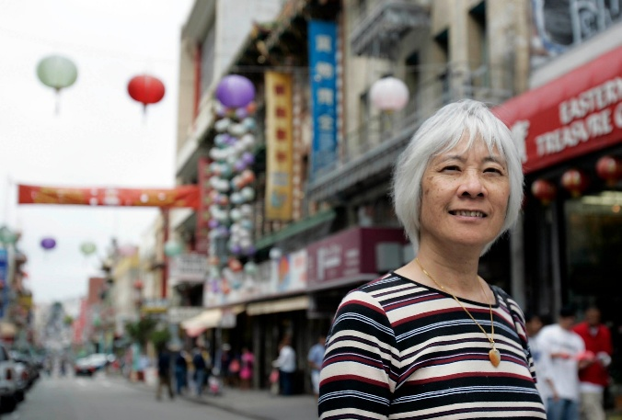

Judith “Judy” Yung (January 25, 1946–December 14, 2020) was a Chinese American librarian, oral historian, community activist, and professor emerita of American Studies at the University of California, Santa Cruz. Working first in public libraries and later in the university, she helped build the _{documentary} record of Chinese immigration, San Francisco Chinatown, and especially the everyday lives of Chinese American women.
Judith Yung was born in San Francisco’s Chinatown, the fifth of six children of immigrants from Guangdong Province. Her father had been detained at the Angel Island Immigration Station in 1921, a family history that later shaped her scholarship.
Yung attended public school by day and Chinese-language school at night for about a decade, becoming bilingual and biliterate. She graduated as salutatorian of Galileo High School in 1963 and also attended St. Mary’s Chinese Language School.
She earned a B.A. in English literature and Chinese language from San Francisco State College (now San Francisco State University) in 1967 and an M.L.S. from the University of California, Berkeley, School of Librarianship in 1968 She earned a PhD at Berkeley in Ethnic Studies, completed in 1994.
Yung’s first career was in public librarianship. By 1969 she was working at the Chinatown Branch of the San Francisco Public Library; in 1973 she became head of that branch—the first person of Chinese descent, and the first Chinese-speaking librarian, to hold the post. Confronting a near-absence of materials on Chinese Americans, especially women, she built Chinese-language and Chinese American collections and argued that library education should train staff to assess community needs rather than merely manage collections.
After a period as associate editor of the bilingual weekly East West: The Chinese American Journal in the mid-1970s, she moved to the Oakland Public Library. In 1976 she developed what has been widely described as the first Asian American branch library in the United States, at the Park Boulevard location (later the Asian Branch Library), hiring multilingual staff and creating Asian-language and Asian American interest collections.

Jung’s library work led directly into public history. In the mid-1970s, after poems carved into the walls of the Angel Island detention barracks came to light, Yung collaborated with historian Him Mark Lai and poet Genny Lim to translate the inscriptions and interview former detainees and staff. The result, Island: Poetry and History of Chinese Immigrants on Angel Island, 1910–1940 (1980; expanded edition, 2014), won the Before Columbus Foundation’s American Book Award in 1982 and became a foundational text in Asian American studies.
From 1981 to 1983, with a Women’s Educational Equity Program grant, she directed the Chinese Women of America Research Project, conducting extensive oral histories, organizing a traveling exhibition, and publishing Chinese Women of America: A Pictorial History (1986).
In 1990 Dr. Yung joined the American Studies faculty at UC Santa Cruz to establish Asian American studies there. She taught Asian American history, women’s history, oral history, and mixed-race studies; chaired the department; received campus awards for teaching and diversity; and was a commencement speaker four times before retiring in 2004 as professor emerita.
Her major monograph, Unbound Feet: A Social History of Chinese Women in San Francisco (1995), used oral history and archival sources to trace Chinese women’s lives from the nineteenth century through World War II and won awards from the Association for Asian American Studies, the Western History Association, and the Women’s Heritage Museum. Companion and later volumes included Unbound Voices (1999); Chinese American Voices, coedited with Gordon H. Chang and Him Mark Lai (2006); the photographic history San Francisco’s Chinatown (2006; revised 2016); The Adventures of Eddie Fung (2007); and, with Erika Lee, Angel Island: Immigrant Gateway to America (2010), the centennial history of the immigration station.
Dr. Yung received the Association for Asian American Studies Lifetime Achievement Award (2006), the Chinese Historical Society of America’s Annie Soo Spirit Award (2007), National Women’s History Month recognition (2015), and the Angel Island Immigration Station Foundation’s Immigrant Heritage Award in Education (2015), among other honors. The American Library Association memorialized her as a pioneer in both librarianship and historical scholarship.
Dr. Judith Yung died in San Francisco on December 14, 2020.
Her papers are held at UC Santa Cruz, and the campus established a memorial fund to support Asian American and Pacific Islander studies.
Yung often described her contribution in librarian’s terms: to recover missing voices and put them on the shelf. From the Chinatown branch stacks to Angel Island’s carved poems and the oral histories of ordinary women, that work recast Chinese American history as a story of community, gender, and endurance rather than of anonymous exclusion alone.

Selected Publications

Yung, Judy. San Francisco’s Chinatown. Charleston, SC: Arcadia Publishing, 2006. Rev. ed., 2016.
Lai, Him Mark, Genny Lim, and Judy Yung, eds. Island: Poetry and History of Chinese Immigrants on Angel Island, 1910–1940. San Francisco: Hoc Doi / Chinese Culture Center of San Francisco, 1980. 2nd ed. Seattle: University of Washington Press, 2014.
Yung, Judy, Ruthanne Lum McCunn, and Russell Leong, eds. Him Mark Lai: Autobiography of a Chinese American Historian. Los Angeles: UCLA Asian American Studies Center and Chinese Historical Society of America, 2011.
Lee, Erika, and Judy Yung. Angel Island: Immigrant Gateway to America. New York: Oxford University Press, 2010.
Yung, Judy. The Adventures of Eddie Fung: Chinatown Kid, Texas Cowboy, Prisoner of War. Seattle: University of Washington Press, 2007.
Yung, Judy, Gordon H. Chang, and Him Mark Lai, eds. Chinese American Voices: From the Gold Rush to the Present. Berkeley: University of California Press, 2006.
Yung, Judy “Bound Feet,” Becoming American: The Chinese Experience, PBS, 2003,
Yung, Judy. Unbound Voices: A Documentary History of Chinese Women in San Francisco. Berkeley: University of California Press, 1999.
Yung, Judy. Unbound Feet: A Social History of Chinese Women in San Francisco. Berkeley: University of California Press, 1995.
Yung, Judy. Chinese Women of America: A Pictorial History. Seattle: University of Washington Press, 1986.

Sources
American Library Association. “Memorial Resolution Honoring Judy Yung.” Adopted January 26, 2021.
Asian/Pacific American Librarians Association. “Library Leaders: Judy Yung.” April 12, 2021.
“Chinese American Heroines: Judy Yung.” AsianWeek, April 11, 2009. Archived October 30, 2009, at the Wayback Machine.
Department of Ethnic Studies, University of California, Berkeley. “Passing of Ethnic Studies Alum Judy Yung.” January 7, 2021.
Hsu, Madeline Y. “Judy Yung (1946–2020).” Perspectives on History, American Historical Association, March 31, 2021
“Judy Yung.” Wikipedia.
“Judy Yung: A Yellow Feminist Force.” East Wind, December 28, 2020.
“Judy Yung Obituary.” San Francisco Chronicle. Posted on Legacy.com.
Online Archive of California. “Judy Yung Papers, 1960s–2020.”
Pan, A. (2020). In Memoriam: Judy Yung. Amerasia Journal, 46(3), 368–380.
“Serving Chinatown—Judy Yung.” American Libraries 4, no. 5 (May 1973): 273. Reprinted and discussed in The Berkeley Revolution.
University of California, Berkeley, School of Information. “Alumna Judy Yung, a Pioneer in Asian American Scholarship, Dies at 74.” January 12, 2021.
University of California, Santa Cruz. “UC Santa Cruz Scholar of Chinese American History Judy Yung Dies at 74.” January 5, 2021.
Whiting, Sam. “Judy Yung, S.F. Chinatown Native and Early Scholar of Chinese American Life, Dies at 74.” San Francisco Chronicle, December 23, 2020.
Yang, Alice. “Announcing the Judy Yung Memorial Fund.” Critical Race and Ethnic Studies, University of California, Santa Cruz. May 11, 2021.

Submitted by ALA Member

