Agnes Lytton Reagan (1914–2013)

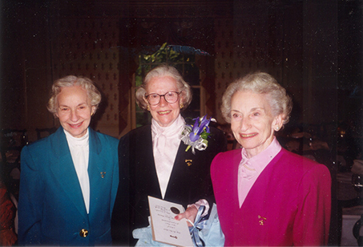
Sisters Betty Lynn, Agnes Lytton and Mary Sue Reagan in 2001

Agnes Lytton Reagan (1914–December 2013) was an American librarian, library science educator, and professor from northwest Arkansas. Reagan built a distinguished career in librarianship that included work at, Emory University, the American Library Association, and the University of Texas at Austin. She served from 1969 to 1975 as the first accreditation officer for the American Library Association in Chicago.
Agnes Lytton Reagan was born in 1914 in northwest Arkansas . She earned a Bachelor of Arts in mathematics from the University of Arkansas J. William Fulbright College of Arts and Sciences in 1935.
She continued her studies at Emory University, where she received a master’s degree in history and a bachelor’s degree in library science.
She earned a Master of Science and a Doctor of Philosophy in library science from the University of Illinois. Her 1957 dissertation was “A Study of Certain Factors in Institutions of Higher Education Which Influence Students to Become Librarians.” (Monograph (revised from the dissertation)
Reagan, Agnes Lytton. A Study of Factors Influencing College Students to Become Librarians. ACRL Monograph no. 21. Chicago: Association of College and Research Libraries, 1958).

Reagan began her professional work on the library staffs of Agnes Scott College and Wellesley College.
From 1947 to 1967 she taught courses in reference and documents at Emory University’s Division of Librarianship.
Dr. Reagan then served from 1969 to 1975 as the first accreditation officer for the American Library Association in Chicago. The position involved administering the accreditation of master’s programs in library and information studies—a central quality-control function for the profession.
From 1975 until her retirement in 1984, she taught reference and government publications at the University of Texas at Austin.
In 1986 the American Library Association honored her with the Beta Phi Mu Award. for distinguished service to education for librarianship.
Dr. Reagan and her sisters donated family papers to the University of Arkansas Special Collections in 1988. The Reagan Family Papers collection (MC 755) includes correspondence, clippings, a scrapbook, and related materials. After the sisters’ deaths, their estate gift of more than $1.2 million to the University of Arkansas Libraries supported purchases of books, periodicals, and digital resources. Additional materials, including books and an antique bookshelf, went to Special Collections.

Dr. Agnes Lytton Reagan died in December 2013.

Sources

“1986 ALA Awards Winners: Agnes Lyton Reagan 1986. American Libraries 17 (June): 470.
“Reagan Family Papers.” ArchivesSpace at the University of Arkansas. Collection MC 755.
“Reagan, Agnes Lytton, 1914-2013.” ArchivesSpace at the University of Arkansas.
“Reagan Sisters Contribute Over $1.2 Million to University Libraries.” University of Arkansas News, July 7, 2015.
Womack, Steve. “Expressing Gratitude to the Reagan Sisters.” Congressional Record 161, no. 107 (July 10, 2015): H5033–H5034.

Submitted by ALA Member

