Cheryl Ann (Landry) McCarthy – 1950- 2021

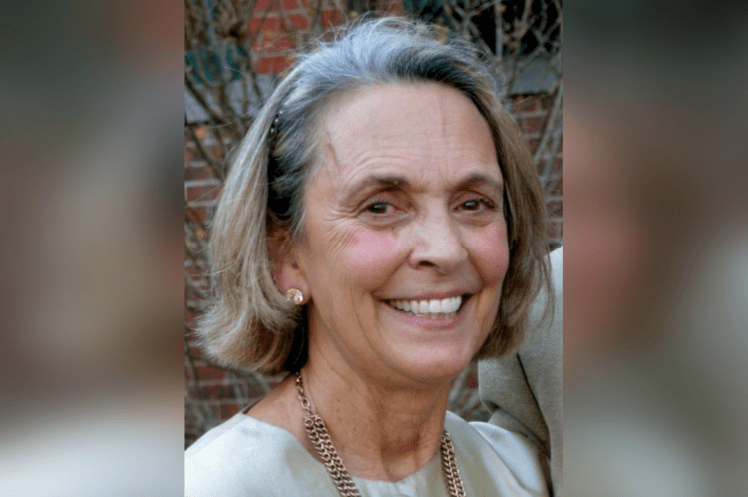

Dr. Cheryl Ann (Landry) McCarthy (May 8, 1950–May 16, 2021) was an American school and academic librarian, library educator, and advocate. She was a professor in the Graduate School of Library and Information Studies (GSLIS) at the University of Rhode Island, where she coordinated school library media and information-literacy programs and later served as interim dean of University Libraries.
McCarthy was born in Newport, Rhode Island and began her career as a K–12 school library media director before moving into higher education. She earned an M.L.I.S. from the University of Rhode Island and a doctorate in library and information studies from Simmons College.
In spring 1993 Dr. McCarthy was appointed assistant professor at the Graduate School of Library and Information Studies (GSLIS) at the University of Rhode Island and spent twenty-five years on the faculty. She coordinated the School Library Media program and the Information Literacy Instruction Certificate program and served as interim dean of University Libraries. She retired in 2016 as professor emerita.
Dr. McCarthy’s research and professional writing focused on the history of school library media programs, online teaching, information literacy from kindergarten through college, and the assessment of library spaces and learning commons.
McCarthy was a prominent association leader in New England.
- President, New England Library Association
- President, School Librarians of Rhode Island,
- Chair the Rhode Island Coalition of Library Advocates,
- Executive Board, Rhode Island Center for the Book.
She was a member of the American Library Association and the American Association of School Librarians for more than twenty-five years. Colleagues remembered her as a mentor to generations of school library media specialists.

Awards:

- New England Library Association’s Emerson Greenaway Award for Distinguished Service for Librarianship (2016);
- Presidential Award from the School Librarians of Rhode Island;
- Designation as one of URI GSLIS’s “Top 50 Distinguished Alumni”;
- Rhode Island Coalition of Library Advocates’ “Sweetheart of the Year”;
- Certificate of accomplishment from U.S. Senator Jack Reed for advocacy on behalf of school and academic libraries.

After retirement she continued taking courses through Salve Regina University’s Circle of Scholars and URI’s Osher Lifelong Learning Institute.
Outside her professional life she was active in Newport’s Irish and Catholic communities, including the Museum of Newport Irish History and the Ladies Ancient Order of Hibernians.
She traveled on religious pilgrimages; a journey to the Holy Land and a Camino de Santiago walk with her daughter Monique were especially important to her. Family accounts emphasize her faith, her love of reading and travel with her grandchildren, and a conviction that her vocation was to find joy in serving others.
Dr. Cheryl McCarthy died May 16, 2021.

Selected Publications
McCarthy, Cheryl A. “A Big Engine That Might: The School Library Media Act.” American Libraries 24, no. 9 (October 1993): 877–80.
McCarthy, Cheryl Ann. “Students’ Perceived Effectiveness Using the University Library.” College & Research Libraries 56, no. 3 (May 1995): 221–34.
Eaton, Gale, and Cheryl McCarthy. “The Art of the Possible: Integrating Information Skills and Literature into the Curriculum.” Emergency Librarian 23, no. 1 (September/October 1995): 24–28, 30.
McCarthy, Cheryl Ann. “A Reality Check: The Challenges of Implementing Information Power in School Library Media Programs.” In 1997 IASL Conference Proceedings (Vancouver, Canada): Bridging the Gap: Information Rich but Knowledge Poor. International Association of School Librarianship, 1997
McCarthy, Cheryl Ann. “Progress in School Library Media Programs: Where Have We Been? Where Are We Now? And Where Are We Going?” In Advances in Librarianship, vol. 30, edited by Danuta A. Nitecki and Eileen G. Abels. Amsterdam: Elsevier, 2006.
McCarthy, Cheryl A., and Danuta A. Nitecki. “An Assessment of the Bass Library as a Learning Commons Environment.” Paper presented at the Library Assessment Conference, Baltimore, MD, October 25–27, 2010.
McCarthy, Cheryl A., and Mary C. MacDonald. “We’re All in It Together: Professional Development Linking Multi-Type Libraries with Information Literacy Instruction Across One State.” In LOEX Conference Proceedings 2014. Ypsilanti, MI: Eastern Michigan University, 2014.

Sources
American Library Association. “Memorial Resolution Honoring Dr. Cheryl Ann McCarthy.” 2020–2021 ALA Memorial #13. 2021 ALA Virtual Annual Conference.
“In Memory.” American Libraries, July/August 2021, 32–33.
New England Library Association. “Emerson Greenaway Award Recipients.” Accessed September 11, 2026.
“RIP Cheryl Ann (Landry) McCarthy.” Newport Buzz, May 18, 2021.

Submitted by ALA Member

