Xiaoqiu Li – 1962-2021

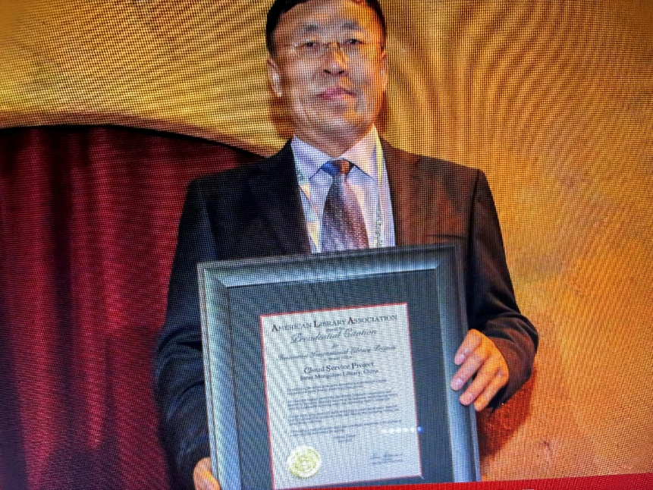

Xiaoqiu Li 李晓秋, c. 1962–2021 was a Chinese librarian, research librarian (yanjiu guanyuan), and cultural administrator best known for his long tenure as director of the Inner Mongolia Autonomous Region Library and for pioneering digital and demand-driven public library services adapted to the region’s vast, sparsely populated pastoral areas.
Two projects he directed won the ALA Presidential Citation for Innovative International Library Project: “Digital Culture into Mongolian Yurts” and “Colorful Cloud Service.”
Li Xiaoqiu was born in August 1962 in Chifeng, Inner Mongolia of Mongolian ethnicity. He began work at the Chifeng City Library in 1981, studied library and information management at Inner Mongolia University from 1983 to 1985, and returned to the Chifeng library, becoming its director in 1988.
After brief roles at the Chifeng Cultural Bureau and as director of the Inner Mongolia Mass Art Museum (2001–2004), he was appointed director of the Inner Mongolia Autonomous Region Library in 2004, a post he held for 13 years. In 2017 he became a party group member and vice director of the Inner Mongolia Culture Department (later the Culture and Tourism Department after institutional reform), overseeing personnel, arts, public services, science and education, and international exchange. He held the senior professional title of research librarian.
As library director he focused on extending services beyond traditional buildings. In 2012 he launched the “Digital Culture into Mongolian Yurts” project. It used Wi-Fi “digital filling stations” at township, village, and mobile herder-camp levels, plus smartphones and tablets, to deliver 24-hour bilingual (Mongolian-Chinese) digital resources from the National Cultural Information Resources Sharing Project to remote pastoralists who lacked reliable internet or fixed cultural facilities. The initiative aimed to close the “last kilometer” of public cultural service. By later reports it had established hundreds of stations across dozens of banners and counties, covering hundreds of thousands of square kilometers and serving well over a million herders and farmers. The project received the American Library Association’s International Innovation Award (the association’s second such award to the same library).

In 2014 the library introduced “Caiyun Service” and a reader-driven acquisition model. Cardholders could borrow newly published books directly from cooperating bookstores; the library then purchased the titles. This reversed the traditional “select-acquire-store-lend” sequence, raised new-book circulation to 100 percent in participating outlets, and treated bookstores as extended library stacks. The model was later adopted by more than 100 libraries in China and also received ALA recognition. Both projects were cited as examples of efficiency-oriented innovation in China’s public cultural service system.
Li Xiaoqiu died 17 May 2021 inside the Inner Mongolia Autonomous Region Library building in Hohhot.
His career spanned four decades in libraries and cultural administration, with the most visible impact coming from practical, technology-enabled services designed for Inner Mongolia’s geography and nomadic traditions.

Sources

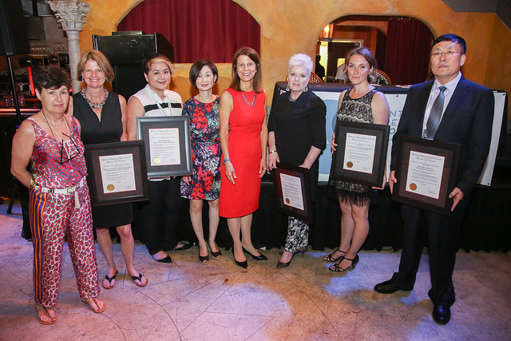

American Library Association. “2018 Presidential Citations.” American Libraries, July 18, 2018.
American Library Association. “A Memorial Resolution Honoring Xiaoqiu Li.” Adopted by ALA Council at the 2021 Virtual Annual Conference (Council III), June 29, 2021.
American Library Association. “International Library Innovators.” American Libraries, September 23, 2016.
“内蒙古自治区文化和旅游厅副厅长李晓秋自杀身亡.” Guancha.cn, May 19, 2021. https://www.guancha.cn/politics/2021_05_19_591238.shtml.

Submitted by ALA Member.

