Susan S. Lazinger -1943-2020

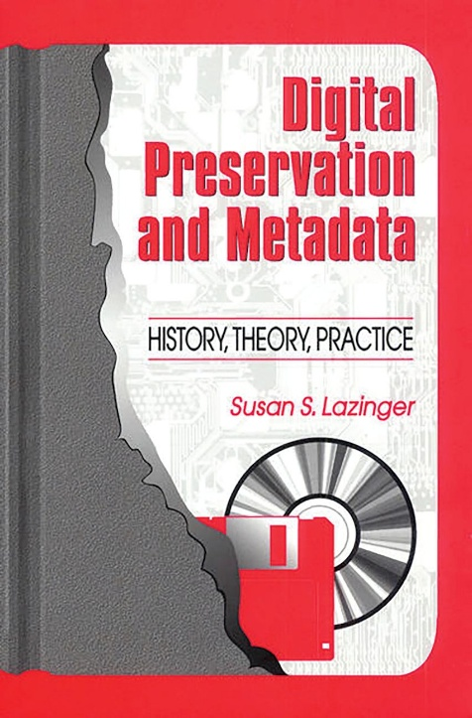

Susan S. Lazinger (born Susan Smernoff; March 12, 1943) was an American-born librarian, educator, and author specializing in digital preservation, metadata, cataloging of non-Roman scripts (particularly Hebrew), and library education. Dr. Lazinger provided foundational texts on preserving electronic resources at a time when digital collections were rapidly expanding.
Susan Lazinger was born in Camden, New Jersey. She earned a bachelor’s degree in Russian from Rutgers University (1961–1965), a Master of Arts in Russian Language and Literature from Smith College (1965–1969), a PhD from Syracuse University in Slavic Languages and Literatures (1973–1978), and a Master of Library and Information Science from the School of Library, Archive and Information Studies at Hebrew University of Jerusalem (1980–1985).
She received several awards during her studies, including a New Jersey state scholarship, a Fulbright Foundation Scholar Award (1976–1977), and a University Fellow designation at Syracuse.
After completing her library degree she worked as Assistant Librarian at the Jewish National and University Library (now the National Library of Israel) in Jerusalem. This institution served simultaneously as Israel’s national library, the central research library of the Hebrew University, and a major repository of Jewish and Israeli materials. Her early work there placed her at the center of Hebrew-script cataloging and the development of automated systems.
Lazinger joined the faculty of the Hebrew University of Jerusalem. She began as senior lecturer and later headed academic programs in the School of Library, Archive and Information Studies. She also coordinated continuing education programs and held administrative roles related to library and information studies.
In 1999 she was a visiting associate professor at North Carolina Central University and a visiting scholar at the University of North Carolina at Chapel Hill.
Dr. Lazinger was active participant in many international activities. She served on the Advisory Board of World Libraries.
She was elected a member of the Standing Committee on Education and Training for the International Federation of Library Associations and Institutions where she was a member of the Subcommittee on Updating IFLA Standards for Library Schools, and served as Secretary/Treasurer and then Chair.
She was on the National Conference Organizing Committee for the 66th IFLA Annual Conference in Jerusalem.
Lazinger’s scholarly work focused on practical and theoretical challenges in librarianship. She co-authored Cataloging Hebrew Materials in the Online Environment: A Comparative Study of American and Israeli Approaches (1998) with Elhanan Adler, examining descriptive and subject cataloging practices, transliteration, and systems such as RLIN and ALEPH (Israel’s research library network).
Her 2001 book Digital Preservation and Metadata: History, Theory, Practice (with annotations by Helen R. Tibbo) addressed threats to digital materials, preservation methods, metadata standards, costs, and institutional frameworks.
Upon retirement she worked as a volunteer at the Israel Museum in Jerusalem, translating from Hebrew to English, and, volunteered with the English language community theater in Jerusalem where she was make-up mistress.
Dr. Susan S. Lazinger died August 2, 2020.

Selected Publications

Lazinger, Susan Smernoff. “Tobin’s ‘A Study of Library “Use Studies”’: An ERIC Update of Neglected Areas of Research.” Government Publications Review 11 (1984): 165–7.
Lazinger, Susan S., and Peretz Shoval. Prototyping a Microcomputer-Based Online Library Catalog. Occasional Papers no. 177. Champaign: Graduate School of Library and Information Science, University of Illinois at Urbana-Champaign, 1987.
Lazinger, Susan S. “Master’s Theses on Topics in Judaica Librarianship in the Graduate School of Library and Archive Studies, The Hebrew University of Jerusalem, 1974–1991: An Annotated Bibliography.” Judaica Librarianship 6, nos. 1–2 (Spring 1991–Winter 1992): 127–31.
Lazinger, Susan S. “ALEPH: Israel’s Research Library Network: Background, Evolution, and Implications for Networking in a Small Country.” Information Technology and Libraries 10, no. 4 (December 1991): 275–91.
Lazinger, Susan S., and others. “Managing Multilinguality: Israel’s Retraining Course for New Immigrant Librarians.” Education for Information 11, no. 3 (1993): 181–88.
Lazinger, Susan S. “To Merge and Not to Merge: Israel’s Union List of Monographs in the Context of Merging Algorithms.” Information Technology and Libraries 13, no. 3 (September 1994): 213–19.
Lazinger, Susan S., and Judith Levi. “Multiple Non-Roman Scripts in ALEPH—Israel’s Research Library Network.” Library Hi Tech 14, no. 1 (1996): 111–16.
Lazinger, Susan S., and Elhanan Adler. Cataloging Hebrew Materials in the Online Environment: A Comparative Study of American and Israeli Approaches. Edited by Sheila S. Intner. Englewood, CO: Libraries Unlimited, 1998.
Lazinger, Susan S. Digital Preservation and Metadata: History, Theory, Practice. Englewood, CO: Libraries Unlimited, 2001.
Intner, Sheila S., Susan S. Lazinger, and Jean Weihs. Metadata and Its Impact on Libraries. Westport, CT: Libraries Unlimited, 2006.

Sources

American Library Association. “Memorial Resolution Honoring Susan S. Lazinger.” Adopted January 26, 2021, ALA Virtual Midwinter Council Meeting.
“Contributor biographical information for Cataloging Hebrew materials in the online environment.” Library of Congress. https://catdir.loc.gov/catdir/enhancements/fy1510/97035508-b.html.
Marina, and Siti Masruroh. “Potret Analisis Tokoh Arsip: Simon Tanner dan Susan S. Lazinger.” IQRA’: Jurnal Perpustakaan dan Informasi 16, no. 1 (May 2022). https://doi.org/10.30829/iqra.v16i1.10291. [“Journal of Library and Information.” Published by the Library of the State Islamic University of North Sumatra].
SciSpace author profile for Susan S. Lazinger. Hebrew University of Jerusalem.

Submitted by ALA Member

