-In Loving Memory of Florante Peter Ibanez (1951 – 2025)
December 8, 2025 News and Updates
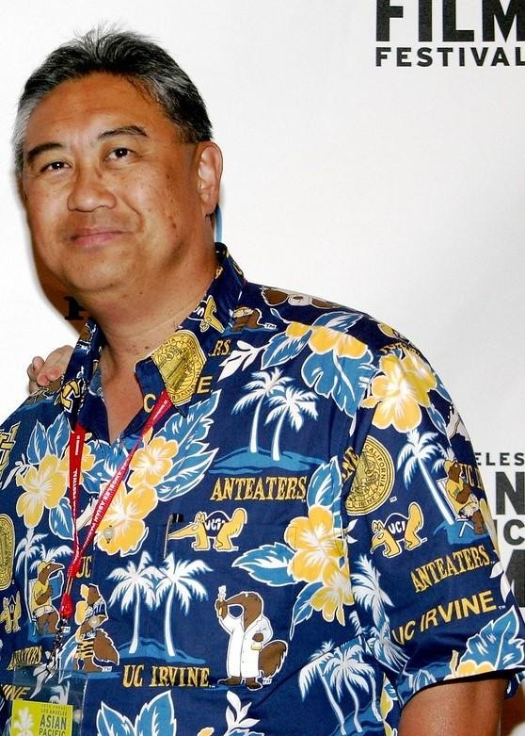
For many of us in APALA, Florante was more than a mentor, colleague, or friend. He was a builder of AANHPI spaces, connections, and new possibilities. Ever-present with his camera, he documented every APALA milestone, ensuring our stories were honored and remembered. As APALA Past President (2010-2011) and our unofficial photographer for many years, Florante had a unique way of making everyone feel seen and valued. He built community with intention, led activism with humility and determination, and offered mentorship that uplifted without overshadowing. His love, wisdom, and devotion to his APALA family are among our most treasured memories.
Florante leaves behind a legacy measured not by years, but by the countless lives he touched and the Filipino and AANHPI communities he strengthened. Because of him, we are more connected, supported, and empowered. His impact lives in every person he encouraged, every story he helped preserve, and each community he helped shape. Additionally, Florante and his life partner Rose donated an archival collection at CSU Dominguez Hills. The donation demonstrates Florante’s capacious work across professional fields and vision.
His community building went beyond the library and archival fields, especially with the Association for Asian American Studies, where he was the “official” photographer for many years. More importantly, at AAAS conferences he spoke about the essential role of librarians and archivists for the field of Asian Americans Studies and opened up spaces for collaborations and critical conversations.
Additionally, beyond our shared profession, Florante created spaces for so many from early on. One of his colleagues shared that he was one of the founders of the local Los Angeles chapter of the Katipunan ng mga Demokratikong Pilipino (KDP) in the 1970s and co-founder of UCLA’s Samahang Pilipino and UCI’s Kababayan. He was also a long-time member of FANHS-LA, co-authored Filipinos in Carson and the South Bay with his life partner, Rose, and served on the boards of the Filipino American Library, LA as Subject, FilAm ARTS, Kayumanggi Lions Club, and many others.
As we reflect on Florante’s life, APALA leadership is also considering how we can best honor his memory in a lasting and meaningful way. Many of us felt a deep personal connection to him – as builder, activist, mentor, professional, and friend – and we want any tribute to reflect the fullness of who he was. We look forward to sharing more opportunities next year, including a potential scholarship award, to celebrate his legacy and continue the important work he inspired.
Florante’s photos and memories of the countless library and community events he documented can be found in his smugmug albums. Also, if you would like to share a personal story or a message to his family, please add it to a memorial Kudoboard. We will share it with Florante’s family on behalf of APALA.
Thank you, Florante, for everything you shared, built, gave, and inspired. We will honor your legacy by nurturing our APALA community, preserving our stories, and standing up for one another – just as you always did.
A viewing has been scheduled for December 20, 2025 from 5:00 to 8:30 PM at Green Hills Mortuary in Rancho Palos Verde, CA 90745. The family would like to invite anyone who can attend and join them in remembrance of Florante Peter Ibanez.
Please fill out the form link to receive details for Florante’s Community Celebration planned for January.
Salamat, Florante. Your spirit lives on in the hearts of all of us.

