Fred McCrae Peterson- 1936-2025

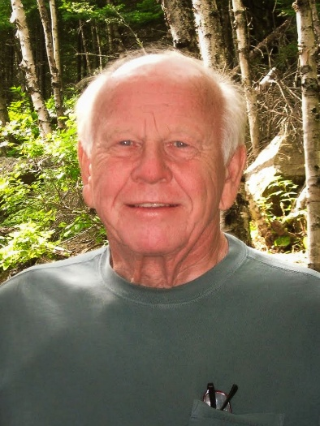

Fred McCrae Peterson (December 29, 1936 – September 6, 2025) was an American librarian, library administrator, and educator whose career spanned cataloging, academic library leadership, library education, and professional association service.
He was born in Minneapolis, Minnesota. Peterson earned a B.A. in International Relations from the University of Minnesota in 1958 and a Master of Library Science from the same institution in 1962. He later received a Ph.D. in Library and Information Science from Indiana University.
Peterson began his professional career in 1961 in the cataloging department at Iowa State University in Ames, Iowa. He rose to Assistant Director and then Associate Director of Libraries before leaving in 1970 to pursue doctoral studies.
In 1973 he joined the faculty of the Catholic University of America in Washington, D.C., as an Assistant Professor. He later served as Associate Director (or Associate Dean) of the library school and as Director of Libraries. During this period, ISUhe supported continuing-education initiatives led by Dean Elizabeth Stone, helped plan a pre-conference associated with IFLA that contributed to the development of IFLA’s Continuing Professional Education and Workplace Learning Section, created an active Friends of the Library program, and chaired the newly established ALA Poster Sessions committee during Stone’s ALA presidency. Those poster sessions remain a feature of ALA conferences.
In 1982 Peterson became University Librarian at Milner Library, Illinois State University ( ISU), in Normal, Illinois, a position he held until his retirement in 1996. At ISU his library received a major grant from the Illinois Board of Education in 1992. He also served on the Illinois State Library Advisory Committee.
Peterson was active in both the American Library Association and the Illinois Library Association. Within ALA he served on the Committee on Accreditation (1993–1995) and chaired the Nominating Committee (1985–1986). He contributed management-related definitions to Heartsill Young’s edition of the ALA Glossary of Library and Information Science.
He served as president of the Illinois Library Association in 1989 and was named Illinois Librarian of the Year in 1994. He welcomed delegates to the Illinois White House conference in 1990.
After retirement Peterson lived for 25 years in San Juan Capistrano, California, before moving to Mission Viejo in 2021. He was a gifted pianist known for lively sing-alongs and took numerous art classes.
Fred McCrae Peterson died in Mission Viejo, California in 2025.

Sources
American Library Association. “Memorial Resolution for Fred McCrae Peterson.” 2025–2026 Memorial #5. Adopted January 28, 2026, ALA Winter Council Session.
“Fred McCrae Peterson Ph.D. Obituary.” September 6, 2025. O’Connor Mortuary .
Illinois Library Association. “ILA’s Origins, Presidents, and Executive Directors.” Accessed August 31, 2026.
Peterson, F. (1991). Conference welcome address—April 4, 1990, Illinois White House conference, Chicago. Illinois Libraries, 73, 457–459.

Submitted by ALA Member

