Keith M. Cottam 1941-2023

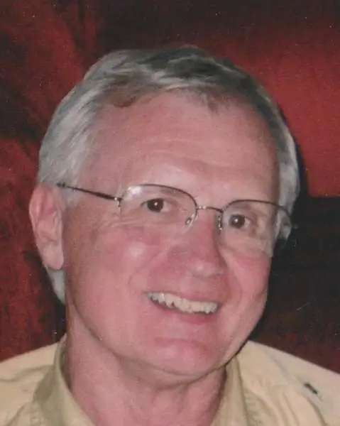

Keith M. Cottam (February 13, 1941–April 9, 2023) was an American academic librarian, library administrator, educator, and author whose career spanned public and university libraries across the United States. He is best known for long service as director and later dean of libraries at the University of Wyoming.
A leader, he was president of the Tennessee Library Association and the Wyoming Library Association.
Cottam was born in St. George, Utah and earned a Bachelor of Science from Utah State University in 1963. He earned a Master of Library Science from Pratt Institute in New York City in 1965. While completing the MLS he trained and worked at the Brooklyn Public Library as an adult services librarian and assistant instructor in a reading-improvement program.
He began his academic library career in 1965 as assistant social sciences librarian (and instructor) at Southern Illinois University Edwardsville. From 1967 to 1972 he served at Brigham Young University as head of the Social Sciences Library in the Harold B. Lee Library and as founding advisor of the BYU Cycling Club.
In the summer of 1971 Cottam served on an advisory team to the National Academy of Public Administration (Học viện Quốc gia Hành chính) in Saigon, South Vietnam; materials from that assignment later formed part of a collection he donated to BYU.
Cottam next became assistant director of libraries for the Undergraduate Library at the University of Tennessee, Knoxville (1972–1977). In 1977 he moved to Vanderbilt University, where he held successive roles as assistant director for public services and employee relations with the Joint University Libraries, associate director and deputy of the Vanderbilt library system, and acting director.

In 1983 he was appointed director of the University of Wyoming Libraries in Laramie, a post he held until 2000; he then served one year as dean of libraries. During his Wyoming tenure he also held faculty rank as professor. After leaving the Laramie campus he became associate dean of the University of Wyoming Outreach School and director of the university’s Casper College Center. He was named professor emeritus of the University of Wyoming at Casper in 2005 and returned briefly as interim director of the Casper College Goodstein Foundation Library (2008–2010).

Professional Activities
Cottam was active in professional associations. He belonged to the American Library Association, served as president of the Tennessee Library Association (1979–1980) and the Wyoming Library Association (1998–1999), and chaired ACRL’s Continuing Education Committee and the College and University Section of the Utah Library Association.
He was a fellow of the Council on Library and Information Resources (1975) and a senior fellow of the UCLA Graduate School of Library and Information Science (1985). He held membership in Phi Kappa Phi and Beta Phi Mu.
In 2001 the University of Wyoming Libraries awarded him the Agnes Milstead Distinguished Librarianship Award
He published on library management, student employees, user education, professional identity, and research methods. He also edited Utah Libraries and served on the editorial board of RQ.
In retirement in Casper, Wyoming Cottam volunteered with Serve Wyoming, the Platte River Trails Trust, the National Historic Trails Interpretive Center), Senior Olympics, Casper Area Chamber of Commerce, and the Wyoming Library Association.
He died in Casper, Wyoming in 2023.
His papers are held at the L. Tom Perry Special Collections at Brigham Young University and the American Heritage Center at the University of Wyoming.
Memorial contributions can be made to the University of Wyoming Library, the Casper College Foundation, the National Historic Trails Center, and the Platte River Trails Trust.

Selected Publications

Cottam, Keith M. “Student Employees in Academic Libraries.” College & Research Libraries 31, no. 4 (July 1970): 246–48.
Cottam, Keith M. Professional Specialists in Academic Libraries. Occasional Papers, vol. 4, no. 1. Washington, DC: Association of Research Libraries, Office of University Library Management Studies, June 1976.
Cottam, Keith M., and Robert W. Pelton. Writer’s Research Handbook: The Research Bible for Freelance Writers. South Brunswick, NJ: A. S. Barnes, 1977.
Cottam, Keith M., and Robert W. Pelton. Writer’s Research Handbook: A Guide to Sources, the Bible for Freelance Writers. New York: Barnes & Noble, 1978.
Cottam, Keith M., and Connie V. Dowell. “A Conceptual Planning Method for Developing Bibliographic Instruction Programs.” Journal of Academic Librarianship 7, no. 4 (September 1981): 223–28.
Cottam, Keith M. “Avoiding Failure: Planning User Education.” RQ 21, no. 4 (Summer 1982): 331–33.
Cottam, Keith M. “The MLS: For the Public Good or for Our Good?” Library Journal 111, no. 3 (February 15, 1986): 111–14.
Cottam, Keith M. “Affirmative Action: Attitude Makes a Difference.” Library Journal 112, no. 9 (May 15, 1987): 47–50.
Cottam, Keith M. “Professional Identity and ‘Intrapreneurial’ Behavior.” Journal of Library Administration 8, no. 1 (Spring 1987): 29–40.
Cottam, Keith M. “Directors of Large Libraries: Roles, Functions, and Activities.” Library Trends 43, no. 1 (Summer 1994): 15–33.

Sources
“Collection: Keith M. Cottam Papers.” BYU Library–Special Collections. Accessed 2026.
“Keith M. Cottam Obituary.” April 10, 2023.
“Keith M. Cottam, acting director of Vanderbilt University Library since 1982, has been named director of the University of Wyoming Libraries,” College & Research Libraries News.
University of Wyoming Libraries. “Library Employee News, April 2023.” In Memoriam of Keith M. Cottam.

Submitted by ALA Member

