Kathie Lynn Coblentz – 1947- 2021

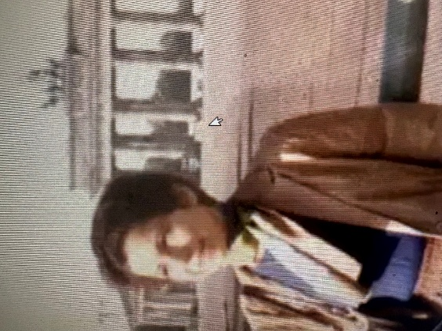

Kathie Lynn Coblentz (November 4, 1947–April 3, 2021) was an American rare-book librarian, cataloger, author, and editor whose entire 52-year professional career was spent at The New York Public Library.
Recruited while still in library school, she became the institution’s third-longest-serving employee and was widely regarded as a master cataloger whose work combined linguistic range, scholarly skepticism, and deep commitment to public access.
She was born in Lansing, Michigan. She earned a Bachelor of Arts in German from Michigan State University in 1968 and a Master of Library Science from the University of Michigan in 1969. She read or spoke thirteen languages and later taught herself Danish, Norwegian, and Swedish so she could read Scandinavian crime fiction in the original.
The New York Public Library hired her in July 1969.
Most of her career was spent as a rare-materials cataloger, latterly in the special formats processing unit of the Miriam and Ira D. Wallach Division of Art, Prints and Photographs, working especially with the Spencer Collection of illustrated books and bindings from all periods and cultures. Colleagues described her catalog and authority records as “artisanally crafted”—the products of detective work, original research, and a refusal to accept received facts at face value.
She cataloged rare books, manuscripts, and original graphic works in English and multiple European languages. She also led public tours of the closed steel stacks beneath the Stephen A. Schwarzman Building, telling visitors that catalogers were “the most important workers in this library” because researchers could not browse the stacks and had to rely on the catalog to request materials.
Coblentz shared her expertise beyond the catalog. She wrote frequently for the NYPL blog on topics ranging from sixteenth-century banned books and movable books to modern Scandinavian crime fiction.
In 2003 she published The New York Public Library Guide to Organizing a Home Library (also issued as Your Home Library), a practical kit that included cataloging software, bookplates, and advice drawn from her own 3,600-volume personal collection housed in sixteen bookcases in a 900-square-foot Manhattan apartment. Her organizing principle was pragmatic rather than orthodox: “Your system doesn’t have to be logical. It just has to work for you.” She arranged her own books by country of origin, size, sentiment, and personal obsession.
Outside librarianship she was a cinephile and editor. She collaborated with film scholar Robert E. Kapsis, a former teacher of hers at the New School, on interview collections including Woody Allen: Interviews (2006) and Clint Eastwood: Interviews, Revised and Updated (2013). She also contributed research, translation of European criticism, editing, and programming to Kapsis’s interactive Multimedia Hitchcock project presented at the Museum of Modern Art and the Academy of Motion Picture Arts and Sciences.
She was a devoted New York Yankees fan, a regular Central Park runner who completed several New York City Marathons, and a member of the library honor society Beta Phi Mu.
On April 3, 2021, while walking home to her West 58th Street apartment, Coblentz was grazed by a vehicle exiting an underground garage, fell, and suffered a fatal head injury.
She was 73. Supervisors and colleagues remembered her as the “matriarch of our work family.”
The American Library Association adopted a memorial resolution recognizing her contributions as a cataloger, mentor, blogger, and author. Her meticulously researched catalog records remain part of NYPL’s infrastructure, connecting researchers to rare materials long after her death.

Selected Publications
Coblentz, Kathie. Your Home Library: The Complete System for Organizing, Locating, Referencing, and Maintaining Your Book Collection. Philadelphia: Running Press, 2003. Also issued as The New York Public Library Guide to Organizing a Home Library.
Kapsis, Robert E., and Kathie Coblentz, eds. Clint Eastwood: Interviews. Conversations with Filmmakers Series. Jackson: University Press of Mississippi, 1999.
Kapsis, Robert E., and Kathie Coblentz, eds. Clint Eastwood: Interviews. 2nd ed., revised and updated. Conversations with Filmmakers Series. Jackson: University Press of Mississippi, 2013.
Kapsis, Robert E., and Kathie Coblentz, eds. Woody Allen: Interviews. Conversations with Filmmakers Series. Jackson: University Press of Mississippi, 2006.
Coblentz, Kathie. “A Tour of the Stacks.” New York Public Library (blog), December 21, 2010.
Coblentz, Kathie. “Movable Books in the Spencer Collection.” New York Public Library (blog), June 23, 2010.
Coblentz, Kathie. “The Pompadour’s Book: A Mystery Manuscript Owned by Madame de Pompadour.” New York Public Library (blog), March 15, 2012.
Coblentz, Kathie. “A Banned Book in the Spencer Collection.” New York Public Library (blog), September 27, 2017.
Coblentz, Kathie. “The Ghost Library of the Château de La Roche-Guyon.” New York Public Library (blog), October 31, 2018.
Coblentz, Kathie. “How to Achieve Spiritual Perfection in 30 Easy Steps.” New York Public Library (blog), May 8, 2020.

Sources
American Library Association. “A Memorial Resolution Honoring Kathie Coblentz.” Presented at the 2021 ALA Virtual Membership Meeting and Annual Council Meeting, May 7, 2021.
“Kathie Coblentz.” Wikipedia. Last modified August 14, 2026.
New York Public Library. “Foreword: Women Who Built NYPL.” Accessed September 10, 2026.
New York Public Library Staff. “NYPL’s Kathie Coblentz: Dedicated Librarian & Master Cataloger.” The New York Public Library (blog), March 1, 2022.
Roberts, Sam. “Kathie Coblentz, 73, Dies; Not Your Ordinary Librarian.” New York Times, April 23, 2021.

Submitted by ALA Member

