Gerald R. "Jerry" Wager – 1948-2004


Gerald R. "Jerry" Wager, was head of reference and reader service in the Rare Book and Special Collections Division (RBSCD), Public Service Collections Directorate of the Library of Congress.
Jerry Wager was born in Youngstown, Ohio, on Oct. 8, 1948. He was awarded an Alumni Distinguished Scholarship by Michigan State University, where he earned a bachelor's degree in mathematics in 1971.
From 1973 to 1985 he was a cataloger at the University of Wisconsin, Madison, where he earned a master's degree in Slavic languages and literature in 1978 and was a lecturer at the School of Library and Information Studies.
He came to LC as a cataloger on the Slavic Team of the former Shared Cataloging in 1985. He joined the Whole Book Cataloging Project in April 1989, as a cataloger on the Religion, Philosophy, and Psychology Team, and stayed with that team until March 1994, when he joined the Cooperative Cataloging Team, Regional and Cooperative Cataloging Division.
He was promoted to leader of the Rare Book Team in June 1995.
American Library Association
Jerry Wager was very active in the Rare Books and Manuscripts Section (RBMS) of the Association of College and Research Libraries, a division of the American Library Association (ALA).
After he became head of reference and reader service in RBSCD in May 1999, he continued to work with the RBMS Bibliographic Standards Committee and with the Program for Cooperative Cataloging in defining the core-level standard for rare books.
He was also a consultant to the Subcommittee on Revision of the Guidelines to Individual Works of Fiction of the ALA Association for Library Collections & Technical Services, Cataloging and Classification Section, Subject Analysis Committee.
RBMS formally celebrated his life and contributions in a resolution approved by its Executive Committee on January 17, 2005, extending sympathy to his partner, friends, and family.

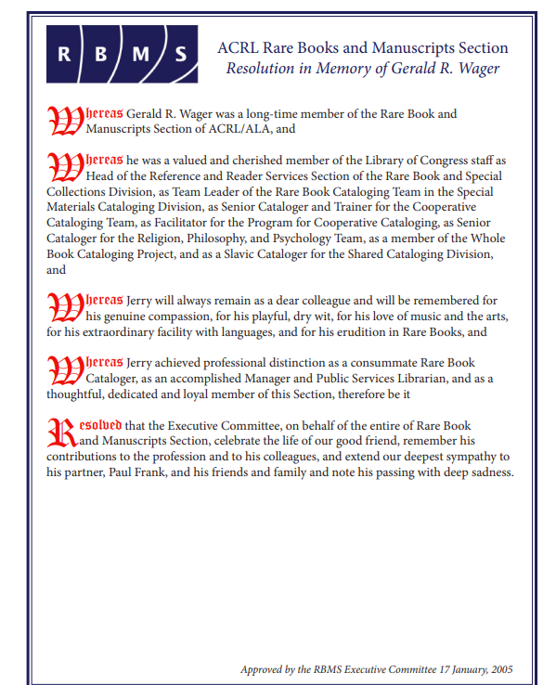

Sources
ACRL Rare Books and Manuscripts Section. “Resolution in Memory of Gerald R. Wager.” Approved by the RBMS Executive Committee, January 17, 2005.
“Gerald (Jerry) Wager (1948-2004).” Member Memorial. Wisconsin Library Association.
“Gerald Wager Obituary.” The Washington Post, published February 7–8, 2004. Legacy.com.
Library of Congress. Cataloging Directorate. “Gerald R. Wager, 1948-2004.” LC Cataloging Newsline 11, no. 4 (March 2004).
Reeder, Robert A. Jerry Wager, Head of Reference and Reader Services, looking over a copy of the Gutenberg Bible in a Library of Congress laboratory. Photograph. July 8, 2003. The Washington Post via Getty Images.

Submitted by ALA Member

