William Landram Williamson - 1920 – 2011

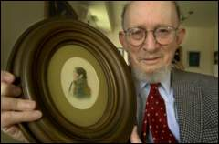

William Landram Williamson (August 13, 1920 – November 19, 2011) was an American librarian, library educator, scholar of library history, and international library consultant.
Williamson born was in Lexington, Kentucky, and raised in Atlanta, Georgia. Williamson earned degrees from the University of Wisconsin (undergraduate), Emory University (library school), Columbia University, and the University of Chicago (doctorate in 1959).
During World War II he served in the U.S. Army as a troopship transport commander.
After the war he worked as a librarian at Baylor University, Montclair State College (New Jersey), and Columbia University, where he held the position of Nicholas Murray Butler Librarian from 1954 to 1964.
In 1966 Dr. Williamson joined the faculty of the University of Wisconsin Library School (later the School of Library and Information Studies) as Professor of Library Science. He taught until his retirement in 1987, focusing on library resources and collection development, library history, research methods, and the role of the library in society.
Students particularly recalled his emphasis on the librarian’s responsibility to foster intellectual freedom and his use of historical and comparative perspectives. He remained actively interested in the school and its graduates until near the end of his life.
Dr. Williamson was a noted scholar of American library history. His principal work, the biography William Frederick Poole and the Modern Library Movement (Columbia University Press, 1963), originated from his University of Chicago doctoral dissertation and examined Poole’s career as representative of the development of modern librarianship in the late nineteenth century.

International work
Dr. Williamson was a member of the International Relations Round Table of the American Library Association. He edited International Leads (a publication of the American Library Association’s International Relations Round Table) for four years.
He also wrote on international library relations and comparative librarianship and served as a critical reviewer in these fields. He organized a major conference on PL-480 in 1967.

Public Law 480

Public Law 480 (PL-480), also known as the Agricultural Trade Development and Assistance Act of 1954 or “Food for Peace,” created a major pathway for U.S. libraries to acquire foreign publications.
The program expanded American research library collections in area studies—especially South Asian and Middle Eastern materials—during the Cold War. By the mid-to-late 1960s, hundreds of thousands of volumes had been distributed (for example, more than 750,000 items from India, Nepal, and Pakistan by 1966 alone). This supported university teaching and research in languages, history, culture, and related fields that would otherwise have been difficult or expensive to build.
Dr. Williamson organized the 1967 conference, The Impact of the Public Law 480 Program on Overseas Acquisitions by American Libraries.

Abstract:

A conference was sponsored by the University of Wisconsin Library School to better inform librarians about the Public Law 480 program under which the Library of Congress acquires foreign language and English publications from developing nations for selected U.S. libraries. Representing the various aspects of the program, members of the panel discussed their experiences informally. The account of the establishment and operation of the program gives details on the legislative history, organization, cooperative cataloging and English-language programs, and future plans. Problems and areas for improvement are revealed in the description of a small college’s experiences with the English-language program. The review of the program’s impact on a large research library illustrates methods of handling an extensive collection and shows the effect the program can have on university teaching and research. Finally, the program’s many implications for the broad areas of librarianship and for the countries themselves are examined, and brief consideration is also given to the possible relationship between this program and the Title 2C or shared cataloging program and the effect on the Farmington Plan. (proceedings available at ERIC).

Internationally, Dr. Williamson served as a library consultant in Indonesia on three occasions (1960–1962, 1970, and 1986) and traveled extensively for research and professional meetings in New Zealand, Australia, England, and Nigeria. He maintained decades-long correspondence with many international colleagues.
Beyond his professional work, Williamson was an early civil-rights activist who marched in Selma, Alabama, in the 1960s and identified as a proud liberal. He was passionate about music, took up the violin later in life, supported the Wisconsin Chamber Orchestra and Madison Symphony Orchestra, and was a long-time subscriber to the Memorial Union Concert series; he particularly admired the works of Hector Berlioz.
Willian Landrum Williamson died at age 91 on November 19, 2011 in Wisconsin. The University of Wisconsin–Madison faculty adopted a memorial resolution in his honor in 2012.

Selected Publications

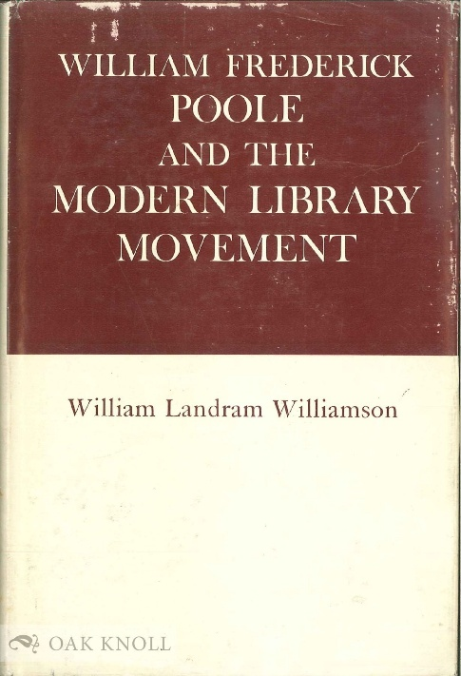

Williamson, William Landram. William Frederick Poole and the Modern Library Movement. Columbia University Studies in Library Service, no. 13. New York: Columbia University Press, 1963.
Williamson, William L., ed. The Impact of the Public Law 480 Program on Overseas Acquisitions by American Libraries: Proceedings of a Conference Held at the Wisconsin Center (Madison, May 12, 1967). Madison: Library School, University of Wisconsin, 1967. ERIC record page: https://eric.ed.gov/?id=ED014993 Full-text PDF: https://files.eric.ed.gov/fulltext/ED014993.pdf
Williamson, William L. University Library Development in Indonesia: A Report to the Ministry of Education and Culture, Republic of Indonesia. [Djakarta]: Himpunan Pustakawan-Chusus Indonesia, 1970.
Williamson, William L., ed. Assistance to Libraries in Developing Nations: Papers on Comparative Studies. Proceedings of a Conference Held at the Wisconsin Center, Madison, Wisconsin, May 14, 1971. Madison: Library School, University of Wisconsin, 1971.
Williamson, W. L. “The Revival of Indonesian Librarianship.” International Library Review 4, no. 4 (1972): 409–15.
Williamson, William L., ed. A Search for New Insights in Librarianship: A Day of Comparative Studies. Proceedings of a Conference Held in the Library School Commons, Helen C. White Hall, University of Wisconsin, Madison, Wisconsin, April 25, 1975. Madison: Library School, University of Wisconsin, 1976.

Sources
“William Williamson Obituary.” Cress Funeral and Cremation Services.
Brujikos, Alex. “Trading Wheat for Books in the Cold War: Public Law 480 (Food for Peace) and Its Connection to Middle East Studies.” Middle East Critique 30, no. 3 (2021): 245–64.
El-Erian, Tahany Said. The Public Law 480 Program in American Libraries. New York: Columbia University, 1972. (Doctoral dissertation; detailed study of the program’s operations and impact.)
Newberry Library. “W.L. Williamson – William F. Poole research papers.”
Includes correspondence between Williamson and the many libraries, research institutions, and individuals from whom he requested information about Poole, 1952-1967; detailed note cards; pages pertaining to the Newberry Library from the original manuscript of Williamson's University of Chicago doctoral dissertation, William Frederick Poole and the Modern Library Movement. There are copies of W. F. Poole's correspondence while head of the Boston Athenaeum (1856-1858), the Cincinnati Public Library (1869-1873), the Chicago Public Library (1874-1879), and the Newberry Library during its founding years (1887-1894); a few newspaper clippings (1874-1895, and a few photographs, including one of Poole, ca. 1876. Also includes an original of Poole's The Ordinance of 1787: a Reply (1882).

Patterson, Maureen L. P. “The South Asian P.L. 480 Library Program, 1962–1968.” Journal of Asian Studies 28, no. 4 (August 1969): 743–54.
“Public Law 480 Programs.” Issue: A Journal of Opinion 8, no. 2/3 (1978): 75–84.
University of Wisconsin–Madison Faculty. “Memorial Resolution of the Faculty of the University of Wisconsin–Madison on the Death of Professor Emeritus William Landram Williamson.” February 6, 2012.
University of Wisconsin–Madison Libraries. “Oral History Interview: William L. Williamson (821).” 2006.
Wagner, Ralph D. A History of the Farmington Plan. Lanham, MD: Scarecrow Press, 2002.

Submitted by ALA Member

