Timothy W. Sineath - 1940 - 2020

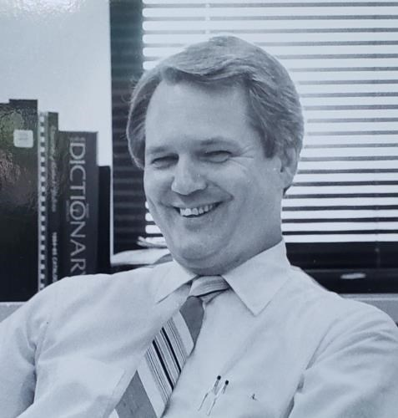

Timothy W. Sineath ( May 21, 1940- June 7, 2020) was an American librarian, library science educator, and academic administrator best known for his long service as dean and professor at the University of Kentucky’s College of Library Science (later part of the School of Information Science).
He was President of the Association for Library and Information Science Education (ALISE) in 1993–94.
He received a B.A. in history from Florida State University in 1962 and an M.S. in library science from the same institution in 1963. He earned a Ph.D. in library science from the University of Illinois in 1970.
Early in his career he worked as a university librarian at the University of Georgia and served as Academic Coordinator of Extension in Library Science at the University of Illinois. Beginning in 1970 he joined the faculty of the School of Library Science at Simmons College in Boston, where he taught and coordinated the doctoral program and the continuing education program.
In 1976 the University of Kentucky Board of Trustees approved his appointment, effective July 1, 1977, as Professor of Library Science with tenure and Dean of the College of Library Science.
He led the college during a period of growth that included attention to emerging information technologies and laboratory facilities for practical training. He later held the titles of Director and Professor Emeritus. Students and colleagues remembered him as a cheerful, supportive, and encouraging presence in the library school.

Association for Library and Information Science Education (ALISE)



Timothy W. Sineath was President of the Association for Library and Information Science Education (ALISE) in 1993–94.
Dr. Sineath was the primary author of the “Faculty” section (covering faculty salaries, ranks, demographics, and related data) of the ALISE Library and Information Science Education Statistical Report for approximately 18 years (into the early 2000s).

He also served as editor (or co-editor) for several volumes of the overall Statistical Report.

These annual reports compiled data from ALISE institutional members (primarily ALA-accredited library and information science programs) on faculty, students, curriculum, income/expenditures, and continuing education.
Dr. Sineath’s
combination of editorial/statistical work and presidential leadership made him one of the key long-term contributors to ALISE’s data-gathering and governance efforts in library and information science education.

Lexington Public Library



Beyond the university, Dr. Sineath was committed to the Lexington Public Library. He joined its Board of Advisors in January 1979 and served for more than forty years on the Board of Advisors or Board of Trustees.
Timothy W. Sineath died on June 7, 2020. The Lexington Public Library Board of Trustees adopted a formal resolution in his memory that celebrated his decades of service to the library and to the people of Lexington.
Resolution in Memory of Timothy W. Sineath

Whereas Tim Sineath joined the Lexington Public Library Board of Advisors in January 1979 and served on the Board of Advisors or Trustees for over 40 years; and
Whereas Tim Sineath was a current member of the Board Development and Building and Property Committees; and
Whereas, Tim Sineath served, at some point during his tenure, on every standing committee, as well as the Eagle Creek Building Committee, Personnel Committee and Nominating Committee, and chaired the Planning Committee and Architect Selection Committees for the Northside Branch and Central Library; and
Whereas. Tim Sineath began volunteering with the Friends of the Library in 2013; and
Whereas Tim Sineath was dedicated to his work with the Friends of the Library, faithfully working three days a week, and served as a role model to other volunteers and employees of the Friends; and
Whereas .Tim Sineath was Director and Professor Emeritus at the University of Kentucky College of Library Science;
and Whereas, Tim Sineath will be remembered as a cheerful, smiling presence in the halls of the Library school and as an encouraging and supportive professor; and
Whereas, Tim Sineath was never afraid to ask a question or share his opinion for the betterment of the Library and the Community; and
Whereas, Tim Sineath brought valuable perspective and insight to the future of libraries; and
Whereas, Tim Sineath was a founding member of the Lexington Public Library Foundation, a generous donor, and a member of the 1798 Society; and
Whereas, Tim Sineath passed away on June 7, 2020;
NOW THEREFORE, BE IT RESOLVED that the Board of Trustees, Advisory Board, and Staff of the Lexington Public Library celebrate the life of Tim Sineath and his many contributions to the Lexington Public Library and the people of Lexington.
-- Lexington Public Library. Board of Trustees. Minutes of the meeting of July 8, 2020.

ALISE REPORTS
Timothy W. Sineath (University of Kentucky) edited the full Library and Information Science Education Statistical Report (also called the ALISE Statistical Report) for multiple years and edited the Faculty section/chapter for approximately 15–17 consecutive years (into the early 2000s). [General series citation: Association for Library and Information Science Education. Library and Information Science Education Statistical Report / ALISE Statistical Report. [Various places]: ALISE, annual.]
- Full reports edited by Timoth W. Sineath
Sineath, Timothy W., ed. Library and Information Science Education Statistical Report, 1991. Sarasota, FL: Association for Library and Information Science Education, 1991.
Sineath, Timothy W., ed. Library and Information Science Education Statistical Report, 1996. Raleigh, NC: Association for Library and Information Science Education, 1996.
- Faculty sections/chapters by Sineath (examples)
These typically appear as Part I or Chapter I.
Sineath, Timothy W. “Faculty.” In Library and Information Science Education Statistical Report 1998. [Place of publication varies]: Association for Library and Information Science Education, 1998.
Sineath, Timothy W. “Faculty.” In Library and Information Science Education Statistical Report 2001, edited by Evelyn H. Daniel and Jerry D. Saye. Reston, VA: Association for Library and Information Science Education, 2001.
Sineath, Timothy W. “Faculty.” In Library and Information Science Education Statistical Report 2002. [Place of publication varies]: Association for Library and Information Science Education, 2002.

Sources
Daniel, Evelyn H., and Jerry D. Saye. “Introduction.” In 2004 ALISE Statistical Report and Database. 2004. (role of Dr. Sineath documented)
Lexington Public Library . (Kentucky).
Lexington Public Library. Board of Trustees. Minutes of the meeting of July 8, 2020-including Resolution in Memory of Timothy W. Sineath).
Kentuckian (University of Kentucky yearbook). 1984. “College of Library and Information Sciences.”
“Timothy Wayne Sineath.” Lexington Herald-Leader, June 14, 2020.
“Timothy W. Sineath.” November 1987. Photograph. College and Research Libraries News Photograph File, circa 1960–2003. American Library Association Archives, University of Illinois at Urbana-Champaign.

Submitted by ALA Member

