Judith S. Rowe - 1931 - 2022

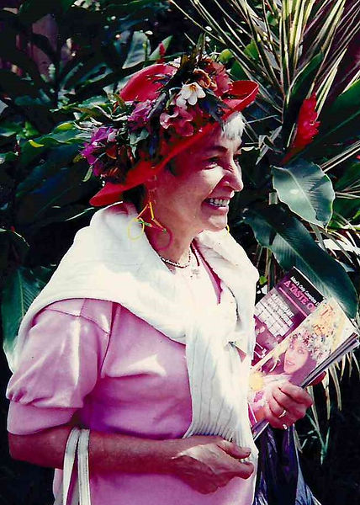

Judith S. Rowe (May 5 1931 - May 5 2022) was a pioneering advocate and practitioner in social science data services, government statistical information, and machine-readable data files, primarily associated with Princeton University.
Born in the 1931s, she attended elementary school during that decade. In the 1950s, while a graduate student at Yale, she married; her husband served in the U.S. Navy. She worked in marketing research and, by the end of the decade, was the mother of two sons. A daughter was born in the 1960s. By the late 1990s she referred to a family that included five grandsons and was preparing for retirement to spend more time with them.
In the 1960s she began part-time work at Princeton University’s Office of Survey Research and Statistical Studies. She attended her first Inter-university Consortium for Political and Social Research (ICPSR) meeting and became Princeton’s Official Representative to ICPSR. She was honored with the William H. Flanigan Award for Distinguished Service as an ICPSR Official Representative in 1997.
Judith Rowe later headed Social Science User Services at the Princeton Computer Center (located at 87 Prospect Avenue) and helped develop census data services and related support.
She established the Princeton-Rutgers Census Data Project at the computer center and contributed to growing local data libraries and services for social science researchers.
Rowe published extensively on government statistics and machine-readable data. She lobbied and organized for improved government statistical reporting and public access to government files, appearing at U.S. congressional and New Jersey legislative hearings.
She played a leading role in the creation of the Census Bureau’s State Data Center program in 1979.
As an expert on machine-readable files within the American Library Association’s Government Documents Round Table (GODORT)—of which she had been a member since 1974 (and earlier of its predecessor Public Documents Committee)—she influenced cataloging standards for computer files in ALA’s Association for Library Collections and Technical Services (formerly the Resources and Technical Services Division).
Although her formal job title was never “librarian” and she did not hold an MLS degree, her work made her a significant force in government information librarianship.
She held elected leadership positions in key professional organizations:
- Leader of the Association of Public Data Users (APDU, 1980–1982),
- Council of Professional Associations on Federal Statistics (COPAFS, 1982–1983),


- President of the International Association for Social Science Information Service and Technology (IASSIST, 1985–1988;

- ICPSR Council (including in the early 1980s).

In 1990 GODORT awarded her the James Bennett Childs Award for lifetime and significant contributions to documents librarianship.
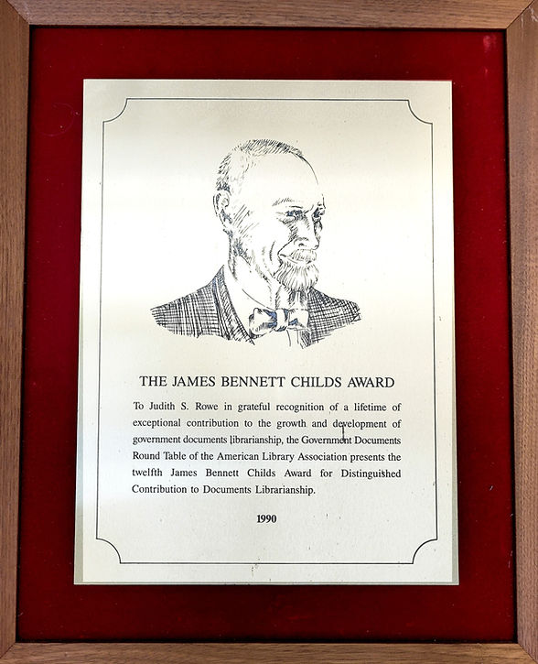

In 1999 she presented “The Decades of My Life,” reflecting on the parallel histories of data archives, computing technology, quantitative social science, and organizations such as IASSIST, at the association’s 25th-anniversary conference.
Rowe’s career helped establish data services as integral to research libraries and advanced collaboration among data producers, users, archivists, and librarians. Her efforts supported the growth of public-use microdata, standardized documentation and cataloging of data files, and broader access to government statistical resources.

Selected Publications
Rowe, Judith S., and Mary Ryan. “Library Service from Numerical Data Bases: The 1970 Census as a Paradigm.” College & Research Libraries 35, no. 1 (January 1974): 7–15. https://doi.org/10.5860/crl_35_01_7.
Rowe, Judith. “The Use and Misuse of Government Produced Statistical Data Files.” RQ 14, no. 3 (Spring 1975): 201–3.
Rowe, Judith S. “National and International Developments in Providing Data Information Services.” In Proceedings of the 4th Annual ACM SIGUCCS Conference on User Services, edited by John H. Esbin, 97–99. Tucson, AZ: ACM, 1976. https://doi.org/10.1145/584296.584336.
Rowe, Judith S. “National and International Developments in Providing Data Information Services.” In Proceedings of the 4th Annual ACM SIGUCCS Conference on User Services, edited by John H. Esbin, 97–99. Tucson, AZ: ACM, 1976. https://doi.org/10.1145/584296.584336.
Rowe, J. S. “Non-American Census Data in Machine-Readable Form.” Demography 14, no. 1 (February 1977): 137–40.
Rowe, Judith S. “United States Secretariat Report.” IASSIST Quarterly 1, no. 1 (1977): 9. https://doi.org/10.29173/iq805.
Rowe, Judith S. “The Decades of My Life.” IASSIST Quarterly 23, no. 1 (Spring 1999): 4. https://doi.org/10.29173/iq575. Presented at the 25th Anniversary IASSIST Conference, May 17, 1999, at Ryerson Polytechnic University, Toronto, Ontario.

Sources
American Library Association. “Judith S. Rowe: 1990 recipient of the James Bennett Childs Award by Government Documents Round Table.” Accessed August 8, 2026.
American Library Association. Memorial Resolution Honoring Judith S. Rowe. 2021-2022 ALA Memorial #19 2022 ALA Annual Conference.
Bordelon, Bobray. “Judith S. Rowe in Memoriam.” IASSIST Blog, May 6, 2022.
Heim, K. M. (1987). Social Scientific Information Needs for Numeric Data: The Evolution of the International Data Archive Infrastructure. Collection Management, 9(1), 1–53.
IASSIST. “Officials” (Past Presidents list). Accessed August 8, 2026. https://iassistdata.org/about/officials/.
ICPSR Staff. “In Memoriam: Judith S. Rowe.” Inter-university Consortium for Political and Social Research (ICPSR), May 10, 2022.
“Judith Rowe.” Accessed August 8, 2026. https://www.judithsrowe.com/.
Rowe, Judith S. “The Decades of My Life.” IASSIST Quarterly 23, no. 1 (Spring 1999): 4. (PDF available via IASSIST Quarterly site).

Submitted by GODORT Member

