Betty Rosenberg - 1916-1993

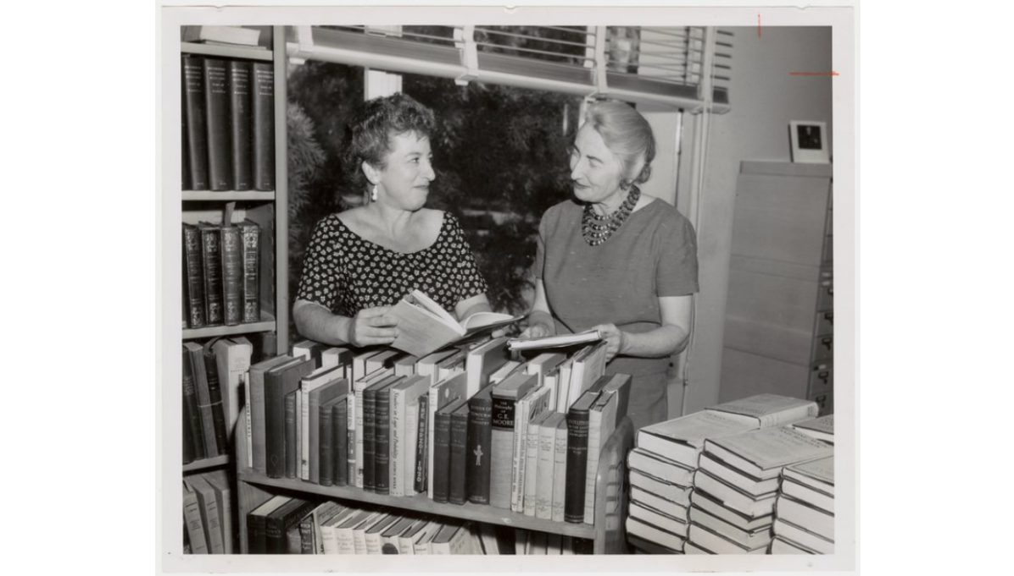

Betty Rosenberg (1916–1993) was a Canadian-born American librarian, library science educator, bibliographer, and author best known for pioneering modern readers’ advisory work through her book, Genreflecting: A Guide to Reading Interests in Genre Fiction (1982).
She coined the term, “genreflecting,” and articulated the influential “First Law of Reading”: “Never apologize for your reading tastes.”
Rosenberg was born October 17, 1916, in Winnipeg, Manitoba, Canada. She immigrated to the United States in 1917 and became a naturalized U.S. citizen in 1923. She earned a B.A. from the University of California, Los Angeles (UCLA) in 1938 and an M.A. from UCLA in 1950. In 1940 she received a Certificate in Librarianship from the University of California, Berkeley.
Her professional career began as a librarian at the Los Angeles County Public Library (1942–1945). She then joined UCLA, where she served as a librarian (1945–1957), bibliographical assistant to the librarian (1957–1961), lecturer (1961–1973), and senior lecturer in library and information science (1973–1977). She became senior lecturer emeritus in 1977.
Rosenberg’s scholarly and professional output focused on popular literature, book collecting, and bibliography. Her book, Genreflecting: A Guide to Reading Interests in Genre Fiction (Libraries Unlimited, 1982) and subsequent editions that followed were enduring contributions to Readers’ Advisory Services.
Genreflecting was published in 1982-- a time when recommending popular genre fiction (westerns, science fiction, horror, fantasy, romance, and related forms) was still controversial in many libraries. Rosenberg’s book systematically defined genres and subgenres, described their characteristics and reader appeals, and listed representative authors, titles, and anthologies. It helped spark the modern revival of readers’ advisory services in the 1980s by rejecting elitist “taste elevation” in favor of matching books to individual readers’ preferences.
Rosenberg’s First Law of Reading—“Never apologize for your reading tastes”—appears in every subsequent edition of the series and remains a foundational principle of contemporary readers’ advisory practice. Later editions were continued and expanded by Diana Tixier Herald and others; the series evolved into a major advisory resource that continues to the present.
There is no confirmed obituary, but in Joyce G. Sarick’s book, Readers’ Advisory Service in the Public Library. (3rd ed. Chicago: American Library Association, 2005) she noted: “Since Rosenberg’s death in 1993, Herald has taken on sole responsibility for Genreflecting.
Betty Rosenberg died in 1993. Beginning with the fourth edition (1995), Diana Tixier Herald assumed sole (or primary) authorship and editorial responsibility for the core volume.
Under Herald’s stewardship, the single-volume reference grew into the full Genreflecting Advisory Series. Libraries Unlimited, the original publisher, became an imprint of Bloomsbury Publishing. All later editions of the core Genreflecting volume and the broader Advisory Series titles continue to appear under the Libraries Unlimited / Bloomsbury imprint. The 8th edition (2019) and subsequent series volumes remain in print and are actively marketed by Bloomsbury as professional resources for readers’ advisory, collection development, and library education.
Rosenberg founded the method and the flagship book; Herald became its long-term steward, collaborator on the final joint edition, and the person who expanded it into the ongoing Bloomsbury series while preserving Rosenberg’s anti-elitist philosophy.
The “Betty Rosenberg Papers, 1950–1992.” are held at the Online Archive of California.

Selected Publications
Rosenberg, Betty. The Romance of Book Collecting. 1978.
Rosenberg, Betty. Booked for Murder. 1979. . [Note: Full publisher and place details for the 1978, 1979, and 1981 titles are not recorded in readily available public catalogs or the UCLA finding aid; they appear to have been issued as separate pamphlets or limited publications before the first two were revised and collected in The Letter Killeth,1982].
Rosenberg, Betty. Bibliomania, or Bound to Kill. 1981

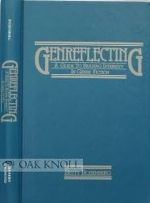

Rosenberg, Betty. Genreflecting: A Guide to Reading Interests in Genre Fiction. Littleton, CO: Libraries Unlimited, 1982.
Rosenberg, Betty. The Letter Killeth: Three Bibliographical Essays for Bibliomaniacs. Los Angeles: Kenneth Karmiole, Bookseller, 1982. (Limited edition of 300 copies in wrappers and 50 numbered and signed copies in cloth; collects revised versions of the 1979 and 1981 essays plus “Publish and Perish.”)
Rosenberg, Betty. Genreflecting: A Guide to Reading Interests in Genre Fiction. 2nd ed. Littleton, CO: Libraries Unlimited, 1986.
Rosenberg, Betty, and Diana Tixier Herald. Genreflecting: A Guide to Reading Interests in Genre Fiction. 3rd ed. Englewood, CO: Libraries Unlimited, 1991.

Sources
“Betty Rosenberg Papers, 1950–1992.” Finding aid. Online Archive of California. Accessed August 1, 2026. UCLA Library Special Collections.
Bloomsbury Publishing. “Genreflecting Advisory Series.” Accessed August 1, 2026.
Dali, Keren. “Readers’ Advisory Interactions with Immigrant Readers.” New Library World 111, nos. 5/6 (2010): 213–22. (Cited in analyses of the post-1980 revival of readers’ advisory that credit Genreflecting.)
Davis, Sally A. Genreflecting: A Guide to Reading Interests in Genre Fiction, by Betty Rosenberg. RQ 25, no. 1 (1985): 152–54.
Dilevko, Juris, and Candice F. C. Magowan. Readers’ Advisory Service in North American Public Libraries, 1870–2005: A History and Critical Analysis. Jefferson, NC: McFarland, 2007. (Discusses Rosenberg’s initiation of Genreflecting in 1982 as part of the shift toward popular fiction and the post-1980 model of readers’ advisory.)
Gilberts of Goleta. Mrs. Martha H. Peterson, UCSB Acquisitions Librarian and Miss Betty Rosenberg, Bibliographical Assistant at UCLA. April 5, 1959. University Archives photographs collection, UArch 112. Department of Special Research Collections, UC Santa Barbara Library, University of California, Santa Barbara.
Herald, Diana Tixier, and Betty Rosenberg. Genreflecting: A Guide to Reading Interests in Genre Fiction. 3rd ed. Englewood, CO: Libraries Unlimited, 1991.
Herald, Diana Tixier. Genreflecting: A Guide to Reading Interests in Genre Fiction. 4th ed. Englewood, CO: Libraries Unlimited, 1995.
Herald, Diana Tixier. Genreflecting: A Guide to Reading Interests in Genre Fiction. 5th ed. Englewood, CO: Libraries Unlimited, 2000.
Herald, Diana Tixier. Genreflecting: A Guide to Popular Reading Interests. 6th ed. Westport, CT: Libraries Unlimited, 2006.
Herald, Diana Tixier, and Cynthia Orr. Genreflecting: A Guide to Popular Reading Interests. 7th ed. Santa Barbara, CA: Libraries Unlimited, 2013.
Herald, Diana Tixier, and Samuel Stavole-Carter. Genreflecting: A Guide to Popular Reading Interests. 8th ed. Santa Barbara, CA: Libraries Unlimited, an imprint of Bloomsbury Publishing, 2019.
Lawrence, Emily. “Is Contemporary Readers’ Advisory Populist? Taste Elevation and Ideological Tension in the Genreflecting Series.” Library Trends 65, no. 4 (Spring 2017): 491–507
Lawrence, E. E. Reading for Democratic Citizenship: A New Model for Readers’ Advisory. PhD dissertation, University of Illinois at Urbana-Champaign, 2019.
Ross, Catherine Sheldrick. “Reader on Top: Public Libraries, Pleasure Reading, and Models of Reading.” Library Trends 57, no. 4 (Spring 2009): 632–56. (Explicitly linked in scholarship to the role of Genreflecting in sparking the readers’ advisory revival; see especially p. 634.)
Saricks, Joyce G. Readers’ Advisory Service in the Public Library. 3rd ed. Chicago: American Library Association, 2005.
Saricks, Joyce G., and Nancy Brown. Readers’ Advisory Service in the Public Library. Chicago: American Library Association, 1989.
Saricks, Joyce G., and Nancy Brown. Readers’ Advisory Service in the Public Library. 2nd ed. Chicago: American Library Association, 1997.
UCLA Library Special Collections. “Betty Rosenberg Papers, 1950–1992.” Finding aid. Online Archive of California. Accessed August 1, 2026.
Wyatt, Neal. “Readers’ Advisory: We Owe Our Work to Theirs.” Reference & User Services Quarterly 54 (Winter 2014. (Credits Rosenberg and Genreflecting with laying the path for later works emphasizing Rosenberg’s nonjudgmental philosophy and influence on genre studies and the valuation of all fiction reading).

Submitted by Kathleen de la Peña McCook

