Peter S. Graham -1939 -2004

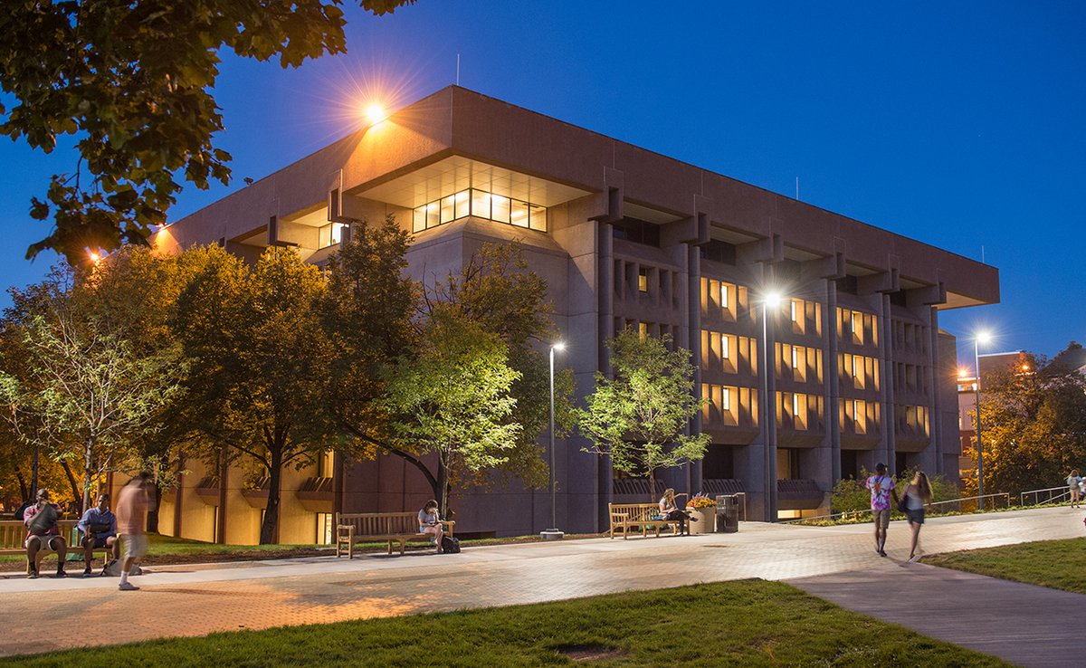
Syracuse University Library

Peter S. Graham (1939–2004) was an American librarian, library administrator, author, and professor. He founded ExLibris the electronic bulletin board/forum in 1990 for rare book and special collections librarians. He moderated it until 1995. He was University Librarian at Syracuse University.
Graham studied English at Columbia University, earned graduate degrees in English Renaissance literature from Columbia and Oxford University, and received a master’s degree in library science from Indiana University.
In his early twenties he participated in the civil rights movement, including sit-ins and protests (he was once arrested with Stokely Carmichael) and worked as office manager for Bayard Rustin during organization of the 1963 March on Washington. He was also involved in science-fiction fandom in his youth under the name Pete Graham.
Earlier in his career, Graham held positions at Columbia University (including assistant director for bibliographic control and head of the Book Acquisitions Department), Indiana University (systems officer, 1979–1981), and the Research Libraries Group (senior systems analyst, 1975–1978).
From 1987 to 1998, he was associate university librarian for technical and networked information services at Rutgers University, where he also served as associate vice president for information services; there he advanced administrative and academic computing and oversaw construction of a new library technical services building.
He served as University Librarian at Syracuse University from September 1, 1998, until shortly before his death. In that role, he revitalized the library’s staff structure by appointing nationally recognized leaders to key positions, advocated successfully for increases in librarians’ salaries and support staff wages, and secured a $1 million base budget increase for the library’s acquisitions budget. He also taught English and textual studies at Syracuse from 2000 to 2003.

Professional Organizations
Graham was active in the American Library Association (ALA) and was elected to the ALA Council in 1993 and re-elected in 1997.
He was chair of the Technical Services Costs Committee of the Resources and Technical Services Division (RTSD, now ALCTS, now Core) and remained an active member.
His paper, “Requirements for the Digital Research Library” (College & Research Libraries, 56, July 1995, received an American Library Association award as the outstanding article of the year in that journal.
He was active in the Bibliographical Society of America, elected to its Council and served on its Publication Committee and Web Advisory Committee.
ExLibris: Founded this electronic bulletin board/forum in 1990 for rare book and special collections librarians (it grew to more than 1,600 members). He moderated it until 1995.
Center for Electronic Texts in the Humanities (joint Rutgers–Princeton initiative): Chaired its board.
Rare Book School (University of Virginia): Served on its advisory board.
Other affiliations: Long-time member of the Renaissance Society of America and the Bibliographical Society (London). He also served on numerous additional advisory boards and governing bodies related to libraries, books, digital preservation, and scholarly publication.
Peter Graham died on August 11, 2004 (some sources list August 12), at his home in Syracuse, New York.
His papers are held by Syracuse University Libraries, and a scholarly commons space in Bird Library is named in his honor.

Selected Publications
Peter S. Graham wrote more than 30 scholarly pieces, with much of his writing and speaking in the 1990s focused on emerging issues of digital preservation, technical services, cataloging, and the development of digital research libraries. He emphasized “intellectual preservation”—ensuring the integrity and authenticity of electronic documents over long periods.
Graham, Peter S. “Electronic Information and Research Library Technical Services.” College & Research Libraries 51, no. 3 (May 1990): 241–50.
Graham, Peter S. “Quality in Cataloging: Making Distinctions.” Journal of Academic Librarianship 16, no. 4 (September 1990): 213–18.
Graham, Peter S. Intellectual Preservation: Electronic Preservation of the Third Kind. Washington, DC: Commission on Preservation and Access (Council on Library and Information Resources), March 1994.
Graham, Peter S. “Requirements for the Digital Research Library.” College & Research Libraries 56, no. 4 (July 1995): 331–39. (Received ALA award as the journal’s outstanding article of the year.)
Graham, Peter S. “The Digital Research Library: Tasks and Commitments.” Presented in related forms at ALCTS Institute (1993) and Coalition for Networked Information (1993); expanded versions appeared around 1995.
Graham, Peter S. “Building the Digital Research Library: Preservation and Access at the Heart of Scholarship.” Follett Lecture Series, UKOLN/JISC, 19 March 1997.
Graham, Peter S. “New Roles for Special Collections on the Network.” College & Research Libraries 59, no. 3 (May 1998): 232–39.

Sources
Morrow, Kevin. “Syracuse University Community Mourns Passing of University Librarian Peter Graham.” Syracuse University News, August 12, 2004. Reprinted in Conservation DistList, August 17, 2004.
“Peter Graham.” Fancyclopedia 3. Accessed August 14, 2026.
“Peter Graham Papers.” Special Collections Research Center, Syracuse University Libraries. Finding aid.
“Peter Graham Scholarly Commons.” Syracuse University Libraries.
“Exlibris-L.” IU List (Indiana University). Accessed August 14, 2026.

Submitted by ALA Member

