Charles Haynes McMullen – 1915-2005

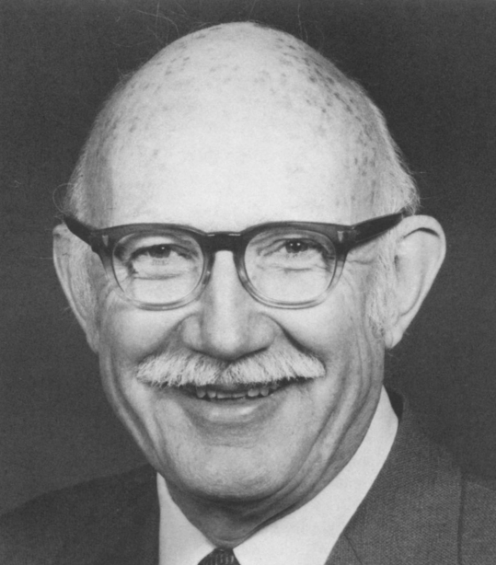
Haynes McMullen
--From Holley, Edward G. “Honoring Haynes McMullen.” The Journal of Library History 21, no. 1 (1986): 3–7.

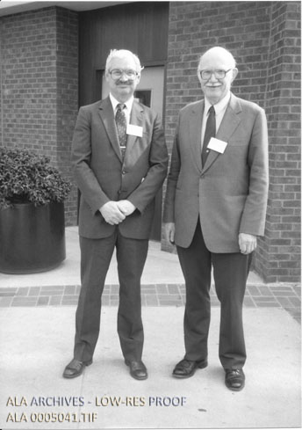
Haynes McMullen (R) and Don Oehlerts (L) at the Library History Seminar VII at the University of North Carolina at Chapel Hill, March 1985.

Charles Haynes McMullen (March 3, 1915 – August 30, 2005), known professionally as Haynes McMullen, was an American librarian, library educator, and historian renowned for his pioneering research on the history of American libraries, especially those existing before 1876. His meticulous documentation of early American libraries remains a foundational resource for library historians, illuminating a period when many libraries operated on a part-time basis and when the professional identity of librarians was still emerging.
He was born in Tarkio, Missouri in 1915. He attended Centre College of Kentucky in Danville, earning a B.A. in 1935. While a student there, his observations of the college librarian’s work inspired him to pursue a career in librarianship. He earned an M.S. in Library Science from the University of Illinois in 1940.
He earned the Ph.D. from the University of Chicago in 1949. His doctoral dissertation examined the history of the University of Chicago Library (founded in 1892), covering its administrators, faculty, and notable episodes such as the acquisition of a Berlin bookstore’s contents under President William Rainey Harper.
After completing his doctorate, Dr. McMullen’s first major position was as head librarian at Madison College (now James Madison University) in Harrisonburg, Virginia. There he encountered the massive 1876 U.S. Bureau of Education report Public Libraries in the United States of America, which listed more than three thousand libraries and sparked his enduring interest in the library movement and institutions that predated it.
In 1951 Dr. McMullen left full-time librarianship for teaching. He joined the faculty of the Indiana University Library School, where he remained until 1972.
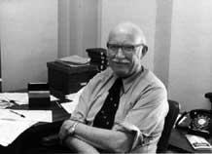

He then moved to the School of Information and Library Science at the University of North Carolina at Chapel Hill, serving until his retirement in 1985 as Professor Emeritus of Library Science.
During these decades of teaching, McMullen systematically investigated early American libraries. With the help of graduate students supported by research assistantships, he and his collaborators gathered information on roughly ten thousand libraries that existed before 1876. Data were recorded on specialized Unisort analysis cards (a mid-twentieth-century punched-card system). By retirement he had assembled a vast body of material that became the foundation of his later publications.

McMullen’s major works include the co-compiled Libraries in American Periodicals before 1876: A Bibliography with Abstracts and an Index (Jefferson, N.C.: McFarland, 1983), prepared with Larry J. Barr and Steven G. Leach, which extended earlier bibliographies of library literature backward to the beginnings of American periodical coverage.


Dr. McMullen’s culminating scholarly achievement was American Libraries before 1876 (Westport, Conn.: Greenwood Press, 2000; Beta Phi Mu Monograph Series, no. 6), with a foreword by Kenneth E. Carpenter. The book synthesized decades of research into the types, distribution, and character of pre-1876 American libraries. His data cards are preserved in the Manuscripts Division of Princeton University Library and underpinned an online database of nearly 10,000 library records developed by the Davies Project.

The Library History Round Table’s Library History Seminar VII was held at the School of Library Science at the University of North Carolina at Chapel Hill and was dedicated to Dr. McMullen.
McMullen also published articles such as “Librarians and the Pursuit of Happiness” in Library Journal (1981) and the reflective “Confessions of a Library Historian” in Virginia Libraries (2002).
Dr. McMullen was active in the American Library Association, including service as chair of the Library Education Division Grants Committee (supporting Asian library students studying in the United States). Colleagues remembered him as a rigorous yet welcoming scholar and “true gentleman.” After retirement he continued research and writing, finding scholarly work more rewarding than pure leisure.
Dr. Charles Haynes McMullein died on August 30, 2005. Memorial contributions were suggested to Feed the Children.

Selected Publications

McMullen, Haynes. “The Administration of the University of Chicago Libraries, 1892–1928.” PhD diss., University of Chicago, 1949.
McMullen, Haynes. “Administration of the University of Chicago Libraries, 1910–28.” Library Quarterly 23, no. 1 (January 1953).
McMullen, Haynes. “American University Libraries, 1955–2005.” College & Research Libraries 16, no. 3 (July 1955): 286–[end page].
McMullen, Haynes. “Ralph Waldo Emerson and Libraries.” The Library Quarterly: Information, Community, Policy 25, no. 2 (1955): 152–62.
McMullen, Haynes. “Research in Backgrounds in Librarianship.” Library Trends 6, no. 2 (Fall 1957): 110-119.
McMullen, Haynes. “COLLEGE LIBRARIES IN ANTE-BELLUM KENTUCKY.” The Register of the Kentucky Historical Society 60, no. 2 (1962): 106–33.
McMullen, Haynes. “SPECIAL LIBRARIES IN ANTE-BELLUM KENTUCKY.” The Register of the Kentucky Historical Society 59, no. 1 (1961): 29–46.
McMullen, Haynes. “The Founding of Social Libraries in Pennsylvania, 1731–1876.” Pennsylvania History: A Journal of Mid-Atlantic Studies 32, no. 2 (April 1965): 137–152.
McMullen, Haynes. “How Should We Tell Librarians of the Future about Libraries of the Past?” Journal of Education for Librarianship 6, no. 1 (1965): 65–68.
Mcmullen, Charles Haynes, and C. H. McMullen. 1966. “Use of Books in the Ohio Valley before 1850.” The Journal of Library History 1 (January).
McMullen, Haynes, Betty Milum, Joe W. Kraus, and Donald C. Dickinson. “The State of the Art of Writing Library History [with Comments].” The Journal of Library History 13, no. 4 (1978): 432–50.
McMullen, Haynes. “A Note on Early American Libraries for Women.” The Journal of Library History 13, no. 4 (1978): 464–65.
McMullen, Haynes. “Librarians and the Pursuit of Happiness.” Library Journal 106, no. 11 (June 1, 1981): 1172–74.
Barr, Larry J., Haynes McMullen, and Steven G. Leach, compilers. Libraries in American Periodicals before 1876: A Bibliography with Abstracts and an Index. Edited by Haynes McMullen. Jefferson, N.C.: McFarland, 1983.
McMullen, Haynes. “The Very Slow Decline of the American Social Library.” Library Quarterly 55, no. 2 (April 1985): 207–25.
McMullen, Haynes, and Larry J. Barr. 1986. “The Treatment of Libraries in Periodicals Published in the United States before 1876.” Journal of Library History 21 (October): 641–72.
McMullen, Haynes. 1987. “Prevalence of Libraries in the Northeastern States before 1876.” Journal of Library History 22 (July): 312–37.
McMullen, Haynes. 1991. “The Prevalence of Libraries in the Middle West and Far West before 1876.” Libraries & Culture 26 (March): 441–63.
McMullen, Haynes. 1991. “Honoring David Kaser.” Libraries & Culture 26 (January): 7–9.
McMullen, Haynes. American Libraries before 1876. Foreword by Kenneth E. Carpenter. Westport, Conn.: Greenwood Press, 2000. (Beta Phi Mu Monograph Series, no. 6.)
McMullen, Haynes. “Confessions of a Library Historian.” Virginia Libraries 48, no. 3 (2002).
Additional note: McMullen’s extensive data cards (ca. 1960–2000) on pre-1876 American libraries underpin the 2000 book and a related online database (Davies Project / Princeton); these are archival research materials rather than formal publications.

Sources

August, Thomas. 2002. “American Libraries Before 1876 (Book).” Papers of the Bibliographical Society of America 96 (1): 126.
Bourdon, Cathleen. 2001. “Labor of Love.” American Libraries 32 (2): 58.
“Dr. Charles Haynes McMullen, Phd Obituary.” McCullough Funeral Home.
Davies Project. “American Libraries before 1876.” Princeton University Library. Samuel Davies (1723–1761) was the fourth president of the College of New Jersey (now Princeton University), serving from 1759 until his death in 1761.The Davies Project at Princeton University Library (begun in 2000 by then-President Emeritus Harold T. Shapiro and Rare Books Curator Stephen Ferguson) is named in his honor. The project focuses on the history of American university libraries and their collections; its major digital accomplishment was making available the large dataset of pre-1876 American libraries compiled by Haynes McMullen. (This is the current online database interface presenting data compiled from McMullen’s research cards on nearly 10,000 American institutional and commercial libraries existing from the colonial period through 1875. The original Davies Project database was first released online by Princeton University Library around 2004; the data were later migrated to this site after the prior version was decommissioned in 2024.)
Goedeken, Edward A. American Libraries before 1876, by Haynes McMullen. The Library Quarterly: Information, Community, Policy 71, no. 4 (2001): 528–30.
“Haynes McMullen Data Cards for American Libraries before 1876.” Finding aid. Princeton University Library, Manuscripts Division. Call number C1666.
Holley, Edward G. “The Past as Prologue: The Work of the Library Historian.” The Journal of Library History) 12, no. 2 (1977): 110–27.
Holley, Edward G. “Honoring Haynes McMullen.” The Journal of Library History 21, no. 1 (1986): 3–7.
McMullen, Haynes. Haynes McMullen Papers, 1961–1976. Record Series 97/1/39. American Library Association Archives, University of Illinois at Urbana-Champaign.
Olbrich, Bill. “Passing the Torch: Haynes McMullen’s American Library History Database and ‘American Libraries before 1876.’” American Libraries before 1876, by Haynes McMullen. Libraries & Culture 37, no. 2 (2002): 132–37.
Olbrich, Bill. Review of American Libraries before 1876, by Haynes McMullen. The Library Quarterly 72, no. 1 (January 2002): 132–137.
“Remembering Haynes McMullen.” SILS Newsletter (University of North Carolina at Chapel Hill School of Information and Library Science), Spring 2006.
Smith, Felicia A. “ALB1876: American Libraries Before 1876.” Reference Reviews 20, no. 8 (2006): 5.

Submitted by Kathleen de la Peña McCook

