Julie Klauber (1951-2002)

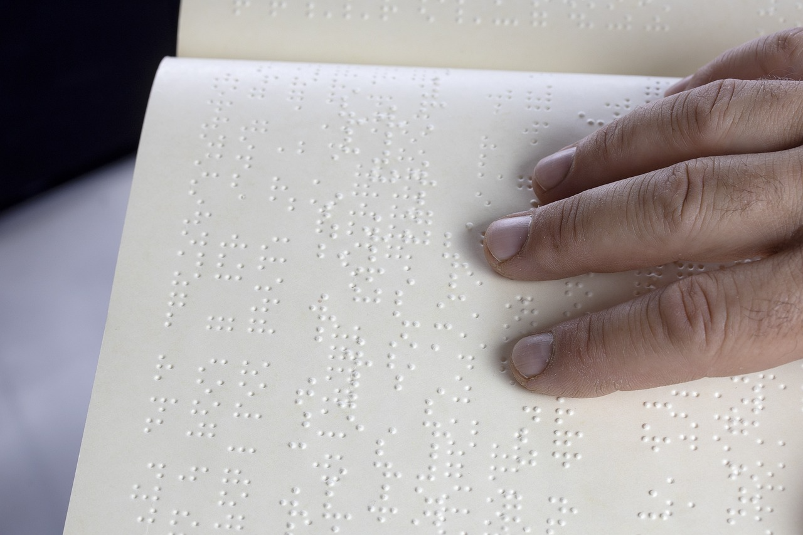
Image by Myriams-Fotos from Pixabay.

“Having information and making it accessible will not alone
bring people with disabilities into the library. Library staff
should work closely with local organizations to let people
with disabilities know that these resources are available.”
--Julie Klauber, quoted in “Diversity.” American Libraries 31, no. 1 (2000): 6. http://www.jstor.org.ezaccess.libraries.psu.edu/stable/25637470.

Julie Klauber was an American librarian and national expert on library services and information resources for people with disabilities, particularly those who are blind or have physical impairments.
She earned her bachelor’s degree from Brooklyn College and her master's degree in library science from Columbia University's graduate school in 1972.
She served for more than 17 years as Outreach Services Administrator (and director of Talking Books Plus) at the Suffolk Cooperative Library System in Bellport, New York.
Through many national venues, she rallied library workers to be deliberative, passionate, and proactive in outreach to disabled people. In one example from American Libraries in1988, she challenged librarians to consider how what they would do if 20% of their communities were part of a specific group. They would likely buy books, tailor programs, and arrange exhibits tailored to that group. “Did you know that approximately 20% of the people in your community have a disability? People with disabilities constitute the largest minority in the country, crossing all socioeconomic classes and ethnic groups,” she reasoned with the audience.
“Ask yourself what services your library provides for this 20% of its community.”
Klauber also taught graduate courses on library and information services for people with disabilities and presented workshops and programs across the United States. Her articles appeared in major professional journals including Library Journal, School Library Journal, and American Libraries. Notable publications include:
- AIDS Information Resources for People with Disabilities: A Handbook for Information Providers in Libraries, AIDS Organizations, and Disability Organizations (1993).
- The resource guide When the Print Is Too Small: Resources and Services for Older Adults with Visual Impairments in Suffolk County, which received a national award from the American Association of Retired Persons (AARP) and the U.S. Office of Disease Prevention and Health Promotion.
Complementing her advocacy in the library field, Klauber was a co-founder of Disability Resources, Inc., a nonprofit organization dedicated to improving awareness, availability, and accessibility of information that helps people with disabilities live independently. She served as managing editor of its award-winning newsletter Disability Resources Monthly (DRM, launched in 1993). Through a grant from the Paralyzed Veterans of America Spinal Cord Injury Education and Training Foundation, the newsletter was distributed without charge to an incredible 2000 public libraries each month—an arrangement that likely disseminated information to millions of disabled patrons. She also became webmaster of the related online guide, the DRM Guide to Disability Resources on the Internet.

Awards
In 2002, she received the Francis Joseph Campbell Award from the American Library Association’s Association of Specialized and Cooperative Library Agencies (ASCLA). The award recognizes outstanding contributions to library service for people who are blind or physically disabled. The citation praised her “boundless energy and devotion to the dissemination of information.”
The Francis Joseph Campbell Award is an annual American Library Association (ALA) honor recognizing outstanding contributions to the advancement of library services for people who are blind or physically handicapped (print-disabled). It consists of a citation and a medal.
Recipients are typically individuals (and occasionally institutions) whose work has significantly improved access to reading materials and library services for this population. Qualifying contributions can include innovative local library programs, national-level advocacy or program development, leadership in professional associations, important publications, technological or administrative improvements, or other activities of recognized importance in the field.
The award was established in 1966 by the Libraries Serving Special Populations Section of the Association of Specialized and Cooperative Library Agencies (ASCLA), a division of the ALA.
It is named for Sir Francis Joseph Campbell (1832–1914), an American-born educator and advocate who lost his sight at age five. Campbell served as music director at the Wisconsin School for the Blind and the Perkins Institution for the Blind. He later co-founded the Royal Normal College and Academy of Music for the Blind in London (1872) and was knighted by King Edward VII for his pioneering work in education and independence for blind people.
Over the decades the award has been presented to a wide range of librarians, administrators, advocates, technology innovators, legislators, and organizations.
Administrative responsibility shifted with ALA organizational changes: from ASCLA to ASGCLA, and by 2021 to the Reference and User Services Association (RUSA).
The award continues to stand as one of the primary professional recognitions in the specialized field of library services for print-disabled patrons.
In addition, Klauber also won ALA’s National Organization on Disability Award presented by the American Library Association in 1999. She also received the Suffolk Independent Living Organization’s Outstanding Individual of the Year award in 1997 and the American Diabetes Association’s Outstanding Volunteer Award in 1992. Along with husband Avery, she received the 1997 Achievement Award for Media Representative of the Year from the New York State Developmental Disabilities Planning Council.
She was selected for Who’s Who in the World in 2001.
Julie Klauber Award
In her honor, Keystone Systems (provider of the KLAS library automation system used by many talking-book libraries) renamed its annual award the Julie Klauber Award in 2003. It recognizes library staff or volunteers who demonstrate outstanding service in the spirit of her work.

Klauber’s career focused on practical, high-impact information access and advocacy for independent living. Jerry Nichols, Director of the Suffolk Cooperative Library System noted in her obituary in Newsday that "Julie was a friend, a teacher and an inspiration to all of us.”

Selected Publications
Klauber, Julie. AIDS Information Resources for People with Disabilities: A Handbook for Information Providers in Libraries, AIDS Organizations, and Disability Organizations. Bellport, NY: Talking Books Plus, Suffolk Cooperative Library System, 1993.

Klauber, Julie. “Toy Story: How to Select and Buy Adaptive Toys.” School Library Journal 42, no. 7 (July 1996): 22–25.

Klauber, Julie. “An Enabling Collection for People with Disabilities.” Library Journal 122, no. 6 (April 1, 1997): 53–56.

Klauber, Julie. “Living Well with a Disability: How Libraries Can Help.” American Libraries 29, no. 10 (November 1998): 52–55.

Sources
American Library Association. Memorial. Midwinter 2003.
Hom, Erica. "Obituaries / Julie Klauber, 51, Worked with the Disabled.” Newsday (Suffolk). (Sept. 14, 2002).
Julie Klauber Award – Keystone Systems

Submitted by Kathleen de la Peña McCook and Brett Spencer

