Cynthia J. “Cinder” Johanson -1946 – 2004

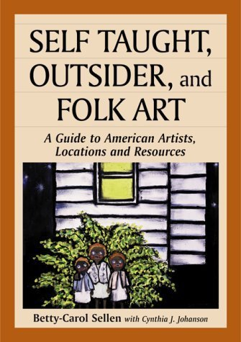

Cynthia J. “Cinder” Johanson (October 17, 1946 – January 14, 2004) was an American librarian, cataloger, and scholar of folk and outsider art who spent more than thirty-four years at the Library of Congress.
She was born on October 17, 1946. Johanson earned a bachelor’s degree from West Virginia University in 1968 and joined the Library of Congress that September as a shelflister.
She left the Washington area to complete a master’s degree in library science at the University of Michigan in 1973, then returned to the Library of Congress as a cataloger in the English Language Section III of the Descriptive Cataloging Division.
She served as president of the Professional Guild (Local 2910 of the American Federation of State, County and Municipal Employees) in 1977 and 1978 and participated in negotiating the first collective bargaining agreement between the Library and the Guild.
In 1978 she became the first head of the Collections Improvement Section in the Collections Management Division (later the Collections Access, Loan, and Management Division). In July 1981 she was appointed head of the Shelflisting Section in the Subject Cataloging Division, supervising seven units and ninety-two staff members.
In August 1986 she became assistant chief of the MARC Editorial Division and served as acting chief for nearly three years. Following the Cataloging Directorate reorganization of June 1992, she joined the Regional and Cooperative Cataloging Division (RCCD) as assistant chief, a position she held until her death. Colleagues credited her with helping the newly formed division’s diverse staff coalesce into an effective unit.
. “Cinder” Johanson also contributed to staff development, working with the Technical Processing and Automation Instruction Office on training for new catalogers hired in 2003 and serving as Cataloging Management Team liaison to a continuing-education task force focused on digital content and metadata.
American Library Association

“Cinder” Johanson was active in the American Library Association (ALA). She served two three-year terms on ALA Council (1986–1991) and participated in the Social Responsibilities Round Table Action Council and the Feminist Task Force.
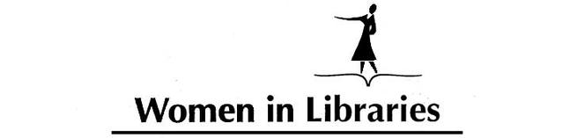
She chaired the ALA Committee on the Status of Women in Librarianship (COSWL) and its tenth-anniversary planning committee, chaired the Special Committee on Pay Equity, and served on the Minority Women Oral History Project Task Force and other groups concerned with the status of women and minorities in librarianship.
Later she worked on the ALCTS Committee on Cataloging: Asian and African Materials.

Photography and Folk Art

Outside her Library duties, Johanson was an accomplished amateur photographer and a member of the Folk Art Society of America. With librarian Betty-Carol Sellen she co-authored 20th Century American Folk, Self-Taught, and Outsider Art (Neal-Schuman, 1993; revised as Self-Taught, Outsider, and Folk Art, McFarland, 2000) and Outsider, Self-Taught, and Folk Art Annotated Bibliography(McFarland, 2002).
Her photographs of American folk and self-taught artists and their works, taken between 1987 and the early 2000s, formed the core of a collection later donated to the Archives of American Art at the Smithsonian Institution.
She was also an avid jazz enthusiast who attended the New Orleans Jazz & Heritage Festival every year.

Johanson died January 14, 2004 in Washington, D.C. In accordance with her wishes, her ashes were to be interred near the grave of her father, William Johanson, in Florida.
A memorial service was held at the Library of Congress on March 29, 2004. The ALA Council observed a moment of silence upon learning of her death at the Midwinter Meeting in San Diego, and a memorial resolution was planned for the Annual Conference in Orlando.

Selected Publications

Sellen, Betty-Carol, and Cynthia J. Johanson. 20th Century American Folk, Self Taught, and Outside Art. New York: Neal-Schuman, 1993.
Sellen, Betty-Carol, and Cynthia J. Johanson. Self Taught, Outsider, and Folk Art: A Guide to American Artists, Locations and Resources. Jefferson, NC: McFarland, 2000.
Sellen, Betty-Carol, with Cynthia J. Johanson. Outsider, Self-Taught, and Folk Art Annotated Bibliography: Publications and Films of the 20th Century. Jefferson, NC: McFarland, 2002.

Sources
AFSCME District Council 20. “Local Unions.”
American Library Association Archives. “COSWL Minutes (Digital Born).” University of Illinois at Urbana-Champaign. Accessed August 6, 2026.
American Library Association. Memorial for Cynthia J. Johanson. Annual Conference 2004.
“Cynthia J. Johanson.” The Washington Post, February 11, 2004.
Cynthia Johanson Photographs of Artists and Works of Art, 1987–2007. Archives of American Art, Smithsonian Institution, Washington, DC
Library of Congress, Cataloging Directorate. “Cynthia J. Johanson, 1946–2004.” LC Cataloging Newsline 11, no. 4 (March 2004). ISSN 1066-8829.
McCook, Kathleen de la Peña, ed. Women of Color in Librarianship: An Oral History. Chicago: American Library Association, 1998. (On behalf of the ALA Committee on the Status of Women in Librarianship.)
Women in Libraries, 1970–. Series 49/2/11. American Library Association Archives, University of Illinois at Urbana-Champaign.

Submitted by former member of the ALA Committee on the Status of Women in Librarianship

