Arthur T. Hamlin – 1913 -1999

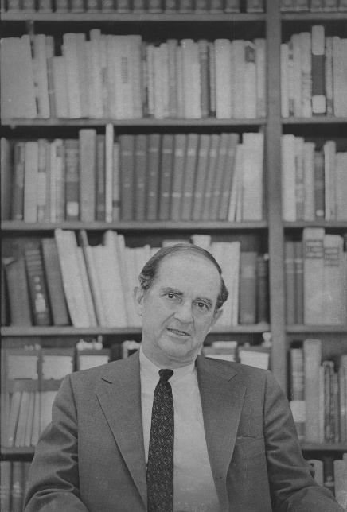

Arthur Tenney Hamlin (January 8, 1913 – January 20, 1999) was an American academic librarian, library administrator, association executive, and historian of university libraries.
He coordinated the American Library Association response to the catastrophic flooding of the Arno River in Florence on November 4, 1966.
Arthur Tenney Hamlin was born on January 8, 1913. He earned an A.B. from Harvard University in 1934 and attended Harvard Graduate School from 1936 to 1938 (during which he wrote a paper on the legislative history of the Agricultural Adjustment Act). He received a Bachelor of Library Science (B.L.S.) from Columbia University in 1939.
Hamlin began his career with positions at the Harvard University Library (1934-1936), the New York Public Library (1939-1940), and the University of Pennsylvania Library (1940-1942).
He was research analyst, Office Naval Intelligence, 1942-1945.
He then returned to the University of Pennsylvania Library, 1945-1949 as chief of service to readers and assistant librarian.
From 1949 to 1956, he served as Executive Director (then called Secretary) of the Association of College and Research Libraries a division of the American Library Association. In this role he produced annual reports and contributed articles on professional topics to College & Research Libraries.
He was University Librarian (director of libraries) at the University of Cincinnati from 1956 to 1968. During this period, he conducted research on library needs of faculty and students and on library use in the United Kingdom; related papers are held at the University of Cincinnati.
Hamlin held two senior Fulbright Program grants: one as a lecturer at the University of Pavia (and other Italian universities) in 1961–1962 under a U.S. educational exchange grant, and another involving the University of Birmingham, England, focused on studying British university libraries.
In 1966 the American Library Association sent him to Florence to investigate flood damage to libraries after the Arno River floods.

Arthur T. Hamlin and Florence flood relief work


Villa I Tatti, The Harvard University Center for Italian Renaissance Studies. “The Story.” CRIA - Committee to Rescue Italian Art.

Hamlin oversaw the American Library Association response to the catastrophic flooding of the Arno River in Florence on November 4, 1966.
Heavy rains caused the Arno to overflow, inundating Florence with a mixture of water, mud, sewage, and heating oil. The flood killed dozens of people and damaged or destroyed vast quantities of cultural heritage.
Libraries were among the hardest hit. The Biblioteca Nazionale Centrale di Firenze (National Central Library), located beside the river, suffered especially severe losses: roughly one-third of its holdings (estimates of 1–1.3 million items) were damaged, including large portions of the historic Magliabechi and Palatine collections, newspapers, periodicals, maps, prints, and catalogs.
Other Florentine libraries and archives also sustained major losses. Manuscripts stored higher up largely survived, but ground-floor and basement materials were soaked and coated in mud.
The ALA quickly dispatched Hamlin to Florence to assess the damage to libraries and report back. He documented the conditions and early rescue efforts in an article, “The Libraries of Florence November 1966,” published in the ALA Bulletin.
From 1967 to 1969 he served as chairman of the ALA International Relations Committee’s Special Committee to Aid Italian Libraries. In this capacity he coordinated American professional and institutional support for the recovery and restoration of books, manuscripts, and other library materials. This work complemented the broader efforts of the Committee to Rescue Italian Art (CRIA) and the international volunteer response known as the “Mud Angels.”
Hamlin’s activities involved correspondence, planning, reporting, and liaison work with key figures on both sides of the Atlantic, including: Paul N. Banks (Chairman of CRIA’s Study Committee of Book Conservation); Emanuele Casamassima (Director of the Biblioteca Nazionale Centrale di Firenze); Verner Clapp (Council on Library Resources); John Charles Finzi and John Lorenz (Library of Congress); Foster E. Mohrhardt (ALA President); Peter Waters (leading British preservation specialist who later influenced U.S. conservation practice)
Hamlin’s files from this period are held in the Rare Book & Manuscript Library at Columbia University. These materials provide primary documentation of ALA’s library-focused contribution to the international recovery campaign
The 1966 Florence flood is widely regarded as a turning point that accelerated the development of modern library and book conservation as a profession. Techniques refined during the recovery (including large-scale drying, cleaning, and phased treatment approaches) influenced practices in the United States and elsewhere. Experts who worked in Florence, such as Peter Waters, later brought those methods to institutions like the Library of Congress. Hamlin’s leadership role represented the organized American library profession’s contribution to the global effort.

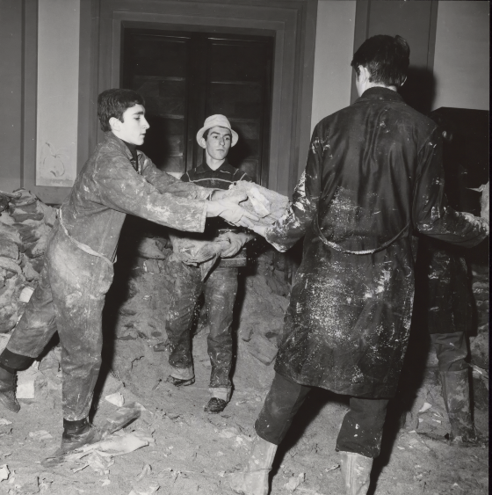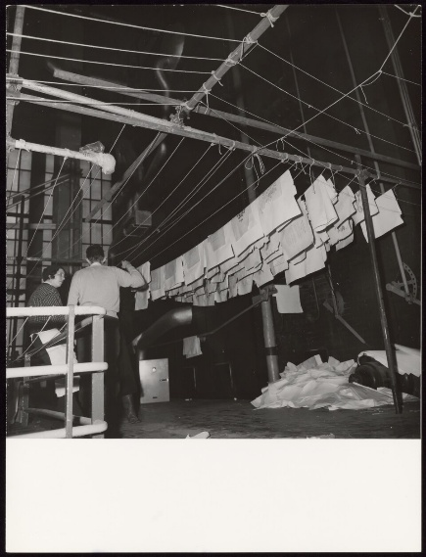
Great stocks of books in the National Library and its historical collections were devastated. Students removing damaged books from the Library. Drying centre for books.

Temple University
In 1968 Hamlin was appointed director of libraries at Temple University in Philadelphia, serving until his retirement in 1979.
He was a member of the task force on a national periodicals system National Commission on Libraries and Information Science, 1975-1977.
Hamlin was a life member of the ALA and ACRL. He was chairman of the building and equipment section of ACRL 1957-1958, chairman adult services special projects committee of ACRL 1959-1960 and member of the ALA council 1958-1962.
He was member of the Bibliographical Society of America.
He was on the Board of Director of the Association Research Libraries, 1973- 1974.
At the state level he was Ohio College Association (president libraries section, 1960-1961) and President, 1965; for the Pennsylvania Library Association he was chairman conference local arrangements committee 1969-1970.
He wrote centennial histories of Harvard’s first alumni club and the Cincinnati club.
His major scholarly work is The University Library in the United States: Its Origins and Development (University of Pennsylvania Press, 1981; later reissued in the press’s Anniversary Collection).
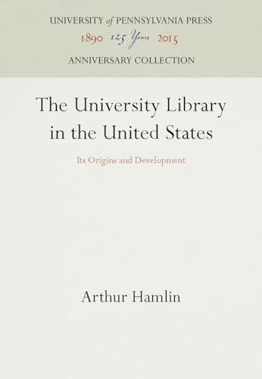
Hamlin also published articles on topics such as college and research library contributions to adult education, professional issues, and library disaster response (including a 1974 piece in Wilson Library Bulletin on flood considerations).

Arthur T. Hamlin died January 20, 1999.

Selected Publications
Hamlin, Arthur T. “The Background and Passage of the Agricultural Adjustment Act from the Standpoint of Legislative History.” 1937. Manuscript. Harvard University.
Hamlin, A. T. (1942). Joining the Junto. Wilson Library Bulletin, 16, 360–363.
Hamlin, Arthur T. “Service Report from Pennsylvania.” College & Research Libraries 11, no. 1 (January 1950).
Hamlin, Arthur T. “Annual Report of the A.C.R.L. Executive Secretary, 1949-50.” College & Research Libraries 11, no. 3 (July 1950).
Hamlin, Arthur T. “Announcing a New A.C.R.L. Service.” College & Research Libraries 12, no. 2 (April 1951).
Hamlin, Arthur T. Review of The Small College Talks Back, An Intimate Appraisal. College & Research Libraries 12, no. 4 (October 1951).
Hamlin, Arthur T. “Membership Distribution Becomes a Reality.” College & Research Libraries 13, no. 3 (July 1952).
Hamlin, Arthur T. “Annual Report of the ACRL Executive Secretary, 1951-52.” College & Research Libraries 13, no. 4 (October 1952).
Hamlin, Arthur T. “The ACRL Annual Report, 1952-53.” College & Research Libraries 15, no. 1 (January 1954).
Hamlin, Arthur T. “The ACRL Annual Report, 1953-54.” College & Research Libraries 16, no. 1 (January 1955).
Hamlin, Arthur T. “The ACRL Annual Report, 1954-55.” College & Research Libraries 17, no. 3 (May 1956).
Hamlin, Arthur T. “The ACRL Grants for 1956.” College & Research Libraries 17, no. 5 (September 1956).
Hamlin, Arthur T. “College and Research Library Contributions to Adult Education.” Library Trends 8, no. 1 (Summer 1959).
Hamlin, Arthur T. “On Being Fully Professional.” College & Research Libraries 21, no. 2 (March 1960).
Hamlin, Arthur T. Review of University of Tennessee Library Lectures; Numbers Ten, Eleven, and Twelve. College & Research Libraries 22, no. 5 (September 1961).
Hamlin, A. T. (1965). Libraries of the universities of Italy. Libri: International Journal of Libraries & Information Services, 15(2), 138–158.
Hamlin, A. T. (1956). Library services act. College & Research Libraries, 17, 428–429.
Hamlin, A. T. (1965). Visiting bookmen in France. ALA Bulletin, 59, 815–818.
Hamlin, Arthur. “The Libraries of Florence November 1966.” ALA Bulletin, vol. 61, no. 2, American Library Association, Feb. 1967, pp. 141–51.
Hamlin, Arthur T. Harvard and Cincinnati: A Century of Civic Service. Hamden, CT: Archon Books, 1969.
Hamlin, A. T. (1970). Book collections of British university libraries. International Library Review, 2, 135–173. https://doi.org/10.1016/0020-7837(70)90057-9
Hamlin, Arthur T. “First Considerations for the Flood Season.” Wilson Library Bulletin 48, no. 8 (April 1974): 660–63.
Hamlin, Arthur T. The University Library in the United States: Its Origins and Development. Philadelphia: University of Pennsylvania Press, 1981.
Hamlin, Arthur T. The Public Library of Renaissance Florence: Niccolo Niccoli, Cosimo de’ Medici and the Library of San Marco, by Berthold L. Ullman and Philip A. Stadter. The Journal of Library History (1974-1987) 9, no. 2 (1974): 189–91.

Hamlin, Arthur T. Arthur Tenney Hamlin: An Informal Autobiography. 1991. Manuscript. University of Pennsylvania Archives & Records Center.

Sources

Note: Arthur T. Hamlin Papers are held at the American Library Association, Columbia University, University of Cincinnati, and Temple University.

American Library Association Archives. “ Hamlin, Arthur T.” University of Illinois at Urbana-Champaign. Accessed August 2, 2026.
Appreciation of service to Arthur T. Hamlin. College & Research Libraries, 17, 385. 1956.
Arthur T. Hamlin Papers, 1961-1968. University of Cincinnati Archives and Rare Books Library.
Arthur Tenney Hamlin (1913–1999).” Find a Grave. Memorial ID 150813935. Citing Saint Andrew’s Memorial Garden, Newcastle, Lincoln County, Maine, USA. Accessed August 3, 2026.
The Book Collector (special issue)- Spring 1967. "Mario M. Witt, "The Flood of 4 November, 1966;" Nicolai Rubenstein, "Return to Florence, January, 1967;"Howard M.Nixon,"British Aid for Florence;" Dennis E. Rhodes, "The Libraries of Florence."
Columbia University. Rare Book & Manuscript Library. “Arthur T. Hamlin Papers, 1967-1969.” Finding aid. Accessed August 2, 2026.
Files of Hamlin, dealing with the American Library Association's (ALA) aid to Italian libraries to help them restore book manuscripts and other library materials after the 1966 floods in Florence. These papers contain correspondence with American and Italian librarians and related memoranda and reports. In addition there are photographs, clippings, pamphlets, monographs, and serials documenting the flood, its aftermath and restoration efforts. The chief correspondents are Paul N. Banks, Chairman, Study Committee of Book Conservation, Committee to Rescue Italian Art; Emanuele Casamassima, Director of the Biblioteca Nazionale Centrale, Florence; Verner Clapp, Council on Library Resources; John Charles Finzi, Library of Congress; John Lorenz, Deputy Director, Library of Congress; Foster E. Mohrhardt, President, ALA; Peter Waters, a preservation specialist.
Conway, Paul, and Martha O’Hara Conway, eds. Flood in Florence, 1966: A Fifty-Year Retrospective. Ann Arbor: Maize Books / University of Michigan, 2016.
Proceedings of a major 2016 symposium marking the 50th anniversary. Multiple contributions specifically address libraries and book conservation, including memoirs and analyses by participants and later specialists (e.g., Don Etherington on developments in treatment of books; Sherelyn Ogden on changing concepts of book conservation and ethics; Sheila Waters on Peter Waters and the origins of library conservation). It is the most comprehensive scholarly overview of the flood’s long-term effects on the conservation profession.

David, Charles W. “Arthur T. Hamlin.” College & Research Libraries 11, no. 1 (January 1950): 75–76. (Announcement of appointment as ACRL Executive Secretary.
Temple University Libraries. Special Collections Research Center. “Arthur T. Hamlin.” Temple History in Photographs digital collection. Accessed August 2, 2026.
Villa I Tatti, The Harvard University Center for Italian Renaissance Studies. n.d. “The Story.” CRIA - Committee to Rescue Italian Art. Accessed August 2, 2026.
Waters, Sheila. Waters Rising: Letters from Florence: Peter Waters and Book Conservation at the Biblioteca Nazionale Centrale di Firenze after the 1966 Flood. Ann Arbor, MI: Legacy Press, 2016.
The most detailed primary-source account of the library recovery. It publishes nearly 50 letters written by British conservator Peter Waters (who organized large-scale salvage and restoration at the BNCF) between late 1966 and 1967, together with narrative context, a timeline, and an accompanying DVD of the 1968 film The Restoration of Books, Florence, 1968. It is essential for understanding the day-to-day technical and organizational response in the library.

Young, Ann-Christe. “Arthur T. Hamlin-People in the News.” College & Research Libraries News 60 (1999).

Submitted by Kathleen de la Peña McCook

