Phyllis Dain 1929 – 2018

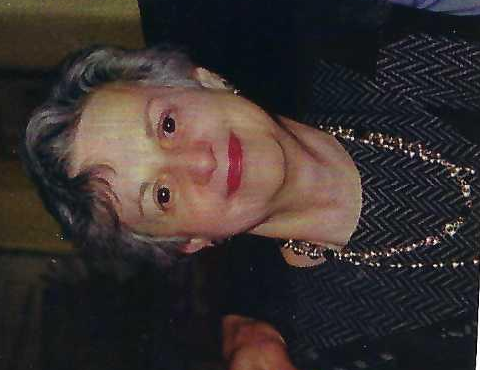
Phyllis Dain. Image courtesy of Leonia Public Library.

Phyllis Dain (November 29, 1929 – June 2018) was an American library historian, educator, and scholar best known for her authoritative works on the history of the New York Public Library (NYPL) and broader contributions to the study of American public libraries and scholarly communication. She served as a longtime faculty member at Columbia University’s School of Library Service and as a mentor to generations of library historians.
The biennial Phyllis Dain Library History Dissertation Award of the American Library Association’s Library History Round Table (LHRT) is named in her honor.
Early Life and Education
Phyllis Dain was born on November 29, 1929, in New York City. She earned a Bachelor of Arts degree from Brooklyn College in 1950. She then pursued graduate studies at Columbia University, receiving a Master of Science in Library Service in 1953, a Master of Arts in U.S. History in 1957, and a Doctor of Library Science (DLS) in 1966. Her doctoral dissertation formed the basis of her first major book on the New York Public Library.
Career
Dain began her professional career in 1953 as a cataloger at the Columbia University Libraries.
In 1957 she started teaching courses in the School of Library Service at Columbia, where she remained a faculty member until her retirement in 1995 as Professor Emerita of Library Service.
During her long academic career, Dr. Dain combined teaching with extensive research and writing in library history, often emphasizing the social, cultural, and institutional contexts of libraries.

Dain played a prominent role in the efforts to preserve Columbia University’s School of Library Service during the university’s budgetary crisis of the late 1980s and early 1990s; the school ultimately closed in 1991. Her papers document correspondence, proposals, and advocacy surrounding that campaign.
She was actively involved in professional organizations, serving as chair of the Library History Round Table of the American Library Association in the late 1970s.
Outside academia, Dr. Dain was a dedicated community member in Leonia, New Jersey, serving on the Board of Trustees of the Leonia Public Library from 1976 until her death.

Scholarship and Publications
Dain’s scholarship focused primarily on the history of the New York Public Library and the evolving role of American public libraries. Her major books include:
- The New York Public Library: A History of Its Founding and Early Years (New York Public Library, 1972), based on her dissertation and widely regarded as a foundational institutional history.
- Libraries and Scholarly Communication in the United States: The Historical Dimension (edited with John Y. Cole; Greenwood Press, 1990).
- Civic Space/Cyberspace: The American Public Library in the Information Age (co-authored with Redmond Kathleen Molz; MIT Press, 1999).
- The New York Public Library: A Universe of Knowledge (Scala Publishers / New York Public Library, 2000), a richly illustrated later volume that extended her earlier research.
Dr. Dain also published numerous articles on library and social history and conducted extensive oral-history interviews (1964–1989 and later) with NYPL librarians, trustees, and administrators, including figures such as Vartan Gregorian, Mrs. Vincent Astor, and longtime branch librarians. These interviews form a significant part of her archival papers.
Later Years and Legacy
After retiring from Columbia, Dain continued her scholarly work and community service. She died in June 2018.
Her papers are held in the Manuscripts and Archives Division of the New York Public Library and document her research, teaching, advocacy for the Columbia library school, and oral-history projects.
The Phyllis Dain Library History Dissertation Award, established by the Library History Round Table, is presented every two years to recognize outstanding English-language dissertations in library history. It honors Dain’s dual legacy as a rigorous scholar and a supportive mentor. Through her books, teaching, and the award that bears her name, she remains a central figure in the historiography of American librarianship.

Dr. Phyllis Dain died in June 2018.

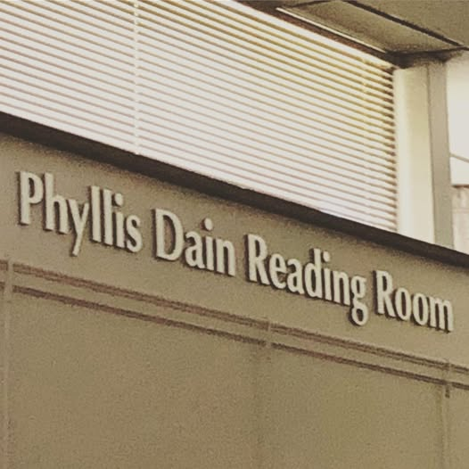

In her memory the Leonia Public Library, New Jersey, where she served on the Board of Trustees of from 1976 until her death, posted at the library’s Facebook page
“In memory of our friend and colleague Phyllis Dain, Trustee Emerita. “A tireless champion for libraries,” Phyllis dedicated her life’s work to library science and fought to protect the rights of patrons.” Dedication of the Phyllis Dain Reading Room.

Selected Publications

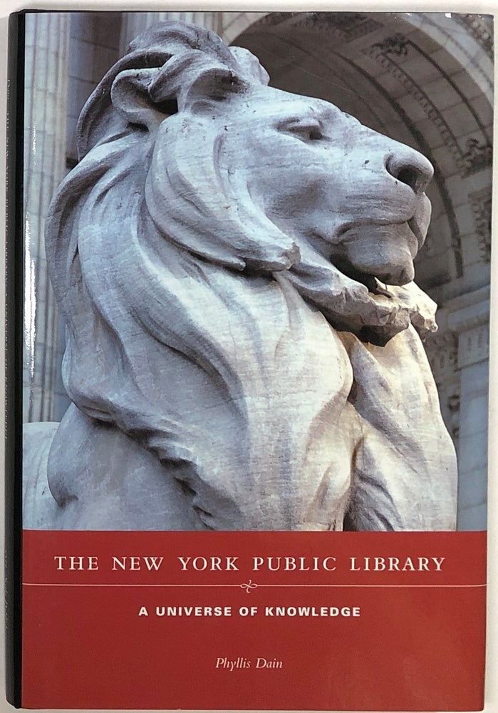

Phyllis Dain . William Frederick Poole and the Modern Library Movement.” 1964. American Documentation 16 (April): 154.
Phyllis Dain. “The New York Public Library: A History of Its Founding and Early Years.” DLS diss., Columbia University, 1966.
Phyllis Dain. The New York Public Library: A History of Its Founding and Early Years. New York: New York Public Library, Astor, Lenox and Tilden Foundations, 1972.
Phyllis Dain. “Ambivalence and Paradox: The Social Bonds of the Public Library.” Library Journal 100, no. 3 (February 1, 1975): 261–66.
Phyllis Dain. “Harry M. Lydenberg and American Library Resources: A Study in Modern Library Leadership.” Library Quarterly 47, no. 4 (October 1977): 451–69.
Phyllis Dain. Review of Public Libraries as Culture and Social Centers: The Origin of the Concept, by Robert Ellis Lee. College & Research Libraries 37, no. 2 (March 1976).
Phyllis Dain. Review of A Century of Service: Librarianship in the United States and Canada, edited by Sidney L. Jackson, Eleanor B. Herling, and E. J. Josey. College & Research Libraries 38, no. 4 (July 1977): 347.
Phyllis Dain. Review of American Library History: A Bibliography, by Michael H. Harris and Donald G. Davis Jr. College & Research Libraries 39, no. 6 (November 1978).
Phyllis Dain and Margaret F. Stieg, eds. “Libraries and Society: Research and Thought.” Special issue, Library Trends 27, no. 3 (Winter 1979). (Includes their joint introduction.)
Phyllis Dain. “The Profession and the Professors.” Library Journal 105, no. 15 (September 1, 1980): 1701–7.
Phyllis Dain and John Y. Cole, eds. Libraries and Scholarly Communication in the United States: The Historical Dimension. Beta Phi Mu Monograph Series. New York: Greenwood Press, 1990.
Phyllis Dain. Contribution in Reading & Libraries: Proceedings of Library History Seminar VIII, Bloomington, Indiana, 9–11 May 1990. Edited by Donald G. Davis Jr. Austin: Graduate School of Library and Information Science, University of Texas at Austin / Beta Phi Mu, 1991.
Dain, Phyllis. 1991. “Public Library Governance and a Changing New York City.” Libraries & Culture 26 (March): 219–50.
Phyllis Dain. Contribution in Libraries & Philanthropy: Proceedings of Library History Seminar IX, 30 March–1 April 1995, University of Alabama, Tuscaloosa. Edited by Donald G. Davis Jr. Austin: Graduate School of Library and Information Science, University of Texas at Austin, 1996.
Dain, Phyllis. 1996. “American Public Libraries and the Third Sector: Historical Reflections and Implications.” Libraries & Culture 31 (January): 56–84.
Redmond Kathleen Molz and Phyllis Dain. Civic Space/Cyberspace: The American Public Library in the Information Age. Cambridge, MA: MIT Press, 1999.
Phyllis Dain. The New York Public Library: A Universe of Knowledge. New York: New York Public Library in association with Scala Publishers; distributed by Antique Collectors’ Club, 2000.
Phyllis Dain. “The Historical Sensibility.” Libraries & Culture 35, no. 1 (Winter 2000): 240–43.

Sources
Columbia University Libraries..” Finding aid. School of Library Service records, 1920s-1992.Rare Book & Manuscript Library / University Archives, Columbia University.
Lee, Felicia R. (April 17, 1990). "Librarians May Lose Oldest School". The New York Times. pp. B1, B4.
Leonia Public Library. 2019. “In memory of our friend and colleague Phyllis Dain, Trustee Emerita. ‘A tireless champion for libraries,’ Phyllis dedicated her life’s work to library science and fought to protect the rights of patrons. Stop by the library to see our dedication of the Phyllis Dain Reading Room.” Facebook, August 20, 2019.
“LHRT 75th Anniversary Gallery.” LHRT News and Notes. Accessed August 22, 2026. https://lhrt.news/lhrt-75th-anniversary-gallery/.
Library History Round Table. “Phyllis Dain: Sad News.” LHRT News and Notes, September 20, 2018.
Library of Congress. “Dain, Phyllis.” LC Linked Data Service. Accessed August 22, 2026.
New York Public Library. “Phyllis Dain Papers, 1956–2001 [bulk 1973–1999].” Manuscripts and Archives Division, Mss Col 18397. Finding aid.

Submitted by Kathleen de la Peña McCook

