Richard J. Cox- 1950- 2026

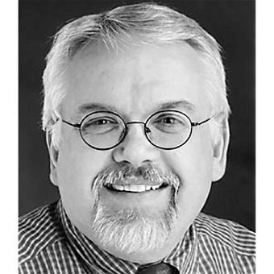

Richard J. Cox (February 9, 1950 - July 11, 2026) was an American archivist, educator, and author who played a leading role in professionalizing archival studies in the United States. He spent much of his career building graduate archival education, writing extensively on appraisal, electronic records, ethics, accountability, and the history of the profession. He held leadership roles in the Society of American Archivists (SAA).
Cox earned a B.A. with honors in history from Towson State College in 1972, an M.A. in history from the University of Maryland in 1978, and a Ph.D. in library and information science from the University of Pittsburgh in 1992. His dissertation examined how U.S. archival institutions and education programs were (or were not) adapting to electronic records, with particular attention to state archives.
Cox began working as an archivist in 1972. His early positions included graduate assistant in archaeology for the St. Mary’s City Commission, editor of the Calvert Family Papers at the Maryland Historical Society (1972–73), and curator of manuscripts there (1973–78).
From 1978 to 1983 he served as City Archivist and Records Management Officer for Baltimore. He then headed the Archives and Records Division of the Alabama Department of Archives and History (1983–86) and worked as associate archivist at the New York State Archives (1986–88), with a concurrent visiting instructorship at the State University of New York at Albany.
In 1988 he joined the University of Pittsburgh School of Information Sciences (now the School of Computing and Information) as a lecturer, advancing to assistant professor (1992), associate professor (1996), and professor (2000). He directed the archives concentration in the master’s and doctoral programs and helped establish a leading doctoral program in archival studies. He supervised eighteen dissertations.

Society of American Archivists
Dr. Cox joined the Society of American Archivists in 1972. He chaired the committee that drafted the first graduate archival education guidelines (adopted 1988), served on the Committee on Education and Professional Development, and sat on SAA Council (1986–89).
He was elected a Fellow of SAA in 1989.
Dr. Cox edited The American Archivist from 1991 to 1995 and served as SAA publications editor (2002–2007.
He received the Society’s Waldo G. Leland Award for writing of superior excellence and usefulness in archival history, theory, or practice in 1991, 2002, and 2005, among other honors such as multiple Arline Custer Memorial Awards from the Mid-Atlantic Regional Archives Conference.
Books and essays by Cox consistently treated archives as a distinct discipline rather than merely an adjunct to history. Notable titles included
- American Archival Analysis: The Recent Development of the Archival Profession in the United States (1990),
- Managing Institutional Archives (1992),
- Documenting Localities (1996),
- Closing an Era: Historical Perspectives on Modern Archives and Records Management (2000),
- Managing Records as Evidence and Information (2001),
- No Innocent Deposits: Forming Archives by Rethinking Appraisal (2004), Archives and Archivists in the Information Age (2005),
- Personal Archives and a New Archival Calling (2008)
He also wrote works on ethics, accountability, and the post-9/11 digital environment He also co-edited Archives and the Public Good and contributed to debates on electronic records, finding aids, and professional education.

Dr. Cox wrote two blogs. They were sequential, not simultaneous: the first on Blogger, the second on WordPress after a multi-year gap. Neither requires a login to read. [Availability might change if Google or Automattic later remove inactive sites, so Wayback Machine copies are a useful backup].

- Reading Archives (2006–2009) [Platform: Blogger (Google Blogspot)
URL: http://readingarchives.blogspot.com The archive of 250 posts is still live. Posts run from October 23, 2006, to May 26, 2009. The final post, “Signing Off,” says Cox was ending the blog but leaving it up.
- Reading Archives and the Academy (2015–2017)
Platform: WordPress.com
URL: https://readingarchivestheacademy.wordpress.com This site is also still live. Posts ran from October 2015 to July 21, 2017. The last post notes that it would be his final entry as he prepared for retirement.
Dr. Cox was a founding partner of the Archival Education and Research Initiative (AERI), a project led by Anne Gilliland at UCLA and originally funded by the Institute for Museum and Library Services to foster community and strengthen doctoral-level education and scholarship in the archival profession. Cox attended all of these events before his retirement.
At the AERI meeting immediately before his retirement, Dr Cox urged archivists—specifically, prospective archival educators—to transform advocacy to deal with political issues, emphasize the role of archives in democratic regimes, embrace the notion of evidence and truth, revisit archival ethics, and develop graduate curriculum and a research agenda that better prepares the next generation of archivists. Farewell to AERI, or Last Words on the Archival Mission.

A 2020 Festschrift, Defining a Discipline: Archival Research and Practice in the Twenty-First Century: Essays in Honor of Richard J. Cox, edited by Jeannette A. Bastian and Elizabeth Yakel and published by SAA in Chicago, surveyed his influence.
Dr. Richard Cox died July 11, 2026.

Selected Publications

Cox, Richard J. A Guide to the Microfilm Edition of the Calvert Papers. Baltimore: Maryland Historical Society, 1973.
Cox, Richard J. A Guide to the Microfilm Edition of the Mordecai Gist Papers. Baltimore: Maryland Historical Society, 1975.
Cox, Richard J., and others, eds. A Guide to the Research Collections of the Maryland Historical Society: Historical and Genealogical Manuscripts and Oral History Interviews. Baltimore: Maryland Historical Society, 1981.
Cox, Richard J. Assessing Alabama’s Archives: A Plan for the Preservation of the State’s Historical Records. Montgomery: Alabama Historical Records Advisory Board, 1985.
Cox, Richard J. “Professionalism and Archivists in the United States.” American Archivist 49, no. 3 (Summer 1986): 229–47.
Cox, Richard J. Strengthening New York’s Historical Records Programs: A Self-Study Guide. Albany: New York State Archives and Records Administration, 1988.
Cox, Richard J. “Educating Archivists: Speculations on the Past, Present, and Future.” Journal of the American Society for Information Science 39, no. 5 (September 1988): 340–43.
Cox, Richard J. American Archival Analysis: The Recent Development of the Archival Profession in the United States. Metuchen, NJ: Scarecrow Press, 1990.
Cox, Richard J. “Library History and Library Archives in the United States.” Libraries & Culture 26, no. 4 (1991): 569–93.
Cox, Richard J. Managing Institutional Archives: Foundational Principles and Practices. New York: Greenwood Press, 1992.
Cox, Richard J. “The Master of Archival Studies and the American Education Standards: An Argument for the Continued Development of Graduate Archival Education in the United States.” Archivaria 36 (February 1993): 221–31.
Cox, Richard J., ed. “Educating the American Archivist for the Twenty-First Century.” Special issue, Journal of Education for Library and Information Science 34, no. 1 (Winter 1993).
Cox, Richard J. “The Roles of Graduate and Continuing Education in Preparing Archivists for the Information Age.” American Archivist 56, no. 3 (Summer 1993): 444–57.
Cox, Richard J. The First Generation of Electronic Records Archivists in the United States: A Study in Professionalization. New York: Haworth Press, 1994.
Cox, Richard J. Documenting Localities: A Practical Model for American Archivists and Manuscripts Curators. Metuchen, NJ: Scarecrow Press and Society of American Archivists, 1996.
Cox, Richard J. “Searching for Authority: Archivists and Electronic Records in the New World at the Fin-de-Siècle.” First Monday 5, no. 1 (2000).
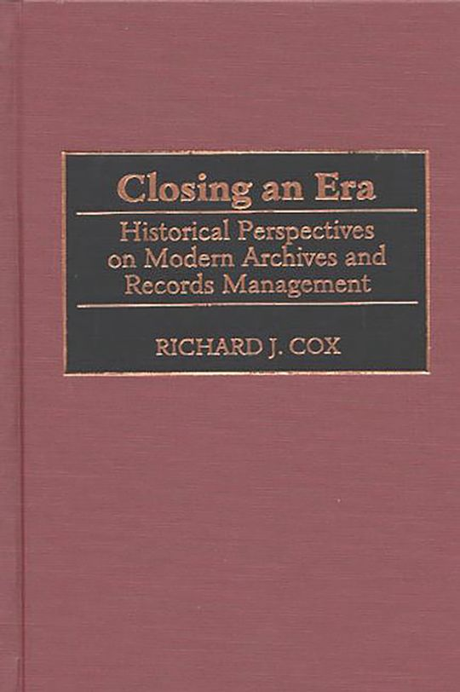
Cox, Richard J. Closing an Era: Historical Perspectives on Modern Archives and Records Management. Westport, CT: Greenwood Press, 2000.
Cox, Richard J. Managing Records as Evidence and Information. Westport, CT: Quorum Books, 2001.
Cox, Richard J., Elizabeth Yakel, David A. Wallace, Jeannette A. Bastian, and Jennifer Marshall. “Archival Education in North American Library and Information Science Schools.” Library Quarterly 71, no. 2 (April 2001): 141–94.
Cox, Richard J., and David A. Wallace, eds. Archives and the Public Good: Accountability and Records in Modern Society. Westport, CT: Quorum Books, 2002.
Cox, Richard J. Vandals in the Stacks? A Response to Nicholson Baker’s Assault on Libraries. Westport, CT: Greenwood Press, 2002.
Cox, Richard J. Flowers After the Funeral: Reflections on the Post-9/11 Digital Age. Lanham, MD: Scarecrow Press, 2003.
Cox, Richard J. No Innocent Deposits: Forming Archives by Rethinking Appraisal. Lanham, MD: Scarecrow Press, 2004.
Cox, Richard J., ed. Lester J. Cappon and the Relationship of History, Archives, and Scholarship in the Golden Age of Archival Theory. Chicago: Society of American Archivists, 2004.
Cox, Richard J. “Lester J. Cappon and the Relationship of History, Archives, and Scholarship in the Golden Age of Archival Theory.” American Archivist 68, no. 1 (Spring/Summer 2005): 74–112.
Cox, Richard J. Archives and Archivists in the Information Age. New York: Neal-Schuman, 2005.
O’Toole, James M., and Richard J. Cox. Understanding Archives and Manuscripts. 2nd ed. Chicago: Society of American Archivists, 2006.
Cox, Richard J. Ethics, Accountability, and Recordkeeping in a Dangerous World. London: Facet, 2006.
Cox, Richard J. “Machines in the Archives: Technology and the Coming Transformation of Archival Reference.” First Monday 12, no. 11 (November 2007)..
Cox, Richard J. “Revisiting the Archival Finding Aid.” Journal of Archival Organization 5, no. 4 (2008): 1–27.
Cox, Richard J. “Archival Ethics: The Truth of the Matter.” Journal of the American Society for Information Science and Technology 59, no. 7 (2008): 1128–33.
Cox, Richard J. Personal Archives and a New Archival Calling: Readings, Reflections and Ruminations. Duluth, MN: Litwin Books, 2008.
Cox, Richard J. The Demise of the Library School: Personal Reflections on Professional Education in the Modern Corporate University. Duluth, MN: Library Juice Press, 2010.
Cox, Richard J. Archival Anxiety and the Vocational Calling. Duluth, MN: Litwin Books, 2011.
Cox, Richard J. “Lester J. Cappon, an Unwritten Textbook, and Early Archival Education in the United States.” Information & Culture 49, no. 3 (2014): 327–50.
Cox, Richard J. “Graduate Archival Education in the United States: A Personal Reflection about Its Past and Future.” Journal of Contemporary Archival Studies 2 (2015): article 3.

Sources
Archival Education and Research Initiative. “AERI – Archival Education and Research Initiative.” Accessed August 28, 2026.
Bastian, Jeannette A., and Elizabeth Yakel, eds. Defining a Discipline: Archival Research and Practice in the Twenty-First Century: Essays in Honor of Richard J. Cox. Chicago: Society of American Archivists, 2020.
RICHARD JAMES COX Obituary | 1950 - 2026 | Pittsburgh Post-Gazette
"SCI Community Saddened by the Passing of Dr. Richard Cox". School of Computing and Information. University of Pittsburgh. July 20, 2026.
Society of American Archivists. Staff and historical pages on publications editors, American Archivist editors, and Fellows. Chicago: Society of American Archivists.
VIAF (Virtual International Authority File). “Cox, Richard J., 1950–.”
Waldo Gifford Leland Award | Society of American Archivists
Wosh, Peter J. Waldo Gifford Leland and the Origins of the American Archival Profession. Chicago: Society of American Archivists, 2011.

Submitted by Kathleen de la Peña McCook

