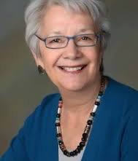
Rafaela G. Castro Dec. 7, 1943 - July 5, 2015

Biography and Remarks at Celebration of Life, delivered by Richard Chabran, July 2015

LATINO DIGITAL ARCHIVE GROUP https://latinodigitalcontent.org/person/rafaela-castro

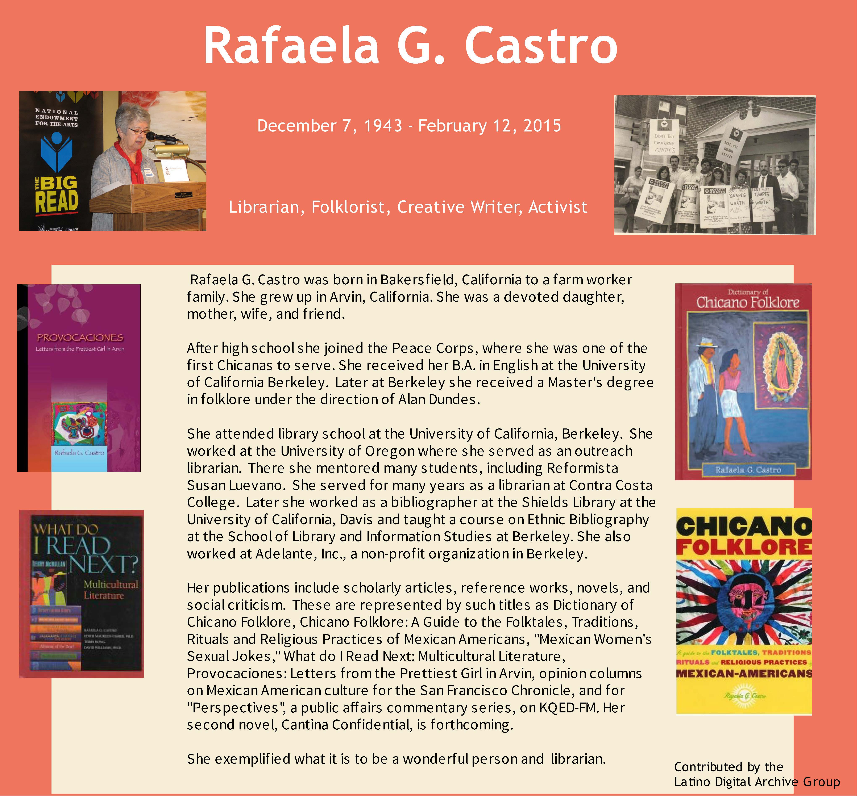
My colleagues Kathryn Blackmer Reyes, Lillian-Castillo-Speed, Norma Coral, Romelia Salinas put together this poster in her honor. It has traveled to two conferences the first was the REFORMA National Conference in San Diego, the second was the National Association of Chicana and Chicano Studies in San Francisco.
From : Remarks at Celebration of Life, delivered by Richard Chabran, July 2015.

Tribute by Roberto Delgadillo (Que descanse en paz, Oct. 30, 2022)
Rafaela G. Castro (1943-2015): In Memoriam (link)
This entry was posted in Archival Work, Chicana and Chicano Studies, Native American Studies and tagged Chicana/o Studies Archives, Rafaela G. Castro, Roberto C. Delgadillo on April 7, 2015 by mujerestalk

RAFAELA CASTRO AS AUTHOR
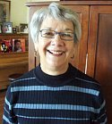
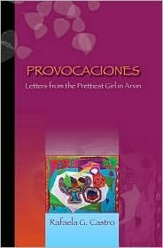
https://www.goodreads.com/author/show/542483.Rafaela_G_Castro
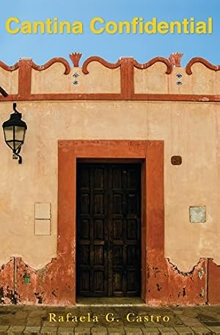
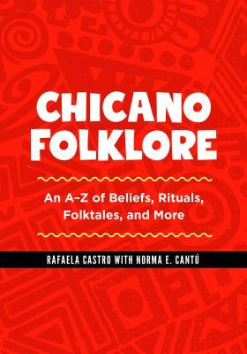

PUBLICATIONS, PRESENTATIONS & MENTIONS:

Castro, Rafaela and Richard Chabrán. 1994. “Discourse and discord: Voices from an academic library.” Reference Librarian, 45/46: 279-296.
A diversity initiative by the ad-hoc group Librarians Association of the University of California is discussed, and results of the group’s report “The Many Voices of Diversity” are outlined. Developing and having access to culturally diverse collections, reference and bibliographic instruction services, and concerns of recruitment, promotion and retention are major areas of the report, which are briefly summarized in this article. Challenges the group encountered in creating this report are discussed, and the article concludes with an 86-item un-annotated bibliography. Published simultaneously as a chapter in Racial and Ethnic Diversity in Academic Libraries: Multicultural Issues, edited by D.A. Curry, S.G. Blandy, and L.M. Martin. New York: Binghamton: Haworth Press. See General Works, 1990s for monograph citation.
Annotation from: https://www.ala.org/sites/default/files/acrl/content/publications/booksanddigitalresources/digital/kaleidoscopic.pdf
Davis-Kendrick, Kaetrena D. “The Kaleidoscopic Concern: An Annotated Chronological Bibliography of Diversity, Recruitment, Retention, and Other Concerns Regarding African Americans and Ethnic Library Professionals in the United States “, Association of College and Research Libraries, Chicago 2009

Castro, Rafaela, 1991. Assessment of the Ethnic Collections in Shields Library. Davis, Calif. in “Here is a working bibliography on ethnic studies, and its history in the university” in https://library.ucdavis.edu/exhibit/imagining-america-anew-ethnic-studies-at-uc-davis/
(Note: This link is to the website that provides the title of Castro’s work. This is not a link to the work itself).

Developing Library Collections for California's Emerging Majority, see. 45. Rafaela Castro. Rafaela Castro, "Assessment of Ethnic Library Collections," p. 45 …
https://www.researchgate.net/publication/254360515_Academic_Libraries_and_the_Culture_Wars_The_Politics_of_Collection_Development

Rafaela Castro: “Mexican Women’s Sexual Jokes” in Perspectives in Mexican American Studies, Vol 1: Readings in Southwestern Folklore, An Anthology.
University of Arizona . College of Social & Behavioral Sciences: Mexican American Studies,
(Note: Perspectives is no longer published)
https://mas.arizona.edu/archives

“My Mom Wrote Her Master’s Thesis on ‘Mexican Women’s Sexual Jokes’” by Solange Castro, Blog entry, May 13, 2025 (Solange Castro: Comic, Playwright, Non-Essential Artist)
https://searchforsanity.com/2025/05/13/my-mom-wrote-her-masters-thesis-on-mexican-womens-sexual-jokes/\

Abstracts from the Nineteenth Annual Conference National Association for Ethnic Studies, Inc. "Ethnic Studies for the Twenty-first Century" California State Polytechnic University Pomona, California March 7.10, 1991 (p.66)
SESSION XIX: "Ethnic Studies Research Library Collections: From the 1960s to the Twenty-first Century." Chair: Rafaela Castro, University of California, Davis. Rafaela Castro, University of California, Davis. "Ethnic Library Collections in California, a Review." It has been well over twenty years that ethnic library collections were first established in California's public and academic libraries. These collections not only represent the history, culture, literature, and growth of the ethnic communities of the state, but they also chronicle the development of ethnic studies research of the last twenty years. Scholarship in civil rights, women's studies, and ethnic studies movements has reached the unexpected point where many researchers in the field were born after the movements started. The development of these library collections, the information preserved and publications released are history, history of a people's movements, and more than likely history that is not preserved, in the average public or academic library. Scholars must pay attention to this history.
https://scholarscompass.vcu.edu/cgi/viewcontent.cgi?article=1437&context=ees#:~:text=Rafaela%20Castro%20started%20out%20the,started%20in%20the%20late%201960s
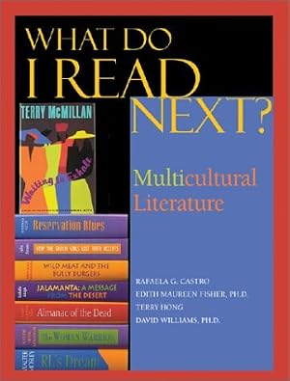

RAFAELA CASTRO IS LISTED IN:
Directory of the Association for Library and Information Science Education 1988-89 https://www.jstor.org/stable/i40013667

TRIBUTE:
Salute to Rafaela Castro, Susana Hinojosa, Wei Chi Poon, Satia Orange, Vivan Sykes:
They were true powerhouses in the library movement, an inspiration to everyone who had the privilege of knowing them. Their lifelong commitment to justice and equity shaped every space they entered as strong women of color. Through their service on local and national library committees, they worked to influence policy, expand access, and insist on equity as a core professional value.
Their work was never simply procedural; it was a deliberate challenge to the systemic inequities that continue to disproportionately affect marginalized communities. Their contributions are not relics of the past. Their legacy actively shapes our present and future as librarians, both current and retired, dedicated to social justice, to building bridges across generations, and to transforming our institutions.
Our responsibility now is to carry their work forward with intention, ensuring that diverse voices are not only heard, but uplifted, centered, and shared.
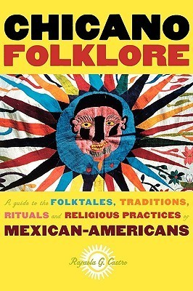
~ Rhonda Rios Kravitz, MSLS, DPA. Dean Emerita, Sacramento City College

