Charlotte Chung-Sook Kim – 1940- 2005

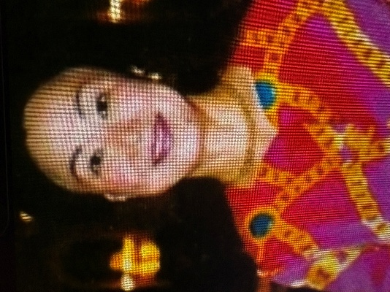

Charlotte Chung-Sook Kim (née Hong; also known as Chung Sook Charlotte Kim) April 15, 1940 - May 1, 2005 was a librarian and library administrator who worked for many years with the Chicago Public Library (CPL).
She earned a bachelor’s degree in English literature from Yonsei University (Seoul ,Korea) in 1962. She participated in performing arts, played the lead role in the school’s play, and was crowned Yonsei University’s May Queen in 1961, a great honor. This made her conscious of her public image, but she valued it for her scholarship and character.
Charlotte Kim came to America at age 23 to pursue a master’s in educational psychology at Duquesne University and earned a master’s in library science from the University of Pittsburgh in 1968.
She worked at the Carnegie Library for almost two decades.
She moved to Chicago to join her husband, Ben H. Kim, and began a long career with the Chicago Public Library (CPL) system around 1990.
Kim advanced rapidly within CPL, rising from branch manager to district chief and then to Assistant Commissioner of Neighborhood Libraries—the highest-ranking Asian American in the system at the time. Colleagues remembered her as a tireless public servant who believed deeply in libraries as community resources, especially in urban settings. She was known for her professionalism, graciousness, and role as a role model for women and immigrants.
The "Charlotte Kim Scholar in Residence Program" took place at CPL as a continuing education initiative for staff from 1999–2008. Scholars included Camila Alire (1999); Leigh S. Estabrook (2002); Kathleen de la Peña McCook (2003); Joan C. Durrance (2004); Michael Stephens (2005); Maureen Sullivan (2006); George Needham (2007) and Patricia Martin (2008).
In 2003 she received the City of Chicago’s Kathy Ostermann Award for outstanding supervisory employee. She also developed the Systemwide Clerical Co-Chairs program, giving clerical staff a stronger system-wide voice and helping many become library leaders.
Beyond her library work, Charlotte Kim was active in community and Korean-American organizations. She was one of the founders of the Chicago Korean YWCA and served as the first president of the Midwest chapter of KOWIN (Korean Women’s International Network).
She emphasized volunteering and community programs throughout her career. Library colleagues remembered her warmth, encouragement, class, energy, and lasting positive influence on the Chicago Public Library system.

Sources
American Library Association. Memorial. Annual. 2005.
"Charlotte Kim Scholars in Residence Program" (PDF). Reporter. 25 (5). Illinois Library Association: 18. October 2007. Archived from the original (PDF) on May 12, 2013.
“Chung Kim Obituary.” Chicago Sun-Times, May 3, 2005.
“Chung Sook Charlotte Kim.” Legacy.com, May 3, 2005.

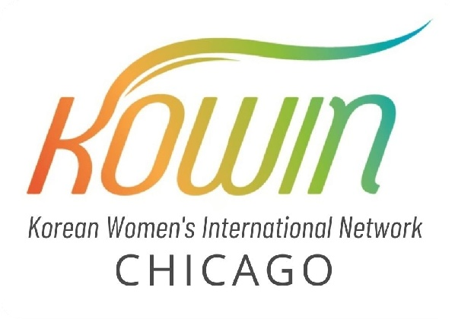
KOWIN -- a network of women leaders of Korean descent around the world with the purpose of networking and facilitating discussion of issues concerning Korean women.
Trailblazers, Includes overview of life and career of Charlotte Chung-Sook Kim.YouTube video, August 27, 2021. Korean American Women’s Storytelling Project.

Submitted by ALA Member

