

Memorial Resolution Honoring John Anthony Tuggle

Whereas the American Library Association and the library and information science community have lost a devoted leader, mentor, and advocate with the passing of John Anthony Tuggle on September 18, 2024; and

Whereas John Tuggle earned a Master of Arts in American History and a Master of Library Science from the University of Southern Mississippi, laying the foundation for a lifetime of professional excellence; and

Whereas he served with distinction as Director of Shreve Memorial Library, providing visionary leadership that transformed the library’s resources, services, and community impact, and held key positions in other library systems including Assistant
Director for Public Services at Live Oak Public Libraries and District Coordinator at Houston Public Library; and

Whereas John Tuggle was a passionate advocate for literacy and early childhood learning, founding the Shreve Memorial Library Children’s Book Festival and promoting initiatives that ensured children across Caddo Parish had access to reading and educational resources; and

Whereas he demonstrated extraordinary community leadership through service as
Board Chair of United Way of Northwest Louisiana, past Board President of the
Gingerbread House Children’s Advocacy Center, membership in the Northwest
Louisiana Veterans Cemetery Foundation, and active involvement in the Rotary Club, as well as through his participation in the American Library Association and the Public Library Association; and

Whereas John Tuggle’s colleagues and community members remember him as an intelligent, empathetic, and generous leader whose dedication to equity, inclusion, and mentorship strengthened both the profession and the lives of countless individuals; and

Whereas John Tuggle’s legacy lives on through the ongoing work of the Shreve Memorial Library and the Shreve Memorial Library Foundation, reflecting his lifelong commitment to transforming lives through libraries; now, therefore, be it

Resolved, that the American Library Association (ALA), on behalf of its members:

1.honors and celebrate the life, career, and enduring contributions of John Anthony Tuggle, whose leadership, vision, and advocacy enriched libraries and communities throughout Louisiana and beyond; and be it further

2.that the American Library Association extends its deepest sympathy and condolences to John Tuggle’s family, friends, colleagues, and all whose lives he touched.
Adopted by the Council of the American Library Association
Wednesday, January 28, 2026, ALA Virtual Winter Council Session
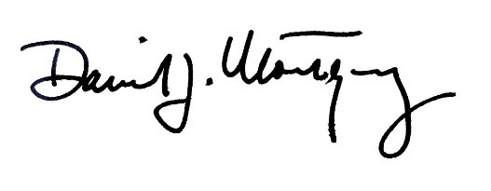
Dan Montgomery, ALA Executive
Director, and Secretary of the ALA
Council

