Vivian Merle Sykes
Researcher, Trainer, Librarian, Storyteller

First Light: January 6, 1949
Embraced by the Ancestors: September 25, 2017

Announcement of Passing:
https://www.dignitymemorial.com/obituaries/red-bluff-ca/vivian-sykes-7583552

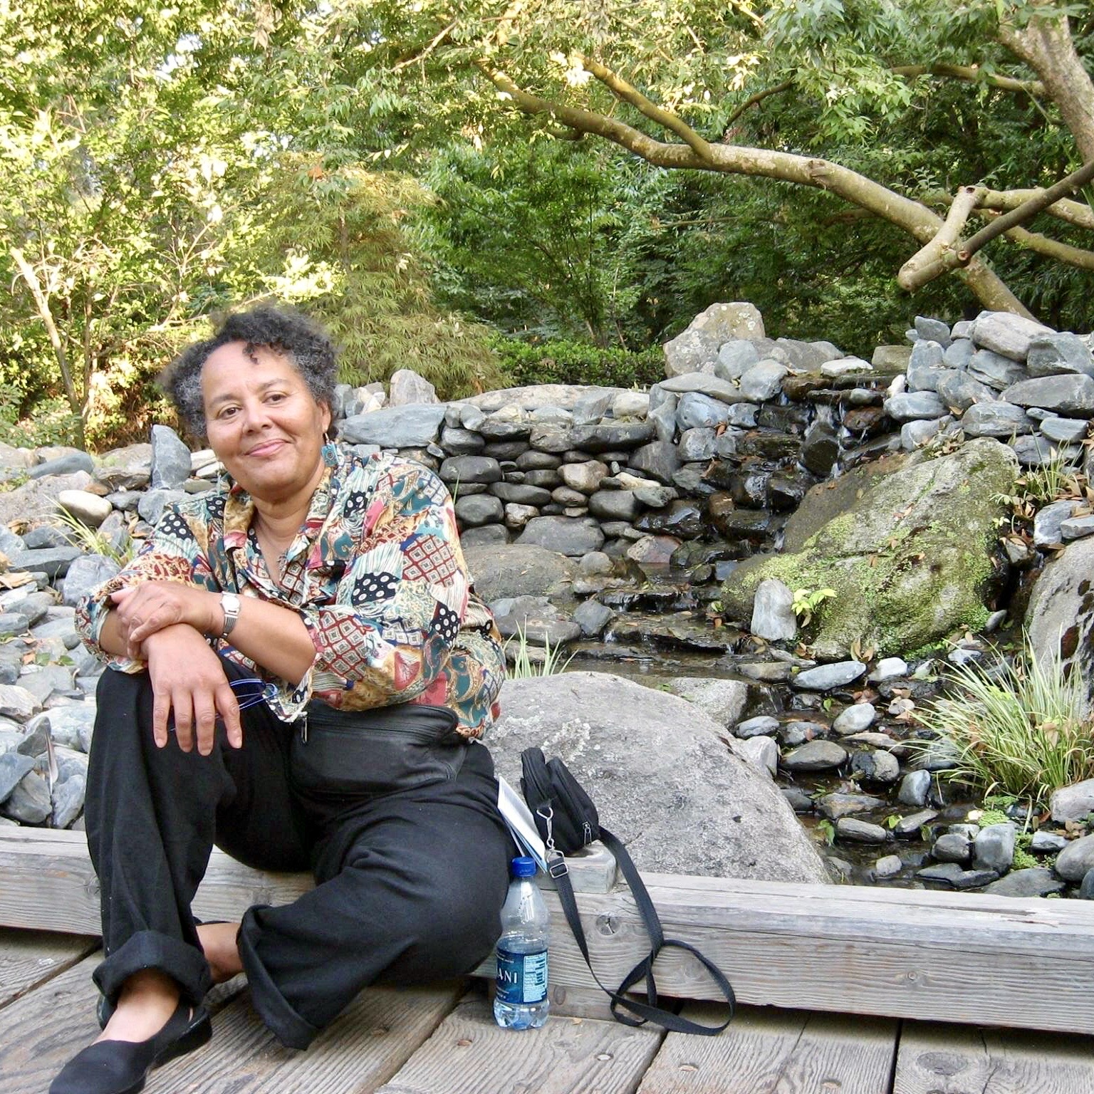

QUOTES (2008-2009):

“I have taught, trained and developed a variety of ways of training national and international groups in the art of celebrating difference and similarities.”

“The purpose of my serving in libraries was to de-mystify the information seeking and learning process.”

“I am a storyteller and I use it as a way to motivate, inspire and create ‘aha’ moments in all types of institutional settings.”

“I reviewed books, developed collections, specialized in re-building dying libraries and celebrated all of the communities in which I served.”

EDUCATION & CAREER

University of Michigan, School of Information Science: Post Graduate education with an emphasis in organizations and organizational change (1991-1997)

University of California at Berkeley, MLIS,1982

Stanford University: MA in American History, 1972

University of Connecticut: BA in American History, 1971

Public Libraries (1988-1997):
San Francisco Public Library: Children’s Librarian at many branches

Academic Libraries (1977 - 1998) :
University of California at Santa Cruz: The first University Multicultural Research Librarian
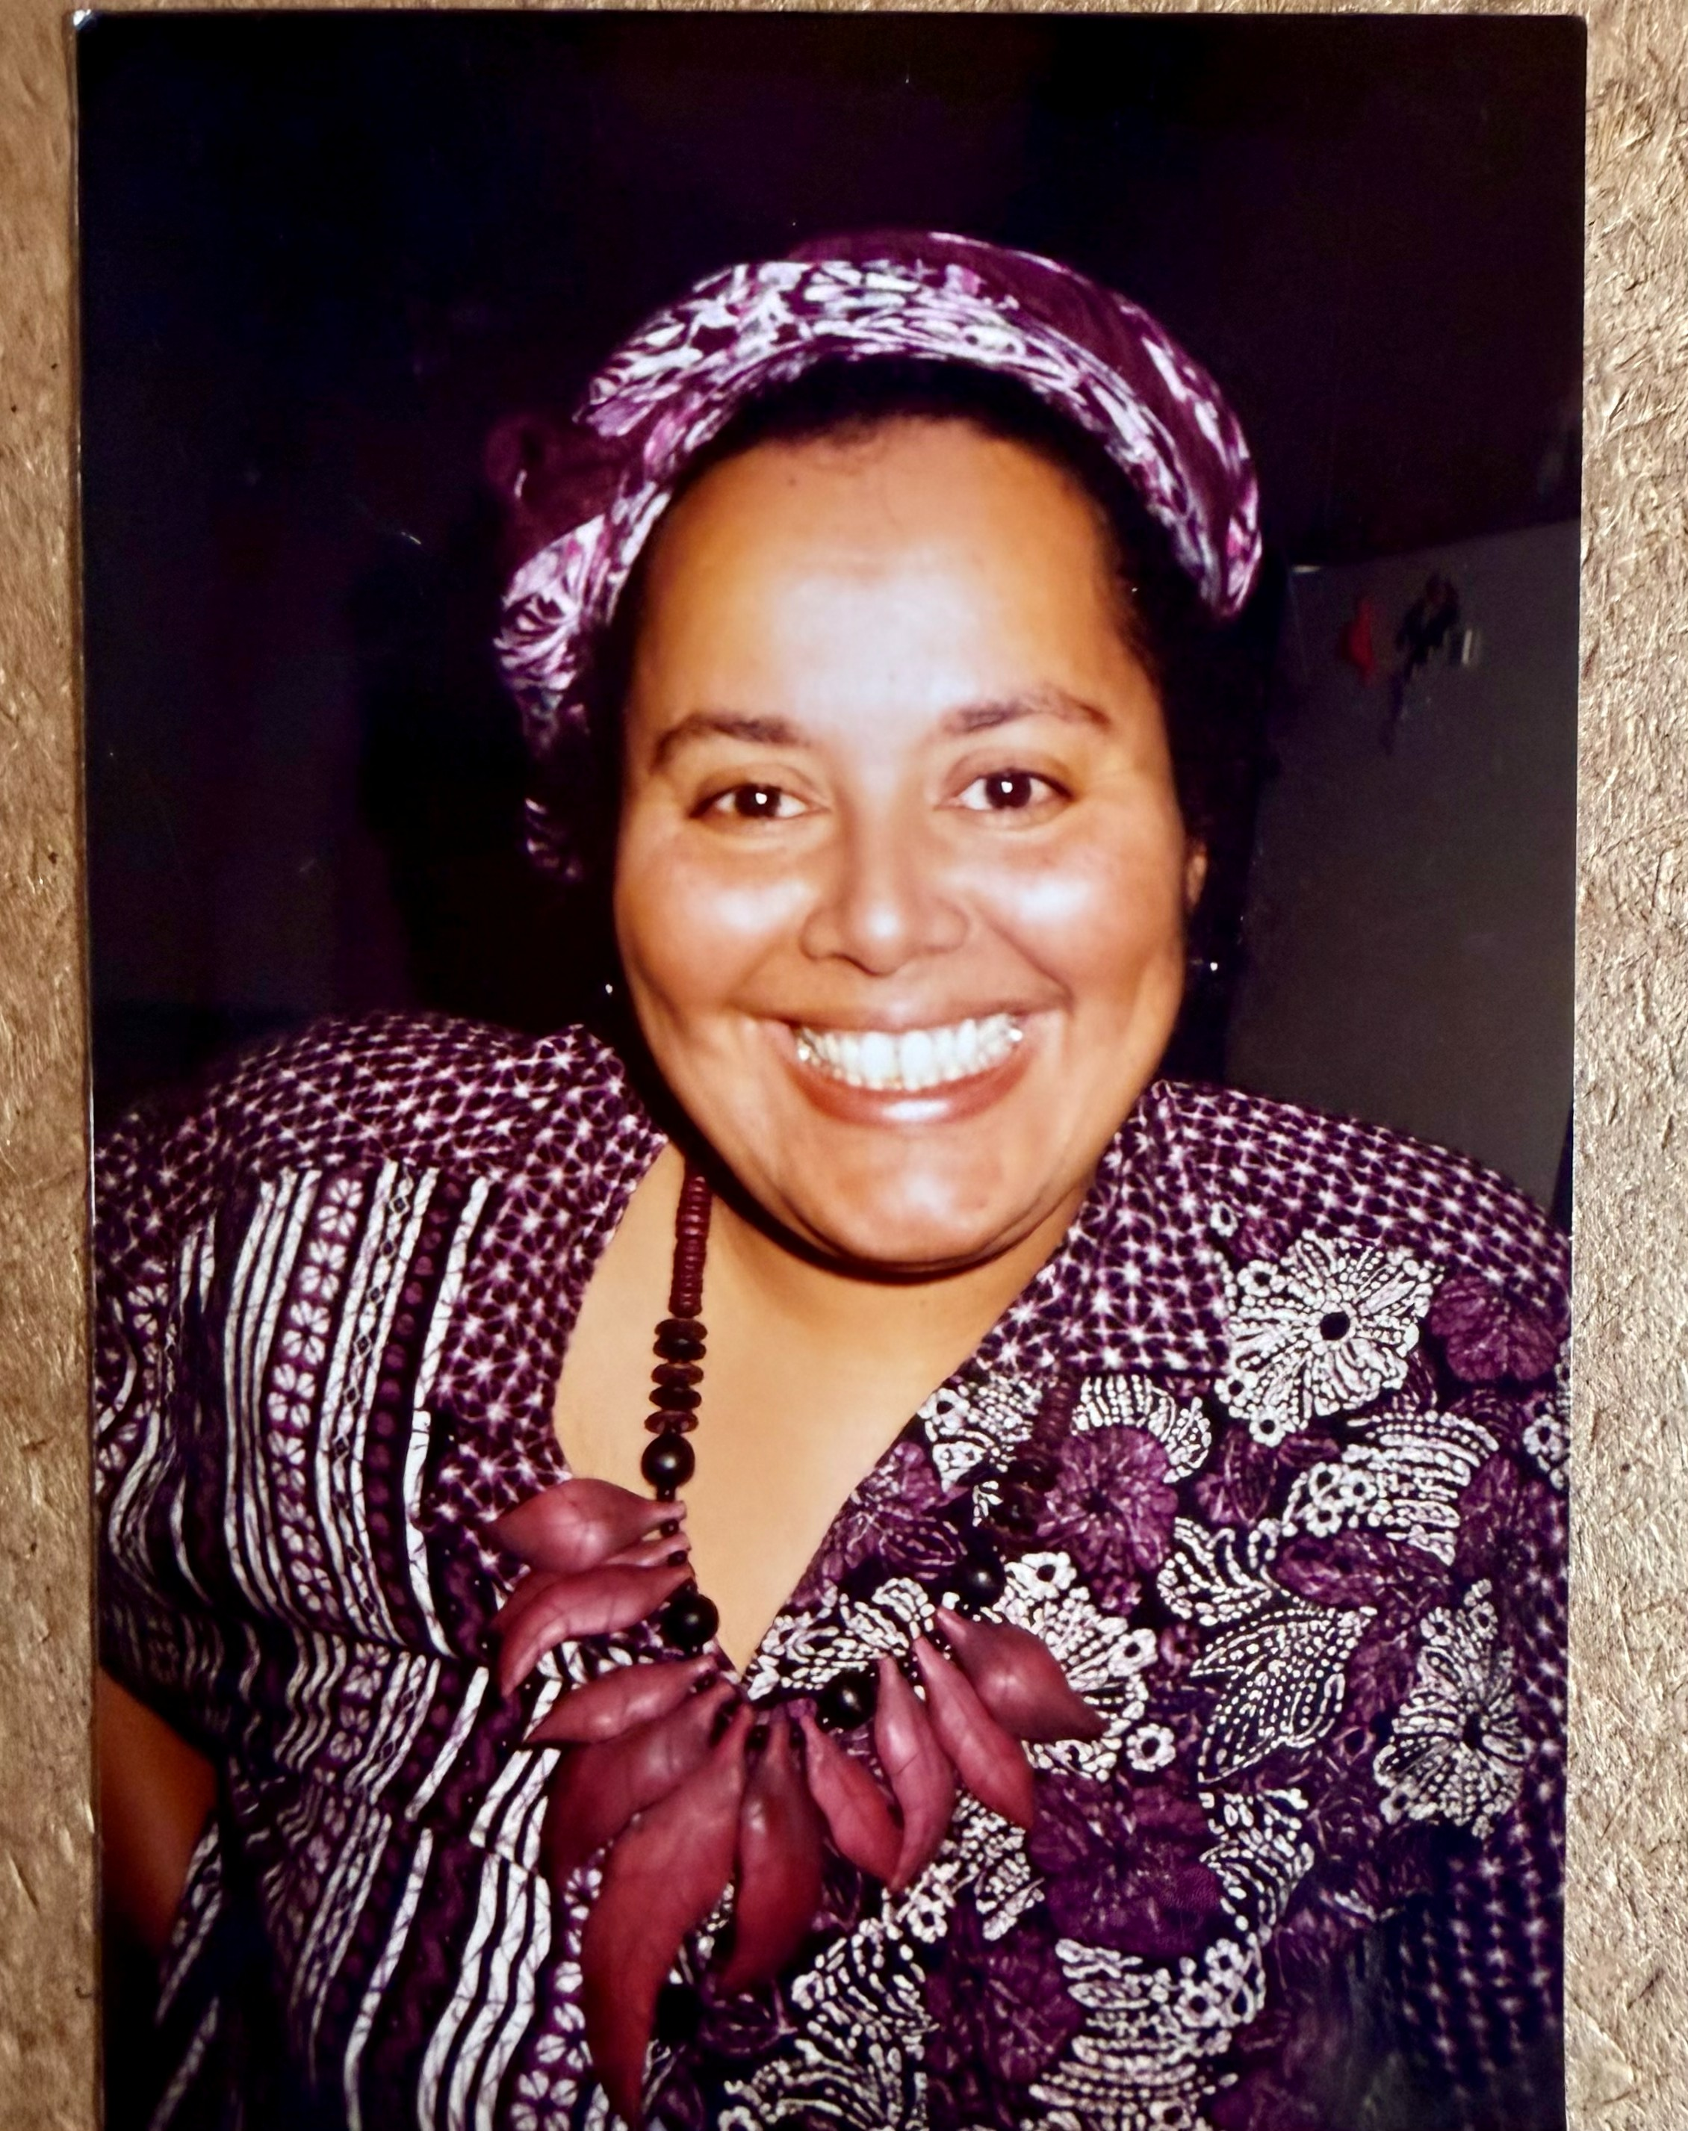
University of Michigan: UAW Long Distance Learning Consortium, Center on Learning and Research of Teaching, Research Asst. to the University Librarian, Undergraduate Studies & Undergraduate Library

Storyteller: All her life as a Trainer and Children’s Librarian and as a Barnes and Noble Children’s Specialist Bookseller in New York City and in Fresno, California

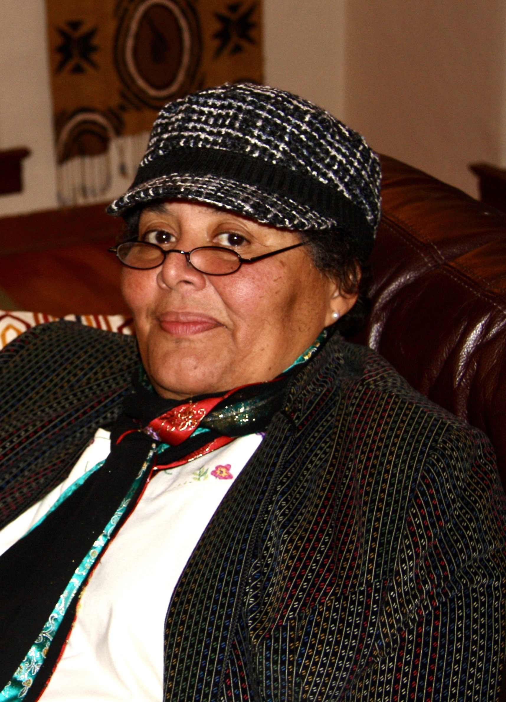
TRIBUTES

From Alexandra Rivera, Associate Dean, Engagement and Organizational Excellence; President Joint Council of Librarians of Color, Inc.; Past President REFORMA; Past ALA Executive Board member; Past ALA Councilor at Large

Vivian Merle Sykes had a profound impact on me, both personally and professionally. She came to the University of Michigan Library in the 1990s to further develop a culture of diversity, equity, and inclusion. I was working as an administrative assistant in library administration and provided secretarial support to her. She quickly became a friend and mentor. She had a magical way of seeing the uniqueness in each individual and nurturing it. In me she saw this crazy mix of identities that I took for granted. She herself had a beautiful mixed heritage. She helped me to understand the marginalization that I felt but couldn’t quite understand. And she taught me to embrace my identities as a superpower, a perspective that I had never considered before.
She creatively approached life with humor and passion. I watched in awe how she interacted with individuals, helping them to engage their curiosity and creativity. She taught through storytelling and through example. The lessons I learned from her I apply every day. I feel honored to have had her in my life.

From Pat Mullan, Art & Music Head Librarian, Ret., Berkeley Public Library
Parallel to her great, big sense of humor was Vivian Sykes’ great, big sense of justice. And powering both was her courage.
Just being in the same room, just having her presence there in the midst of it all, was supportive and motivating.
She’d cross her arms, she’d twinkle her eyes. Sometimes, she’d close her eyes. Sometimes, she’d bellow.
By being her strong, smart, funny, courageous self, Vivian would get you on your feet, talking. Standing you up to speak the truth, even before you thought you could.
And later, she’d have you bent over laughing.

From Rhonda Rios Kravitz, MSLS, DPA, Dean Emerita, Sacramento City College

Salute to Rafaela Castro, Susana Hinojosa, Wei Chi Poon, Satia Orange, Vivan Sykes:

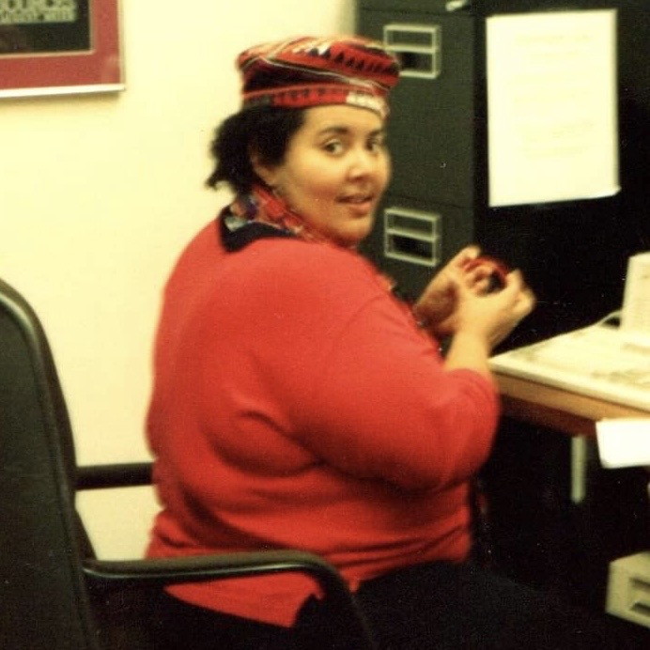
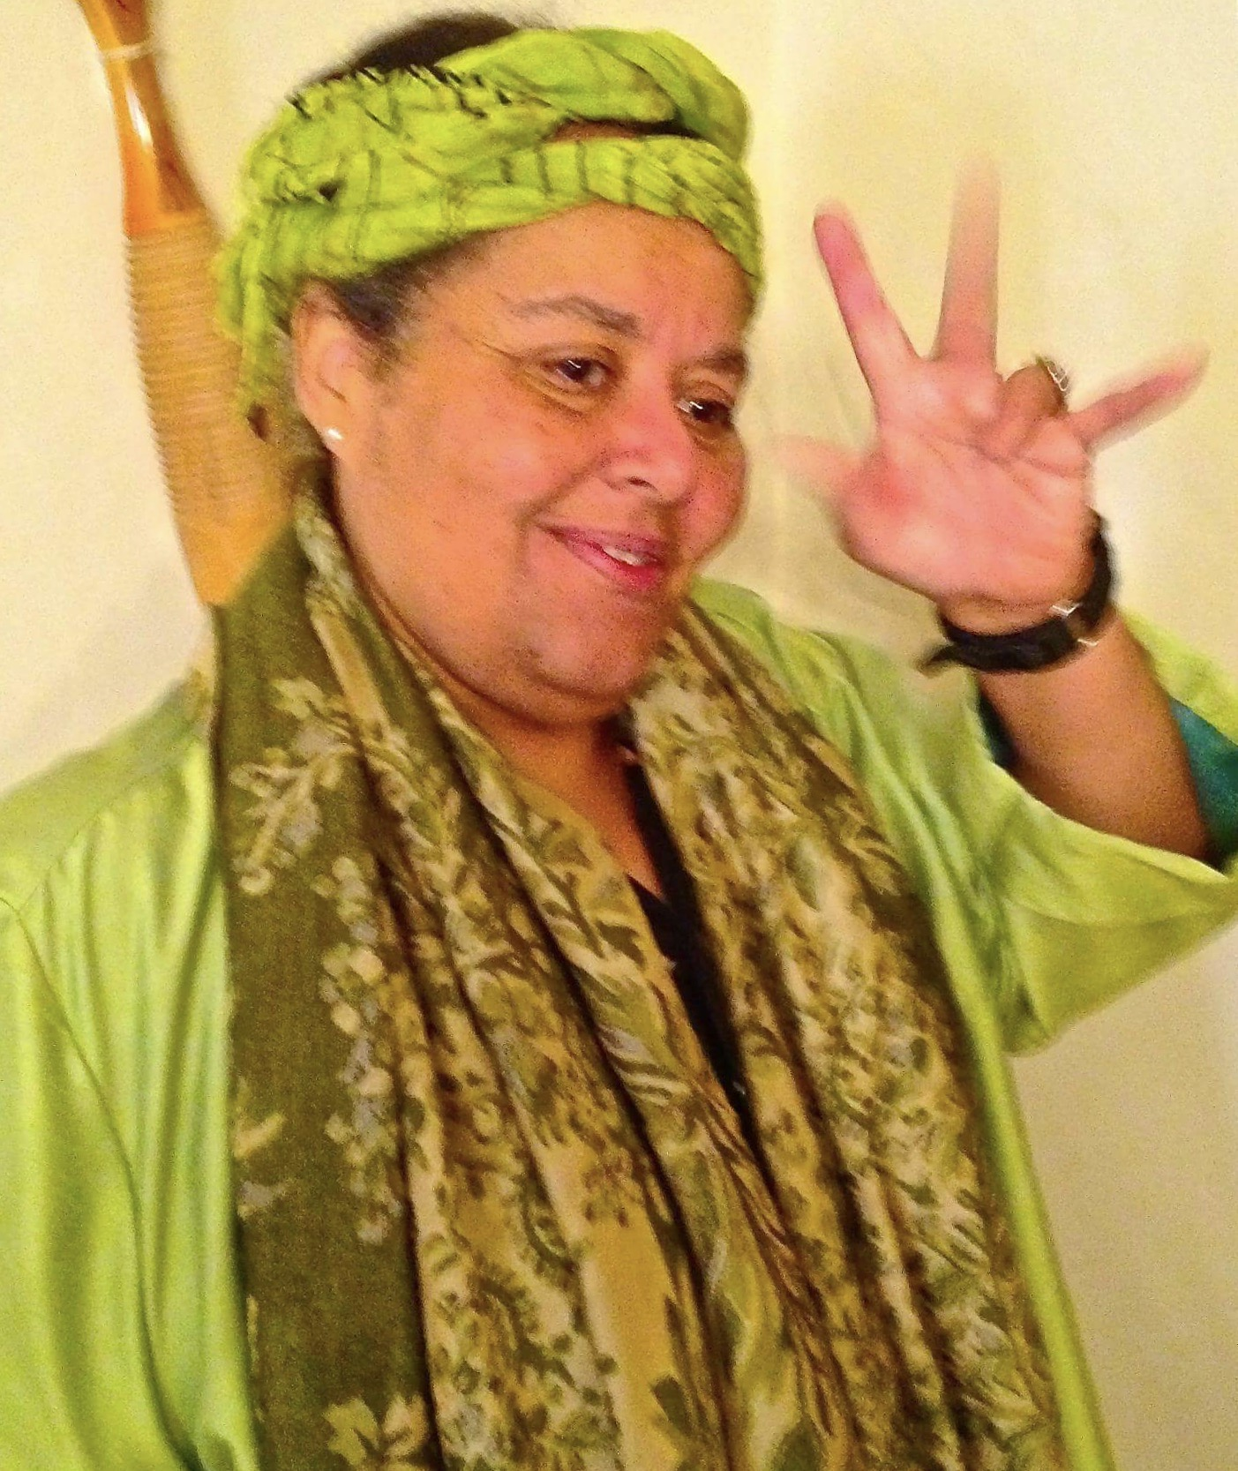
They were true powerhouses in the library movement, an inspiration to everyone who had the privilege of knowing them. Their lifelong commitment to justice and equity shaped every space they entered as strong women of color. Through their service on local and national library committees, they worked to influence policy, expand access, and insist on equity as a core professional value.
Their work was never simply procedural; it was a deliberate challenge to the systemic inequities that continue to disproportionately affect marginalized communities. Their contributions are not relics of the past. Their legacy actively shapes our present and future as librarians, both current and retired, dedicated to social justice, to building bridges across generations, and to transforming our institutions.
Our responsibility now is to carry their work forward with intention, ensuring that diverse voices are not only heard, but uplifted, centered, and shared.

ABOUT VIVIAN
LIRT(Library Instruction Roundtable News), Sept., 1991, Vol. 14, No.1 “1992 (In Conference Program Committee by Cindy Cunningham, p. 6)
“Four librarians, representing school, academic, and public libraries, described instruction/outreach programs which are now being used or have been used with culturally diverse clientele”
LIRT, March, 1993, Vol.15, No.3 (in ACRL-BIS Discussion Forum: Teaching Diverse Populations: Do We Need to Change? Sunday, Jan 24, 1993, 2:00 pm)
“Vivian Sykes discussed methods such as storytelling and honor, that would personalize instruction, and that to understand that no one has all the answers”
Flagg, Gordon “Leading the Way in Outreach: Vivian Sykes Profiled: University of California/Santa Cruz’s Mulitcultural Services Librarian.” American Libraries 20 (1989): (Also cited in: BIBLIOGRAPHY OF THE HISTORY OF LIBRARIES IN CALIFORNIA, 1973-2003 by Suzanne M. Stauffer, Ph.D, p. 180)
Bob’s World: Where wonders never cease…Online Autobiography, Bob Diaz, ”My Life Story:1988”, July 31, 202. https://bobdiaz.net/2021/07/
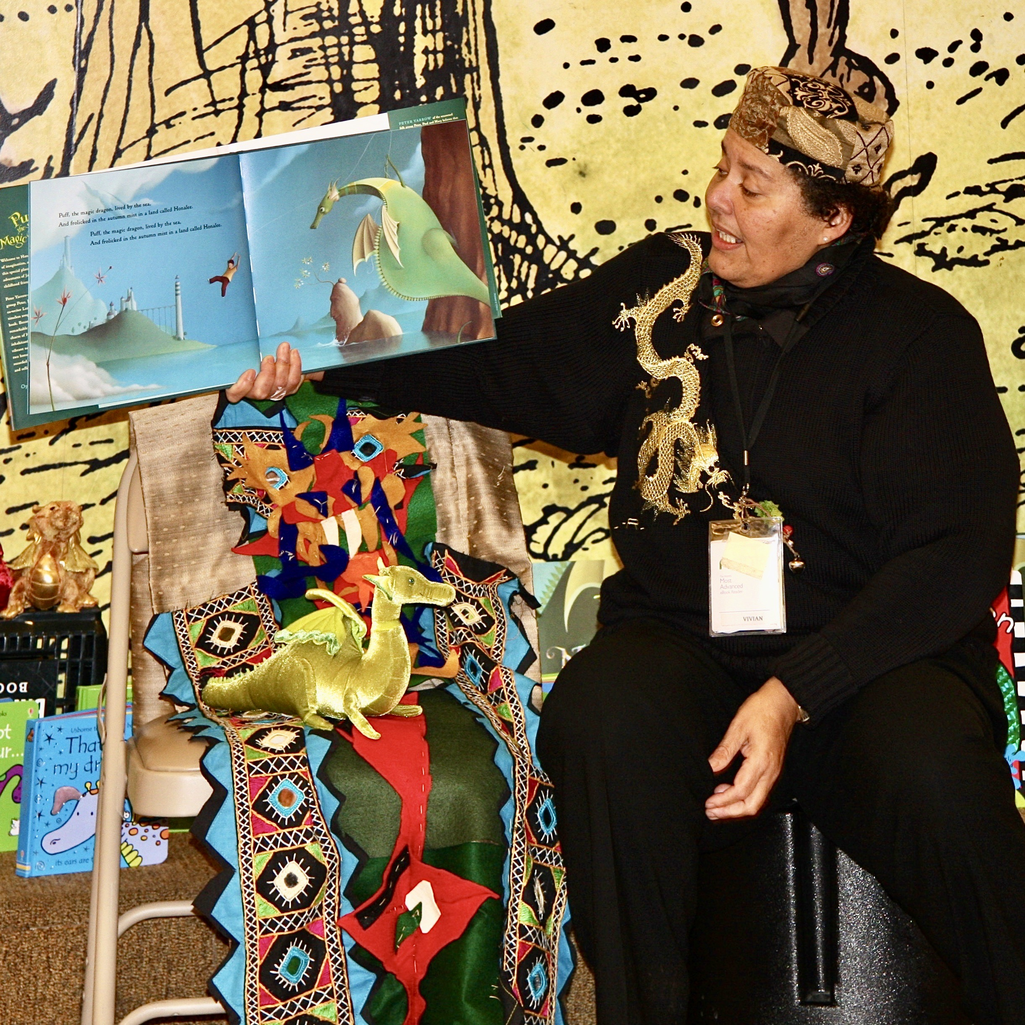
“A couple of weeks after we received the initial training, Dr. Kendall was brought in again and gave an all-staff presentation on the issue of racism and the challenges of overcoming it. Another person, Vivian Sykes, an African American librarian from San Francisco, also spoke about her personal experiences with racism in librarianship. Both presentations were hard hitting, and it left a lot of the nearly all-white staff feeling very uncomfortable. Once the presentations were given, the staff was then required to participate in a series of small group discussions, and I, as one of the group facilitators, helped to lead these. “
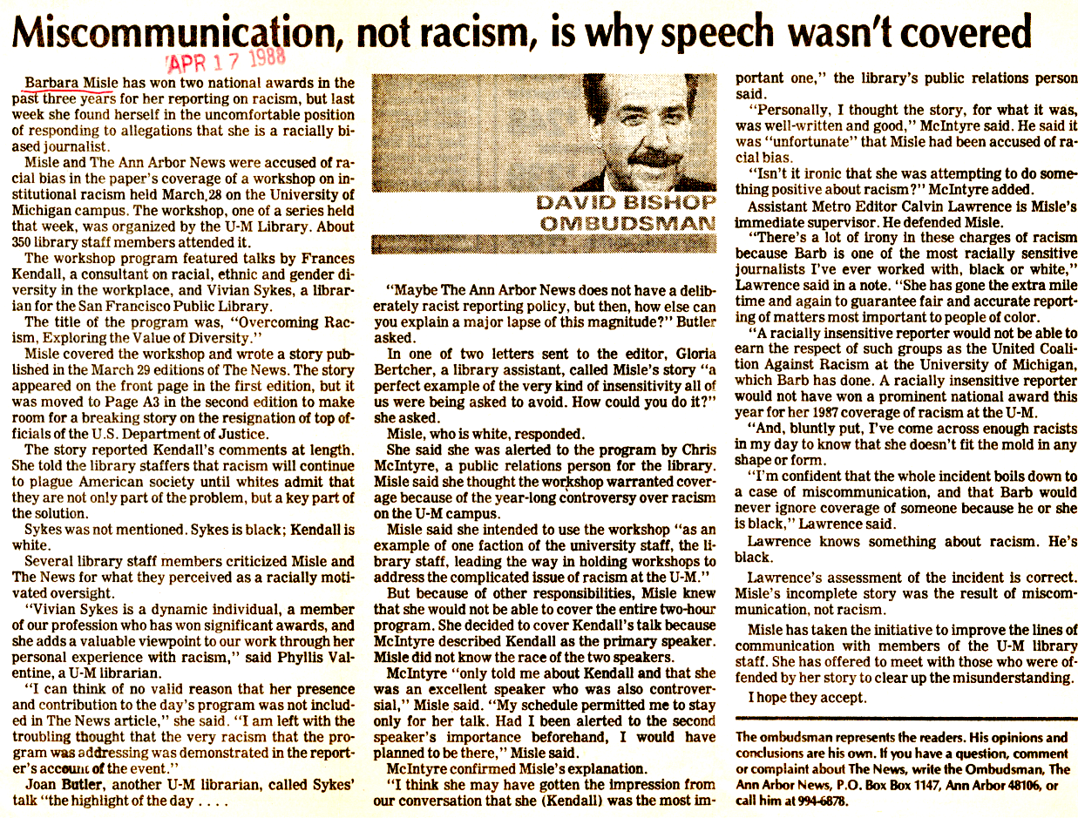
Article available online at
https://aadl.org/aa_news_19880417-miscommunication_not_racism_is_why_speech_wasnt_covered

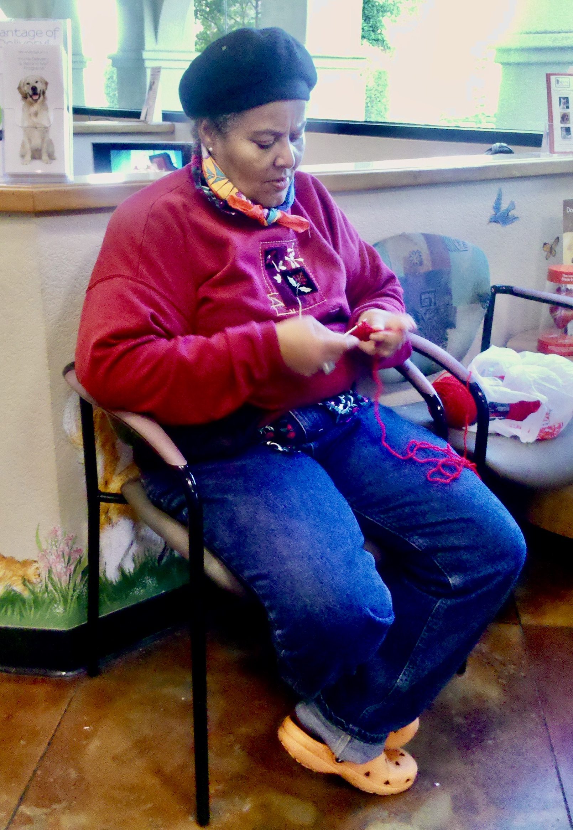

PUBLICATIONS

Sykes, Vivian. “Perspectives on Cultural Diversity” in Cultural Diversity in Libraries, ed. by Donald E. Riggs and Patricia A Tarin. Neal Schuman, c1994.

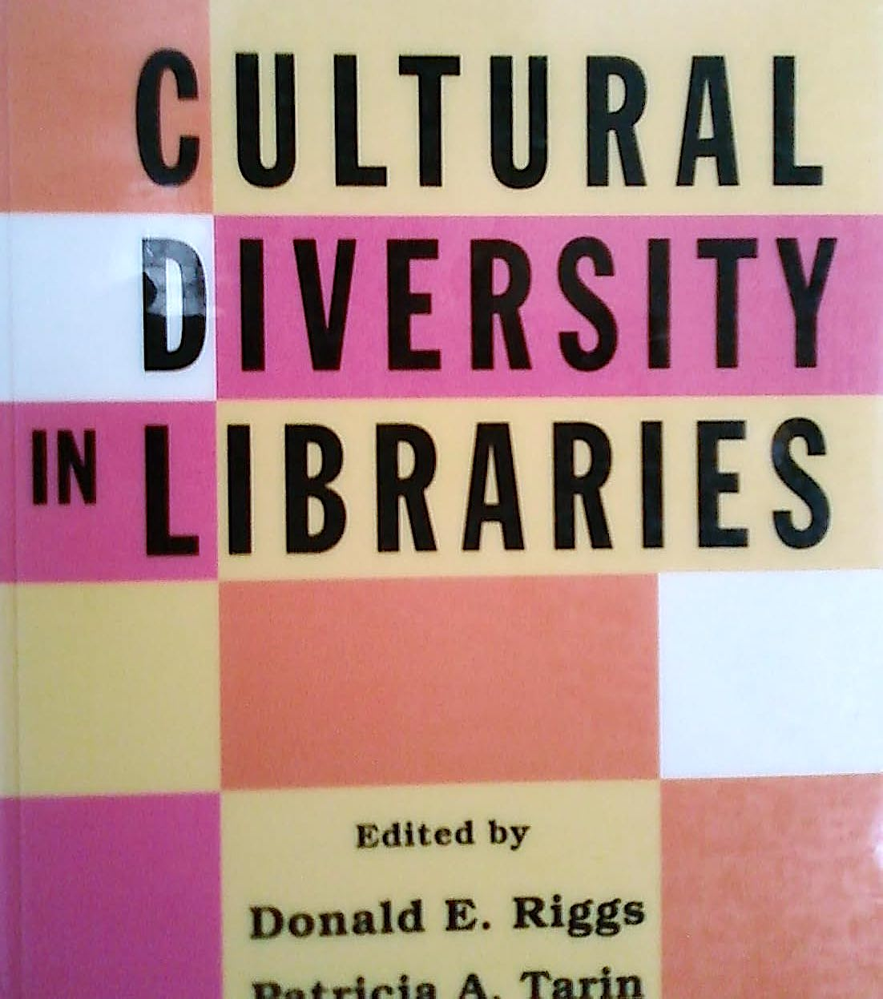

PERSONAL TRIBUTE by Sandra Ríos Balderrama
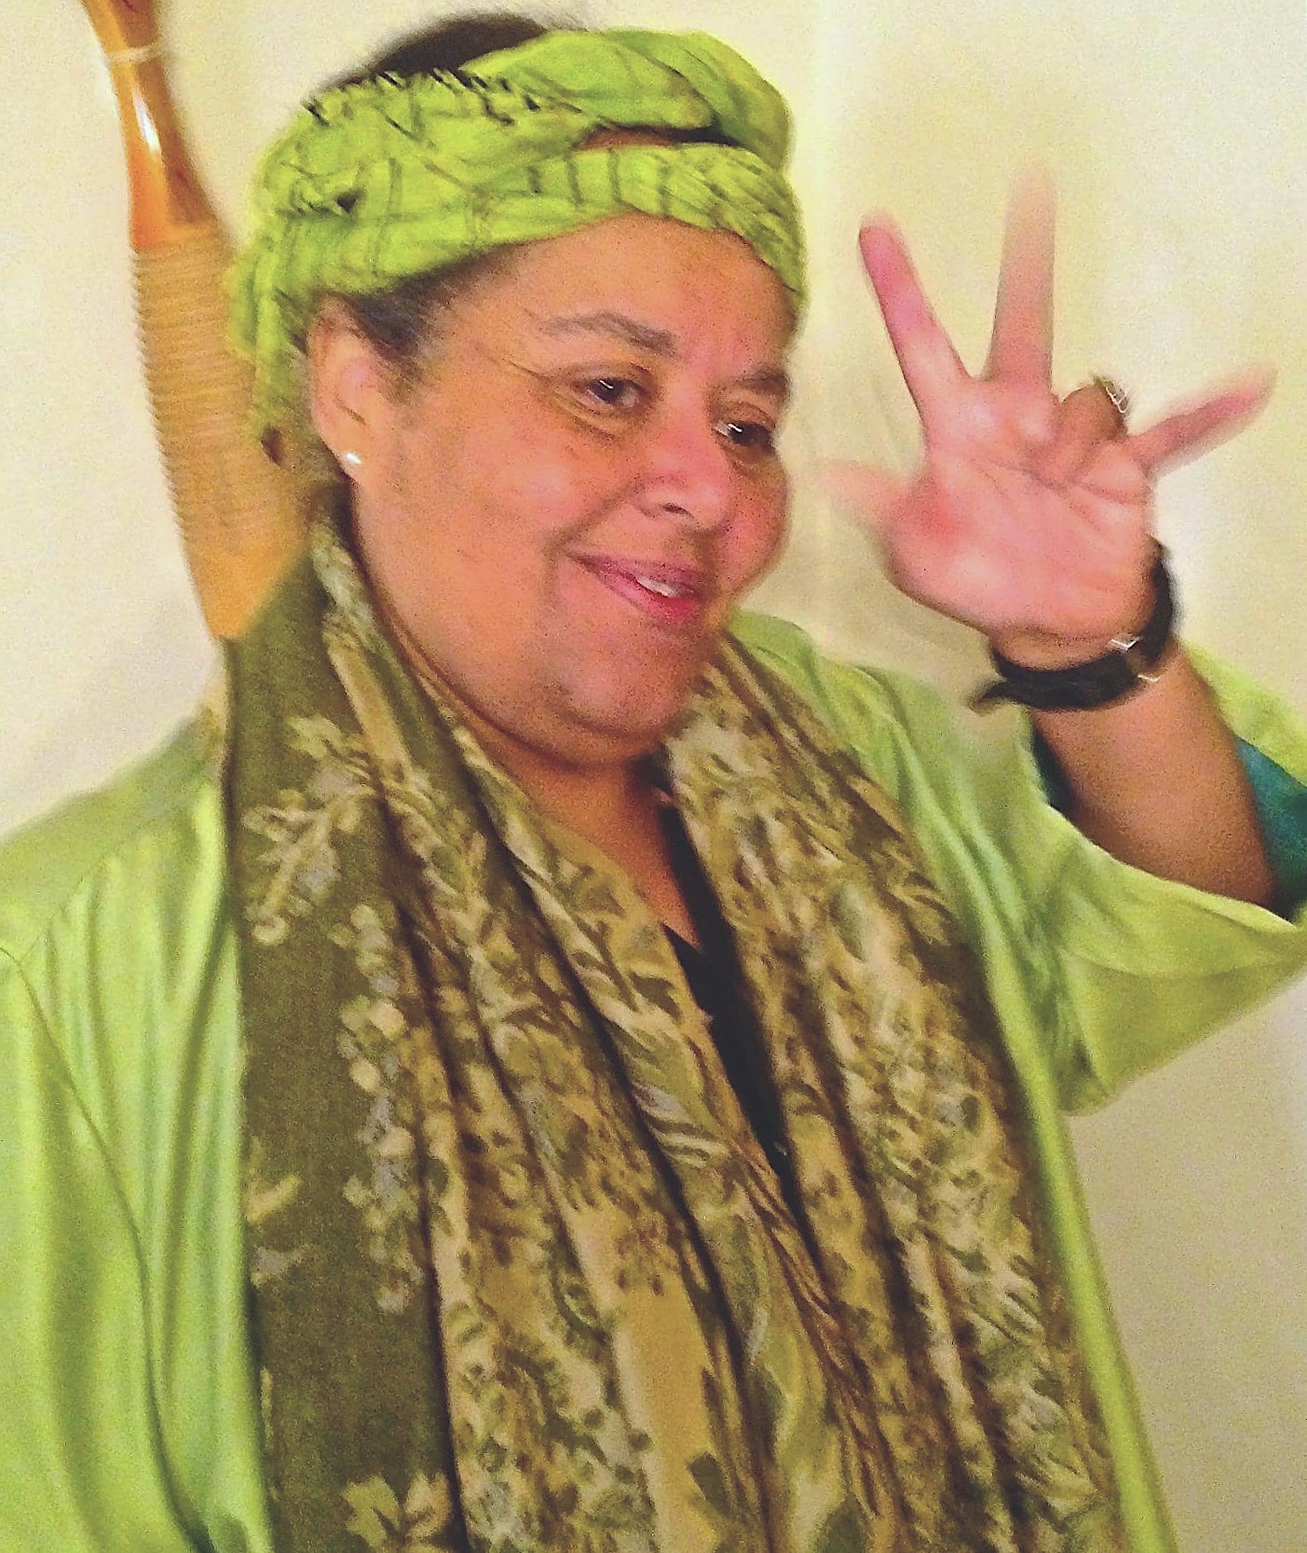
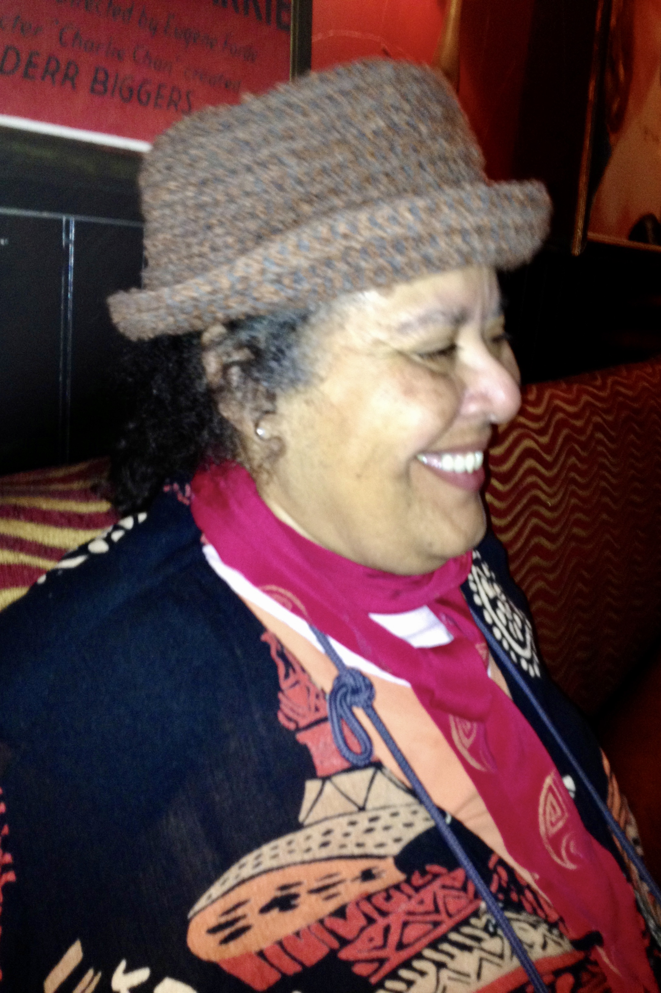
Vivian embodied HEART - the global drum beat that is our shared mother. She celebrated colors, textures, and sounds by what she wore, how she spoke, and how she sought and fought to make public and academic libraries inclusive. Ever curious and so well studied - I used to call her “my encyclopedia”— with love and admiration. She was a counter-force in libraries and in life — always pointing to beauty, creativity, affirmation and pride of our own heritage, colors, cultures, contributions and stories. She viewed our stories as part of the world and thus, they must be respected and shared by librarians and library workers, in order for library institutions to be relevant, real, true and to be safe spaces for all of us to be and become.
Vivian didn’t write much in library journals and books because she lived and worked in real time. She loved nature, adventure, art, films and was proud of her Caribbean, Black/African-American, Indigenous, & Jewish heritage. Many times when I was with her — people would ask “What are you?”
I think Viv was other-worldly. Only here for a little while.
Such an extraordinary gift she was. Such gifts she has left behind.

