W. David Rozkuszka (1943–1997)

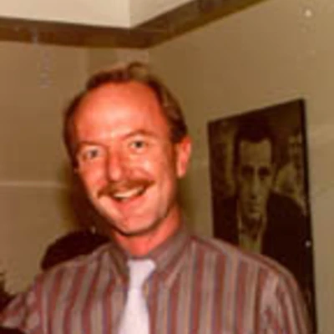

W. David Rozkuszka (1943–1997) was an academic librarian specializing in government documents, particularly foreign and international official publications. His career at Stanford University Libraries left a lasting institutional legacy through the exceptional collections he developed, and his memory endures nationally through the GODORT scholarship established in his name to support future generations of documents librarians.
W. David Rozkuszka was born August 21, 1943, in Ludlow, Massachusetts. He earned a BA degree at Loyola University, Chicago in 1965 and a master’s degree from Syracuse University in 1967.
Rozkuszka joined Stanford University Libraries in 1967 and spent his entire professional career there until retirement.
His career at Stanford University Libraries included positions focused on government information:
· Foreign documents librarian
· Head (director) of the Jonsson Library of Government Documents
· International documents librarian
· African and Middle Eastern bibliographer

He presented on the topic,” “Subnational Official Publications: Problems and Prospects at the 1988 SALALM Conference and on the topic of “Government Publishing in the Third World at the Second Annual International Studies Conference (1990).
He retired in February 1994 and was honored with the title, Librarian Emeritus. His most significant achievement was the systematic development of Stanford’s foreign and international government documents collections, which became among the strongest in the United States.
A colleague recalled that “David’s legacy to Stanford was building one of the finest foreign documents collections in the U.S.” A Stanford history professor specifically praised Rozkuszka’s work on British materials, noting that he had developed “maybe the best collection of British government documents in the world.”
His expertise extended to acquisitions and bibliographic control of official publications from Europe, Latin America, Africa, and the Middle East. He was particularly active in professional networks supporting these areas, including membership in the Association of College & Research Libraries (ACRL) Western European Studies Section and the Seminar on the Acquisition of Latin American Library Materials (SALALM).
Rozkuszka was an engaged member of the American Library Association’s Government Documents Round Table (GODORT). His work aligned with the round table’s mission of improving access to, preservation of, and bibliographic control over government information. His practical impact through collection development and quiet advocacy for foreign documents made him a respected figure in the community.
The most visible and ongoing tribute to Rozkuszka is the W. David Rozkuszka Scholarship, established in 1994 by GODORT in his memory. It provides funds annually to an individual who is currently working with government documents (or government information) in a library and is pursuing or completing a master’s degree in library science. The scholarship was created to honor Rozkuszka’s commitment to the field and to support emerging professionals—especially those already gaining practical experience in documents work. It continues to be awarded each year at the ALA Annual Conference, with recipients selected for their interest in government documents librarianship. Funding has been supplemented over time through bequests (including from Rozkuszka himself), silent auctions, and donations from GODORT members.
The scholarship’s criteria explicitly reflect Rozkuszka’s own path: supporting practicing documents staff who seek formal library education. It has helped dozens of students over nearly three decades and remains one of GODORT’s core awards, directly tying his name to the future of the profession he served.
Rozkuszka’s service work on the Stanford Committee for Land and Building Development ensured architectural integrity within the University and adherence to the vision of the early builders. Maintaining vistas was of particular importance to David, and many a Stanford tree owes its location to David's insistence that no vista be blocked.
W. David Rozkuszka’s legacy is one of quiet excellence in collection development and mentorship through example. At Stanford, his work enriched the Jonsson Library of Government Documents and continues to benefit researchers in history, political science, international relations, and area studies. Nationally, the scholarship ensures that his commitment to government information lives on by lowering financial barriers for the next generation of documents librarians. In an era of rapidly changing formats (from print to digital), his emphasis on comprehensive, high-quality international collections remains a model for specialized government information services.

Selected Publications

Rozkuszka, W. David. “Government Publications.” In Collection Management: A New Treatise, edited by Charles B. Osburn and Ross Atkinson. Foundations in Library and Information Science 26. Greenwich, CT: JAI Press, 1991.
Rozkuszka, W. David. “Status of Government Documentation and Publishing in the Third World.” Government Publications Review 19, no. 1 (January–February 1992): 3–9.
Rozkuszka, W. David. British Public Record Office Archival Material at Stanford University: With Appendices for UC/Berkeley and Selective U.S. Libraries. Guide to Government Publications Series. Stanford, CA: Stanford University Libraries, Jonsson Library of Government Documents, 1994.

Sources
American Library Association. “GODORT David W. Rozkuszka Scholarship.” ALA.org. Accessed July 4, 2026.
Eckman,Chuck. “In Memoriam: David Rozkuszka.” DttP: Documents to the People 25 (1997): 57. HathiTrust Digital Library.
Latta,Ann. “In Memorium--W. David Rozkuszka.” Stanford University Libraries. SUL News Notes, vol. 6, no. 4 ( January 31, 1997 )
Spiegel, Pam. “People in the News.” College & Research Libraries News.
“W. David Rozuska, Stanford librarian, dead at 53.” ProQuest Trade Journals.

Submitted by GODORT Member -KMc

