A. Robert Rogers – 1927- 1985

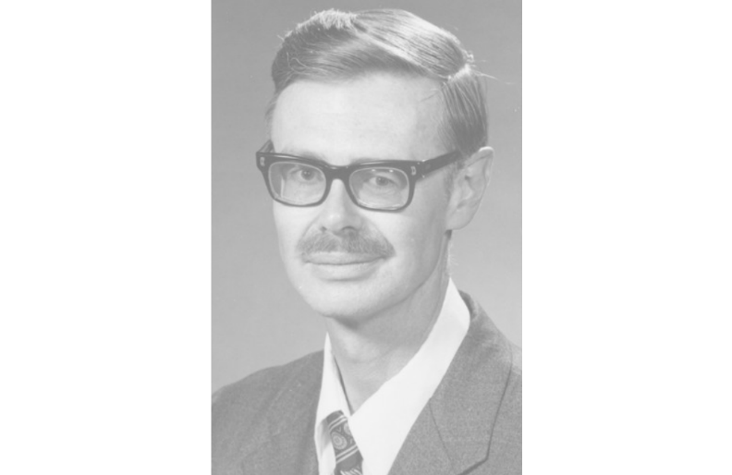

A. Robert Rogers (Amos Robert Rogers, 1927–1985) was a Canadian-born librarian, library educator, scholar, poet, and administrator best known for his leadership as Dean of the School of Library Science at Kent State University (now Kent State University School of Information) and his contributions to international librarianship, particularly studies of libraries in the Soviet Union, Iran, and Hungary.

Amos Robert Rogers was born September 9, 1927, in Berry Mills (near Moncton), New Brunswick, Canada. He grew up on a family farm and attended a one-room schoolhouse before graduating from Moncton High School in 1944.

He entered the University of New Brunswick (UNB) in Fredericton as a Beaverbrook Scholar. He earned a B.A. in 1948 in philosophy and history, along with the Governor General’s Gold Medal for greatest proficiency. He also won prizes including the Bliss Carman Memorial Poetry Prize. While at UNB he edited the literary magazine The Fiddlehead (1947–48 and 1951–53).

Rogers continued his studies with an M.A. in philosophy from the University of Toronto in 1950. On a Beaverbrook Overseas Scholarship, he earned an Academic Post-Graduate Diploma in Librarianship from the University of London in 1953; his thesis was a bibliography of New Brunswick writers, Books and Pamphlets by New Brunswick Writers, 1890–1950.

He later completed a Ph.D. in Library Science at the University of Michigan in 1964. His two-volume dissertation, American Recognition of Canadian Authors Writing in English, 1890–1960, examined U.S. perceptions of Canadian literature through library catalogs, curricula, anthologies, reviews, and prizes.

Rogers began his professional career as assistant librarian (1951–55) and then executive librarian (1955–56) at the University of New Brunswick, Harriet Irving Library. He served as acting Secretary of the New Brunswick Library Association (NBLA).
He promoted the development of regional libraries through speeches, letters, and advocacy efforts. These activities contributed to the opening of a community library in Centreville, New Brunswick.

He worked as an adult assistant at the Detroit Public Library (1957–59).

In 1959 he joined Bowling Green State University (BGSU) Library in Ohio as assistant to the director; he became acting director in 1961 and director in 1964, serving until 1969.
During his tenure he oversaw planning and construction of a major new library building (completed in the mid-1960s).

He became a naturalized U.S. citizen on November 18, 1965.

In fall 1969 Rogers joined the faculty of the School of Library Science at Kent State University in Kent, Ohio.

He was an active member of the Ohio Library Association and received two notable honors:
- “Article of the Year” award in 1973 for his article “Some Impressions of Three Russian Libraries” (published in the Ohio Library Association Bulletin).
- Librarian of the Year Award in 1976.

He served as a member of the American Library Association Council from 1972 to 1976.

He was promoted to professor at Kent State University and served as Dean from 1977 until his death in 1985. As dean he strengthened the program’s national reputation, particularly in integrating technology into library education, and was known for innovative teaching methods.

Rogers made significant contributions to international librarianship. He visited the Soviet Union in 1973 (studying major libraries in Moscow and Leningrad) and published influential articles including “Some Impressions of Three Russian Libraries” and “Censorship and Libraries in the Soviet Union” (both 1973).

He spent 1976–77 in Iran as a visiting professor at Pahlavi University in Shiraz, where he taught and conducted research on library education, reference services, and school libraries in Fars Province.

He also visited Hungary in 1982 and published on Hungarian libraries; at the time of his death he was planning research in China.

A. Robert Rogers died June 22, 1985, in Ravenna, Ohio.

Selected Publications

Rogers, A. Robert. “Books and Pamphlets by New Brunswick Writers, 1890–1950.” Thesis for the Academic Post-Graduate Diploma in Librarianship, University of London, 1953.

Rogers, A. Robert. “Recent Poets of Fredericton.” Maritime Advocate and Busy East 44, no. 7 (March 1954): 11–19.

Rogers, A. Robert. The White Monument. Ryerson Poetry Chapbooks, no. 160. Toronto: Ryerson Press, 1955.

Rogers, A. Robert, and Arturs Baumanis. “Soviet Classification and Cataloging.” The Library Quarterly 28, no. 3 (July 1958): 172–86.

Rogers, A. Robert. “In Joyful Service: An Appreciation of the Career of Marjorie Thompson.” APLA Bulletin 24, no. 3 (Spring 1960): 56–58, 75.

Rogers, A. Robert. “American Recognition of Canadian Authors Writing in English, 1890–1960.” Ph.D. dissertation, University of Michigan, 1964. 2 vols.

Rogers, A. Robert. “Some Impressions of Three Russian Libraries.” Ohio Library Association Bulletin 43 (1973): 4–10.

Rogers, A. Robert. “Censorship and Libraries in the Soviet Union.” Journal of Library History, Philosophy, and Comparative Librarianship 8, no. 1 (1973): 22–29.

Rogers, A. Robert. “Canadian Literature in American Libraries.” The Library Quarterly 43, no. 1 (January 1973): 1–26.

Rogers, A. Robert. The Humanities: A Selective Guide to Information Sources. Library Science Text Series. Littleton, CO: Libraries Unlimited, 1974. (2nd ed., 1979.)

Rogers, A. Robert. “Report on Six-Year Programs in the United States.” Journal of Education for Librarianship 15 (1975).

Rogers, A. Robert, and Ali A. Emdad. “Library Use at Pahlavi University.” College and Research Libraries 39, no. 6 (November 1978): 448–55.

Rogers, A. Robert, Nooshin Mehdizadeh, et al. “School Libraries in Fars Province, Iran” [also cited as “Libraries in Shiraz, Iran”]. International Library Review 10 (1978): 77–91.

Rogers, A. Robert, and Mahvash Keshmiri. “Education for Librarianship at Pahlavi University, Shiraz, Iran.” International Library Review 11 (1979): 259–67.

Rogers, A. Robert. “Glimpses of Some Hungarian Libraries and Library Schools.” International Library Review 15 (1983): 307–14.

Rogers, A. Robert, and Kathryn McChesney. The Library in Society. Library Science Text Series. Littleton, CO: Libraries Unlimited, 1984.

- Early poetry contributions (1940s–early 1950s) appeared in journals such as The Fiddlehead, Imagi, The Albatross, and Alberta Poetry Yearbook, though specific titles and dates for many individual poems are scattered.

Sources

Belier, Patricia L. “Amos Robert Rogers.” New Brunswick Literary Encyclopedia. University of New Brunswick. Accessed via nble.lib.unb.ca. Fall 2010.

Kent State University. “History.” School of Information.

Kent State University Libraries. Special Collections and Archives. “Rogers, A. Robert.”

Linderman, Eric Graham. “A. Robert Rogers and International Librarianship.” Master’s research paper, Kent State University, 1998. ERIC ED423915. Accessed July 7, 2026.

Linderman, Eric G. “A. Robert Rogers: The Influence of His Canadianism on His Work as a Library Educator.” Libraries & Culture 35, no. 4 (Fall 2000): 499–513.

Rogers, A. Robert. Papers. Special Collections and Archives, Kent State University Libraries, Kent, Ohio.

Wynar, L.R. “In Memoriam. A. Robert Rogers, September 9, 1927 – June 22, 1985.” Ethnic Forum 5 (Fall 1985): 146.

Submitted by ALA Member

