Noel Peattie- 1932-2005

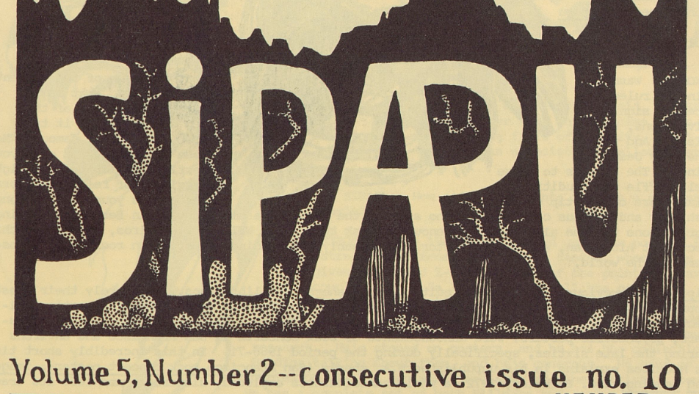
Header from the cover of SIPAPU, Pettie’s newsletter that reviewed small-press, counterculture, underground, and alternative literature for the library community

Noel Roderick Peattie (1932–2005) was an American librarian, poet, small-press publisher, and advocate for intellectual freedom and alternative literature. His work bridged library science, countercultural publishing, and poetry, reflecting deep commitments to social justice, the “inner life,” and access to dissenting voices.
Peattie was born on November 28, 1932, in Menton, France, to naturalist and author Donald Culross Peattie and author Louise Redfield Peattie. The family immigrated to the United States in 1933; he grew up in Santa Barbara, California. He earned a B.A. in philosophy from Pomona College in 1954 and an M.A. in philosophy from Yale University in 1955. He later obtained an M.L.S. from the University of California, Berkeley, in 1961.
Peattie began his professional career as a cataloging librarian at California State University, Los Angeles (1961–1966). In 1966 he joined the University of California, Davis, where he served as Acquisitions Librarian (and later in humanities roles) until his retirement in 1992. He lived for many years in Winters, California, near Davis.
A longtime member of the American Library Association (ALA) and the California Library Association, Peattie was active in the ALA Social Responsibilities Round Table (SRRT) and the Alternatives in Print Task Force. The Alternatives in Print Task Force (often abbreviated AIP or AIP Task Force) was a subgroup of the American Library Association’s (ALA) Social Responsibilities Round Table (SRRT). It focused on promoting the collection, acquisition, and use of alternative, small-press, progressive, underground, radical, and counter-mainstream publications in libraries.
In 1995 he received the Jackie Eubanks Memorial Award for outstanding achievement in promoting the acquisition and use of alternative materials in libraries.
Publishing and Literary Work
Peattie founded and edited Sipapu, a biannual newsletter (roughly 1969–1993) that reviewed small-press, counterculture, underground, and alternative literature for the library community. It ran for approximately fifty issues over twenty-five years and became a key resource for librarians interested in non-mainstream publishing. He later compiled selections in A Passage for Dissent: The Best of Sipapu, 1970–1988 (McFarland, 1989).
His writings include:
- Co-authoring A Cup of Sky (Houghton Mifflin, 1950) with his father.
- The novel Amy Rose: A Novel in Four Parts (Regent Press, 1995), an erotic work featuring a woman librarian.
- Hydra and Kraken; or, The Lore and Lure of Lake-Monsters and Sea-Serpents (Regent Press, 1996).
- Co-authoring The Freedom to Lie: A Debate about Democracy with John Swan (McFarland, 1989).
- Essay collection Inner Life; or, The Politics of Daydreaming (with Notes from the Dreamer) (Regent Press, 2005).
- Several poetry collections published by Regent Press: Western Skyline (1995), In the Dome of Saint Laurence Meteor (1999), King Humble’s Grave (2001), Sweetwater Ranch (2003), and the posthumous The Testimony of Doves (2005).
Peattie’s poetry often evoked rural life, nature, and reflection; his prose addressed censorship, democracy, intellectual freedom, and the importance of the inner life amid modern pressures. He also contributed to other works, such as cartoons in Nuke (McFarland, 1988). His papers (1972–2002), held at UC Davis, include correspondence with figures like poet Gary Snyder.
A Quaker (member of the Society of Friends) and Democrat, Peattie enjoyed sailing, printing, and the company of cats. He once humorously compared library functions to a cat’s behavior in the pages of Sipapu. He valued silence, solitude, and the right to one’s own thoughts, arguing that demands for freedom, justice, and a better world ultimately rest on protecting the “inner life.”
Peattie died January 13, 2005, in Davis, California.
Colleagues remembered him as a witty, gracious, and principled figure—a model for librarians committed to alternative voices and intellectual freedom. A memorial service was planned with his Quaker meeting and family, including nephew David Peattie. His books remained available through Regent Press, and his influence persists in library circles focused on social responsibility and small-press collecting.

Selected Publications.
Peattie, Noel, and Donald Culross Peattie. A Cup of Sky. Boston: Houghton Mifflin, 1950.
Peattie, Noel, ed. Sipapu. Biannual newsletter, ca. 1969/1970–1993. (Review of small-press and counterculture literature for the library profession; issued from the Davis, California area.)
Peattie, Noel. 1975. The Living Z : A Guide to the Literature of the Counter-Culture, the Alternative Press, and Little Magazines. [Place of publication not identified]: [Margins].
Dodson, Bert. Nuke: A Book of Cartoons. Contributions by Noel Peattie. Jefferson, NC: McFarland, 1988.
Peattie, Noel, comp. A Passage for Dissent: The Best of Sipapu, 1970–1988. Jefferson, NC: McFarland, 1989.
Peattie, Noel, and John Swan. The Freedom to Lie: A Debate about Democracy. Jefferson, NC: McFarland, 1989.
Peattie, Noel. Amy Rose: A Novel in Four Parts. Oakland: Regent Press, 1995.
Peattie, Noel. Western Skyline: New Poems. Oakland: Regent Press, 1995.
Peattie, Noel. Hydra and Kraken; or, The Lore and Lure of Lake-Monsters and Sea-Serpents. Oakland: Regent Press, 1996.
Peattie, Noel. In the Dome of Saint Laurence Meteor. Oakland: Regent Press, 1999.
Peattie, Noel. King Humble’s Grave: New Poems. Oakland: Regent Press, 2001.
Peattie, Noel. Sweetwater Ranch: New Poems. Oakland: Regent Press, 2003.
Peattie, Noel. Inner Life; or, The Politics of Daydreaming (with Notes from the Dreamer). Oakland: Regent Press, 2005.
Peattie, Noel. The Testimony of Doves: New Poems. Oakland: Regent Press, 2005.

Sources
American Library Association. Social Responsibilities Round Table. “SRRT Resolutions 2005: In Loving Memory of Noel Peattie.” Accessed July 21, 2026. [Full Memorial below Sources].
American Library Association. “SRRT - Alternative Media Task Force
American Library Association. “Highlights of SRRT History.”
Bundy, Mary Lee, and Frederick J. Stielow, eds. 1987. Activism in American Librarianship, 1962-1973. New York: Greenwood Press.
Dodge, Chris. “Remembering Noel Peattie.” librarian.net, January 13, 2005.
“Noel Peattie Papers, 1972-2002.” Online Archive of California.
“Peattie, Noel 1932–2005.” Encyclopedia.com. Accessed July 21, 2026.
“Noel Peattie.” Library Journal, February 15, 2005, 21.
Noel Peattie, obituary, Sacramento Bee, March 6, 2005.

********************************************************************
In Loving Memory of Noel Peattie
Text of 205 SRRT resolution, adopted at ALA Midwinter, in loving memory of Noel Peattie.
Adopted at 2005 Midwinter Meeting.

WHEREAS we remember the librarian, the advocate of social responsibilities, the author:
A Cup of Sky, co-authored with his father, Donald Culross Peattie (1898-1964). Boston: Houghton Mifflin, 1950.
Sipapu, 1969-1993, 14 linear ft., UC Davis Library,
A Passage for Dissent: the best of “Sipapu” 1970-1988, Jefferson NC: McFarland & Co, 1989.
The Freedom to Lie: a debate about democracy, with John Swan, Jefferson NC: McFarland & Co, 1989.
Western Skyline: new poems, Oakland: Regent Press, 1995.
Amy Rose: a novel in four parts, Oakland: Regent Press, 1995.
Hydra & Kraken: Or, the Lore and Lure of Lake-Monsters and Sea-Serpents, Oakland CA: Regent Press, 1996.
In the Dome of Saint Laurence Meteor, Oakland: Regent Press, 1999.
King Humble's Grave, Oakland: Regent Press, 2001.
Sweetwater Ranch: new poems, Oakland: Regent Press, 2003.
And WHEREAS we remember the host who kept our wine glasses and our conversations full:
And WHEREAS we remember the man who answered the question, “What kind of society do you want, anyhow?”
“The answer I propose is: that the society I desire, and which, on a universalizing principle, I want for all, is a society which protects, promotes, and honors the inner life.
I would further suggest, is that the demands, heard from pole to pole, for freedom, justice, security, equality, education, a safe environment, and a better life for the world's children,—are all grounded in, and reach downward to, this elemental human need: silence, solitude, and the right to rule one's own thoughts: the sanity of the inner life.
And Finally: this inner life, I contend, is an endangered species: assaulted without, and subject to disease within.”
And WHEREAS we remember the lover of cats:
“Before we leave the library world, we recollect our long-held belief that a library, and the library profession, find their analogy in our cat. The brain of the cat directs him to go out and find a mouse: this is Administration. He perceives, by sight, sound, and smell, the mouse: this is Collection Development. He catches the mouse: this is Acquisitions. He digests the mouse: this is Cataloging and Serials. He comes in and tells us about the mouse: this is Reference. He curls up in a ball and enjoys the mouse: this is Circulation. Finally, later on, he produces, for the out-of-doors, an Annual Report, which no one wants to see. So he buries it. However, he loves, and expects, regular supplies of goodies, and adores being brushed and cuddled and told how beautiful he is. And he has no morals, no politics, and no religion.” Sipapu v.23, no. 2, 1993, p. 12
And WHEREAS we remember the poet:
The Way to Get Through Life
is to try! yes, how?
to forget
most of it.
Like, all the years at school,
(but not the lifelong friends,
then, the weekends that were joy;
city adventures);
and rather hope for, much later:
vast witty banquets;
at which you'll be honored
—poems of a lifetime!—
under glittering chandeliers.
And welcome: all goings to bed:
even those
alone:
except the last,
except the last.
—The Testimony of Doves, forthcoming

Submitted by ALA Member

