Andre Norton- 1912 – 2005
Submitted as the 500th tribute to “Librarians We Have Lost” by Carolyn Caywood

Andre Norton, the first woman to be Gandalf Grand Master of Fantasy,[ to be SFWA Grand Master, and to be inducted by the Science Fiction and Fantasy Hall of Fame was a librarian in the Cleveland Library System for 18 years.

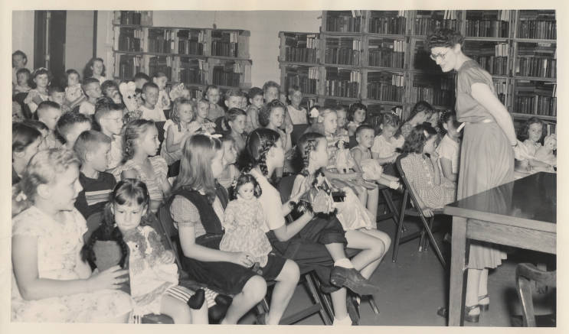



Andre Norton bibliography

Sources
Don Boozer, host. “The Imaginative History of Andre Norton.” Featuring Jeff Karem. Page Count. Cleveland Public Library, April 21, 2026. Podcast.
Meg Metcalf. “Andre Norton: The Librarian Who Changed Science Fiction.” Headlines & Heroes (blog), Library of Congress, July 23, 2024.
Ruane, Therese. “NORTON, ANDRE.” Encyclopedia of Cleveland History. Case Western Reserve University. Accessed July 14, 2026. https://case.edu/ech/articles/n/norton-andre/.

Submitted by Carolyn Caywood, recipient of the 2006 Freedom to Read Foundation (FTRF) Roll of Honor Award.

