William Gerard Noel- 1965-2024

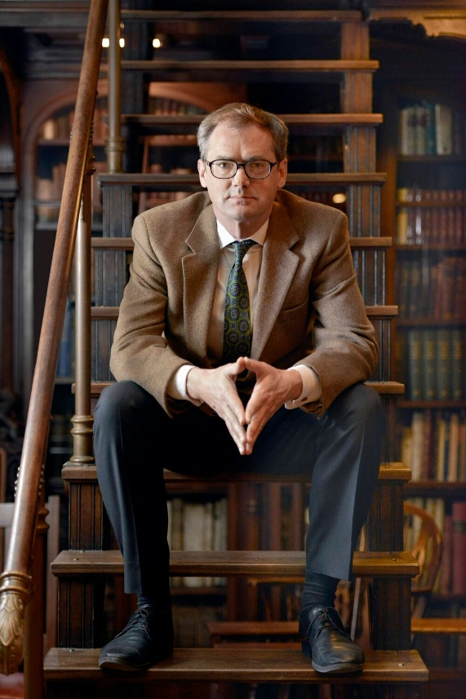

William Gerard Noel (August 1, 1965 – April 29, 2024), commonly known as Will Noel, was a British-born archivist, librarian, curator, and scholar renowned for his expertise in medieval manuscripts, his work in the digital humanities, and his advocacy for open access to cultural heritage collections.
He held prominent leadership positions at major U.S. institutions, most notably leading groundbreaking projects like the Archimedes Palimpsest recovery and advancing digitization efforts at the Walters Art Museum, University of Pennsylvania, and Princeton University.
Dr. Noel
was a member of the Rare Books and Manuscripts Section (RBMS) of the Association of College and Research Libraries (ACRL), a division of the American Library Association which focuses on rare books, manuscripts, and special collections librarianship.
Born in Bradford, United Kingdom, Noel attended Marlborough College. He then studied at the University of Cambridge (Downing College), earning a B.A., M.A., and Ph.D. in art history with a specialization in medieval studies. His doctoral dissertation, “The Making of BL. Harley Mss. 2506 and 603,” explored scriptorium practices and illustrated textual transmission in the Middle Ages. After completing his Ph.D. in 1992 he served as a British Academy Postdoctoral Research Fellow.

Dr. Noel began his curatorial career in the United States as Assistant Curator of Manuscripts at the J. Paul Getty Museum in Los Angeles. He later returned briefly to Cambridge before taking the position of Curator of Manuscripts and Rare Books at the Walters Art Museum in Baltimore (starting around 1997). There, he became a leader in digitizing medieval manuscripts and making them freely available online to the public.
In 2012, he joined the University of Pennsylvania Libraries in several key roles: Director of the Kislak Center for Special Collections, Rare Books, and Manuscripts; Founding Director of the Schoenberg Institute for Manuscript Studies; and Associate Vice Provost for External/Strategic Partnerships.
He developed OPenn, an innovative open-access portal aggregating digitized collections from Penn and other Philadelphia-area institutions (including the Free Library of Philadelphia, Philadelphia Museum of Art, Haverford, and Swarthmore). He also chaired the Philadelphia Consortium of Special Collections Libraries (PACSCL) from approximately 2018–2022.
In March 2020, Noel was appointed the inaugural John T. Maltsberger III ’55 Associate University Librarian for Special Collections at Princeton University Library. In this role, he drove major transformations: expanding digitization (including ~1,700 Islamic-world codices and advanced multispectral imaging), championing acquisitions that emphasized diversity and inclusion (such as a rare 11th-century Hebrew-Arabic dictionary, African American historical newspapers, and works by Jacob Lawrence), and shaping engaging exhibitions and public programs at the Milberg Gallery (e.g., on Toni Morrison and global activism).
He was an active faculty member at the Rare Book School at the University of Virginia, co-teaching courses on medieval manuscripts and fifteenth-century books.

Archimedes Palimpsest Project.

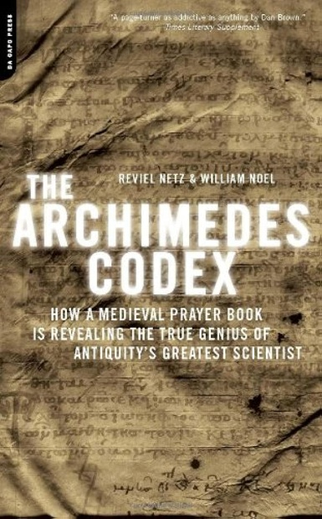

Noel’s most celebrated achievement was directing the international Archimedes Palimpsest Project. This collaborative effort used advanced imaging technologies (including multispectral imaging and X-ray fluorescence at facilities like Stanford’s synchrotron) to recover erased texts by the ancient Greek mathematician Archimedes from a 13th-century Byzantine prayer book palimpsest.
The project revealed unique treatises such as The Method and Stomachion. He co-authored the book The Archimedes Codex: How a Medieval Prayer Book Is Revealing the True Genius of Antiquity’s Greatest Scientist (2007) with Reviel Netz. The work earned the Neumann Prize from the British Society for the History of Mathematics and was the subject of his widely viewed 2012 TED Talk, “Revealing the lost codex of Archimedes” (TEDxSummit).
A passionate champion of open data and unrestricted digital access, Noel was named a White House Open Science Champion of Change by the Obama Administration in 2013.
He was founding Executive Editor of the journal, Manuscript Studies during his time as Director of the Schoenberg Institute for Manuscript Studies at the University of Pennsylvania Libraries.
Noel became a U.S. citizen in 2017 while remaining deeply connected to his English roots.

Sandars Lectures in Bibliography at Cambridge University Library
In 2019, Dr. Noel delivered the Sandars Lectures in Bibliography at Cambridge University Library on “The Medieval Manuscript and Its Digital Image.” Noel explored the relationship between physical medieval manuscripts and their digital surrogates, arguing that institutions should prioritize open datasets over polished virtual recreations.
- Lecture One – Collections
Examines how digital collections are presented online and questions what information scholars actually receive about the images they use.
- Lecture Two – Interfaces
Looks at different interfaces for accessing manuscript images (including multispectral viewers and crowdsourcing platforms) and how they shape research and audiences.
- Lecture Three – Tools
Discusses digital tools for codicology (the archaeology of the book), including work on book structure, size, and format developed at the Schoenberg Institute.

Untimely Death
On April 10, 2024, while visiting Edinburgh, Scotland, Dr. Noel was struck by a van while on the sidewalk. He died from his injuries on April 29, 2024, at age 58.
His death prompted widespread tributes across library, medieval studies, and digital humanities communities. A memorial service was held on June 28, 2024, at the Princeton University Chapel (livestreamed), followed by a reception at Firestone Library.
Noel’s legacy endures through the open digital resources and collaborative projects he championed, the strengthened special collections he led, and the countless scholars, students, and colleagues he inspired to embrace technology for broader access to knowledge.

Selected Publications and Presentations
Noel, William. The Harley Psalter. Cambridge: Cambridge University Press, 1995.
van der Horst, Koert, William Noel, and Wilhelmina C. M. Wustefeld, eds. The Utrecht Psalter in Medieval Art: Picturing the Psalms of David. London: Harvey Miller, 1996.
Binski, Paul, and William Noel. Medieval Seal Matrices in the Schøyen Collection. Stroud: Sutton, 2001.
Binski, Paul, and William Noel, eds. New Offerings, Ancient Treasures: Studies in Medieval Art for George Henderson. Stroud: Sutton, 2001.
Noel, William, and Daniel Weiss, eds. The Book of Kings: Art, War, and the Morgan Library’s Medieval Picture Bible. London: Third Millennium Publishing, 2002.
Noel, William. The Oxford Bible Pictures: Ms. W. 106, The Walters Art Museum, Baltimore and the Musée Marmottan Monet, Paris. Luzern: Faksimile Verlag; Baltimore: The Walters Art Museum, 2004.
Netz, Reviel, and William Noel. The Archimedes Codex: How a Medieval Prayer Book Is Revealing the True Genius of Antiquity’s Greatest Scientist. New York: Da Capo Press, 2007.
Holcomb, Melanie, et al. Pen and Parchment: Drawing in the Middle Ages. New York: Metropolitan Museum of Art; New Haven: Yale University Press, 2009. (Contributor)
Netz, Reviel, William Noel, Natalie Tchernetska, and Nigel Wilson, eds. The Archimedes Palimpsest. 2 vols. Cambridge: Cambridge University Press, 2011. (Vol. 1: Catalogue and Commentary; Vol. 2: Images and Transcriptions)
Noel, William. “Revealing the lost codex of Archimedes.” TEDxSummit, April 2012. Video, 14:54.
Dr. Noel served as Executive Editor of the journal Manuscript Studies (Schoenberg Institute for Manuscript Studies).
Noel, William, and Ralph M. Rosen. “The Syriac Galen Palimpsest Project: An Introduction.” Manuscript Studies 3, no. 1 (2018): 1–8.
Noel, William. “The Medieval Manuscript and Its Digital Image: Lecture 1: Collections.” Sandars Lectures 2018–19, Cambridge University Library, March 11, 2019. YouTube video, 59:19. https://www.youtube.com/watch?v=7S45VsnUxG0.Lecture 2
Noel, William. “The Medieval Manuscript and Its Digital Image: Lecture 2: Interfaces.” Sandars Lectures 2018–19, Cambridge University Library, March 12, 2019. YouTube video, 1:00:51. https://www.youtube.com/watch?v=EVKkzvpDkl8.Lecture 3
Noel, William. “The Medieval Manuscript and Its Digital Image: Lecture 3: Tools.” Sandars Lectures 2018–19, Cambridge University Library, March 13, 2019. YouTube video, 57:09. https://www.youtube.com/watch?v=0E84MxBH3mU.

Sources

American Library Association. “ALA Memorial Resolution Honoring William Noel.” 2024 ALA Annual Conference. Monday, July 1, 2024, ALA Annual Conference, San Diego, CA.
Cambridge University Library. “Sandars Readership in Bibliography.”
Chestnut Hill Local. “William Gerard Noel.” May 17, 2024.
Department of History of Art, University of Cambridge. “The Department deeply regrets to note the death of Dr William Noel following a road accident in Edinburgh on April 10. He was 58.” May 3, 2024.
Noel, William. “Revealing the lost codex of Archimedes.” TEDxSummit, April 2012. Video, 14:54.
“Penn Libraries’ OPenn Service, A Digital Platform for Viewing Ancient Manuscripts”
University of Pennsylvania Almanac, Volume 67, Number 34 (April 13, 2021).
Princeton University Library. “In Memoriam: William Noel, the John T. Maltsberger III ’55 Associate University Librarian for Special Collections.” Princeton University Library, May 8, 2024.
Rare Book School. “Will Noel †.”
Walters Art Museum. “Lost and Found: The Secrets of Archimedes.” October 16, 2011.
WHYY. “William Noel, champion of open data, has died.” May 3, 2024.
Wikipedia contributors. “William Noel (archivist).”

Submitted by ALA Member

