Elizabeth Morrissett-1920- 2003

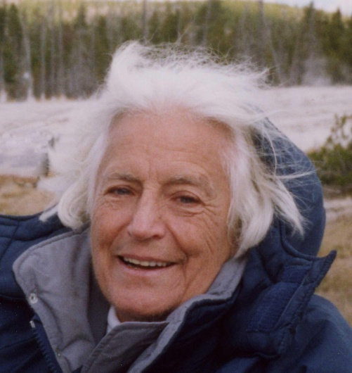

Elizabeth Morrissett (1920- 2003) was an American academic librarian and social justice activist within the library profession. She is best known for her leadership roles in university libraries and her extensive involvement in the American Library Association’s (ALA) Social Responsibilities Round Table (SRRT), where she advanced causes related to peace information, anti-racism, sexism awareness, and progressive librarianship.

She graduated from the University of Akron in Akron, OH, in 1941, and received a Masters of Library Science in 1944 from the University of Michigan in Ann Arbor.

Positions held include DuPont Organic Chemistry Department Librarian, 1944 - 1945; Science and Technical Librarian at Antioch College 1945 - 1948; Librarian at the University of California, Berkeley, 1948 - 1950; Librarian at University of Colorado, Boulder, 1969 - 1976 ; Librarian at Auraria Library, Denver, Co, 1976 – 1980.

Morrissett served as Director of the Library at Montana College of Mineral Science and Technology (Montana Tech) in Butte, Montana from 1980 - 1986. In this role, she was active in the Montana Library Association and advocated for library funding and resources. She later became Library Director at Alaska Pacific University (APU) in Anchorage, Alaska, serving from 1986 to 1990. She held additional professional addresses in Juneau, Alaska, during parts of her career.

Morrissett was a prominent figure in ALA’s Social Responsibilities Round Table (SRRT) during the 1970s through the early 1990s. She coordinated the Peace Information Exchange task force, contributed to the editorial board of the SRRT Newsletter, and frequently served as secretary pro tem or participant in Action Council meetings. She was involved in key initiatives and resolutions addressing racism and sexism awareness in libraries, correspondence with the Council on Interracial Books for Children, and broader social responsibility issues in the profession.

Her professional papers (1976–1989) are held in the ALA Archives at the University of Illinois and document her work on these topics, including controversies surrounding ALA resolutions on racism and sexism.

She was active in profession and civic organizations: She was a member of the American Library Association; Colorado Library Association; Mountain Plains Library Association; International Federation of Library Associations; Boulder County Volunteer & Information Center; Boulder County Parks & Recreation Advisory Board member; Women's International League for Peace & Freedom, Boulder; Denver Executive Committee of American Friends Service Committee; and the League of Women Voters.

In her later years, Morrissett lived in the Boulder/Denver area of Colorado. A library at Friends School Boulder (a Quaker-affiliated independent school) was named the Elizabeth Morrissett Library in her honor; the addition opened in fall 2001.

Elizabeth Morrissett passed away in 2003 in Colorado (Denver area).

Sources

American Library Association. Memorial. Annual Conference, 2004.

American Library Association. Social Responsibilities Round Table. Various minutes and newsletters, 1978–1990. https://www.ala.org/rt/srrt (specific PDFs cited in research, e.g., SRRT Minutes 19780125, SRRT Newsletter issues from 1986–1987).

Friends School Boulder. “History.” Accessed 2026.

Jankowska, Maria Anna. “The Need for Environmental Information Quality.” Issues in Science and Technology Librarianship, no. 26 (Spring 2000).

Montana State Senate, Local Government Committee. Minutes of Meeting, March 5, 1983.

Morrissett, Elizabeth. Obituary. Denver Post, 2003. Via Legacy.com.

Submitted by ALA Member

