Lois P. Mills – 1917 -2000

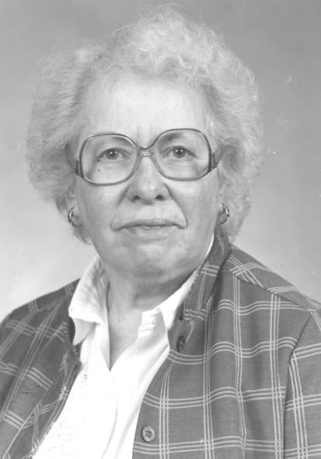

Lois P. Mills (1917–2000) was an American librarian, educator, military veteran, and foundational figure in government documents librarianship. She played a central role in the early development of the American Library Association’s Government Documents Round Table (GODORT), and wrote its first official history. She was honored with the James Bennett Childs Award, GODORT’S highest honor in 1998.

Her career spanned high school librarianship, university teaching and administration, and national advocacy for public access to government information.
Born in 1917, Lois P. Mills served in the U.S. Army as a Sergeant First Class in the Women’s Army Corps (WAC) from 1944 to 1949.


She worked in cryptography and was present in the European theater during the D-Day invasion of Normandy on June 6, 1944, following the troops as part of the Allied effort. Her military service deeply influenced her later life; she was interred with honors at Arlington National Cemetery on April 17, 2002.
After her discharge, she pursued librarianship, beginning as a high school librarian in Madison, Wisconsin.
Career at Western Illinois University
Lois P. Mills joined Western Illinois University (WIU) in Macomb, Illinois, in 1954 as the high school librarian for the university’s Laboratory School (Western High). She taught and administered the lab school library for 14 years (1954–1968).
In 1968 she transferred to the main university library, where she served for 19 years as Government Publications and Legal Reference Librarian. She built and led the Government Publications and Legal Reference sections from the ground up, transforming them into robust resources and making WIU an active participant in the Federal Depository Library Program (FDLP) by the 1980s.
She was a member of the Illinois Library Association and co-founder and first Chair of the Illinois Library Association Government Documents Roundtable.
Beyond her primary duties, Mills was deeply engaged in campus life. She was active in the American Association of University Professors (AAUP), participated in faculty governance, and served as faculty advisor to the student newspaper Western Courier.
In 1979 she became the first woman named the Annual Faculty Lecturer at Western Illinois University, and delivered an address entitled "Freedom of Information.”
She held the rank of associate professor and was named emerita upon retirement in 1987.

Contributions to GODORT and Librarianship

Lois P. Mills was a charter member of the American Library Association Government Documents Round Table (GODORT) and participated in its formative meeting in April 1972 in St. Louis.
She chaired the Constitution and Bylaws Committee, drafting key organizational documents and helping shape the round table’s structure.
She served as GODORT Assistant Chair (1974–1976) and chaired the Ad Hoc Committee on Federal Depository Legislation (1976), which proposed major revisions to Title 44 of the U.S. Code and engaged directly with congressional staff. She also contributed to later structural reviews of GODORT.
Lois P. Mills served on the Depository Library Council to the Public Printer of the United States from 1978 to 1981.
She also served as chair of the GODORT Awards Committee in the late 1970s/early 1980s.

In 1992 she wrote A History of the Government Documents Round Table of the American Library Association, 1972–1992, the definitive early chronicle of the organization (later reprinted with a continuation by Larry Romans and Sandy Peterson).
She represented ALA as an alternate member of the congressional Joint committee on Printing Ad Hoc Advisory Committee on Revision of Title 44 where she advocated depository libraries' access to electronic government information.
Lois P. Mills testified for ALA at Congressional hearings, lobbied the Congress and other government policy makers on behalf of the depository library program, Freedom of Information, appropriations for library programs and unfettered access to information.
After retirement Lois P. Mills remained active in ALA, serving as Treasurer and Executive Board member of the Intellectual Freedom Round Table.

Awards and Legacy
Mills received two of GODORT’s highest honors:
The CIS/GODORT/ALA “Documents to the People” Award in 1978 for outstanding contributions to documents librarianship and the James Bennett Childs Award in 1998 for lifetime achievement in the field.
Her photograph is displayed on a plaque at the entrance to Western Illinois University Government and Legal Information Unit in recognition of her foundational work. Colleagues remembered her as a dedicated mentor and advocate who strengthened both local collections and national policy on government information access.
She died in December 2000. Her interment at Arlington National Cemetery in 2002 underscored the esteem in which her wartime service was held.
Lois P. Mills’s legacy endures through the collections she built, the GODORT history she documented, the organizational structures she helped create, and the generations of librarians and students she influenced. She exemplified the intersection of military service, librarianship, and advocacy for open government information.

Sources

American Library Association. Government Documents Round Table. “History of GODORT.” American Library Association.
American Library Association. Government Documents Round Table. “Memorial Resolution for Lois P. Mills.” 2001 GODORT Resolutions. American Library Association, 2001. [full resolution after Sources]
Facebook. “Lois P. Mills” [memorial or personal page/post]. Facebook. Accessed July 4, 2026.
Malone, Charles E. “The History of the Law Library at Western Illinois University.” Illinois Libraries 86, no. 2 (Summer 2006): 4–10. [article notes: through the leadership of librarian Lois Mills, the Western Illinois University Library became an active participant in the Federal Depository Library Program (FDLP) by the 1980s. … To supplement the government documents in the depository collection, librarian Mills had also established an exemplary legal reference collection.”]
Mills, Lois P. Interment Record. Arlington National Cemetery, Arlington, Virginia. Burial date 17 April 2002. Column 15, Court 6, Section X, Niche 2. https://www.arlingtoncemetery.mil/.
Western Illinois University Libraries. Archives and Special Collections. “Women of Western.” Accessed July 4, 2026.
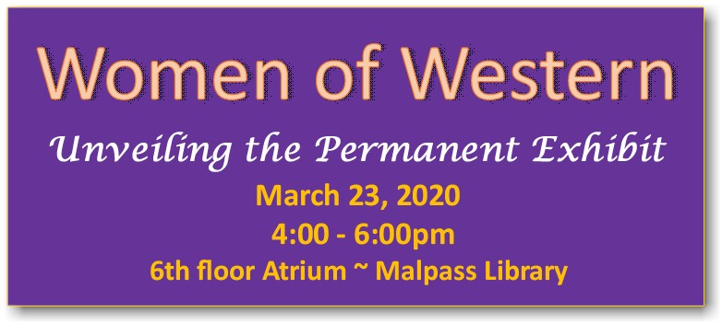

American Library Association. Government Documents Round Table.
“Memorial Resolution for Lois P. Mills.” 2001
WHEREAS, Lois P. Mills was a life-long champion of Democracy and energetically worked to change policies, laws, regulations and procedures to ensure open government and "Documents to the People"; and
WHEREAS, Lois served her country during the Second World War as a Master Sergeant in the U.S. Army Security Agency, and continued to serve the cause of Democracy by resuming her career after the War as an educator, librarian, and advocate for good and open government; and
WHEREAS, Lois was an active member (1952-2000) of the American Library Association (ALA) where she advocated open meetings, membership involvement in ALA policy development, and changes in the Federal Depository Library Program to assure the public's access to government information in all formats including microform, CD-ROM, and on-line; and
WHEREAS, Lois' career at Western Illinois University (WIU) began in 1954 when she was appointed as an Instructor serving as the High School Librarian in the Laboratory School and teaching library science, and in 1968 she became the Government Publications and Legal Reference Librarian, a position she retired until 1987 when she retired as a Professor; and
WHEREAS, during her tenure in the Government Publications Department at WIU, she guided a fledgling depository into national prominence, providing superior public access to all of its government information collections; and
WHEREAS, Lois was a long-time member of the Illinois Library Association and was a co-founder and first Chair of the Illinois Library Association Government Documents Roundtable; and
WHEREAS, as a member of ALA, Lois helped found the Government Documents Round Table (GODORT) of the American Library Association in 1972 and was an active member of it until her death; and
WHEREAS, Lois served on a series of ALA committees working on proposed changes to the printing, publishing and dissemination laws of the United States, and served as GODORT Representatives to the Freedom to Read Foundation; and
WHEREAS, Lois represented ALA as an alternate member of the congressional Joint committee on Printing Ad Hoc Advisory Committee on Revision of Title 44 where she advocated depository libraries' access to electronic government information; and
WHEREAS, Lois testified for ALA at Congressional hearings, lobbied the Congress and other government policy makers on behalf of the depository library program, Freedom of Information, appropriations for library programs and unfettered access to information; and
WHEREAS, Lois was the recipient of the CIS/ALA/GODORT "Documents to the People" Award in 1978 and the James Bennett Childs Award in 1998; and
WHEREAS, Lois served on the Depository Library Council to the Public Printer of the United States from 1978 to 1981; and
WHEREAS, in 1979 Lois was the first woman to be named as the Annual Faculty Lecturer at Western Illinois University, and delivered an address entitled "Freedom of Information;" now, therefore, be it
RESOLVED, that the American Library Association honor Lois P. Mills for her work supporting Democracy and the public's easy and equitable access to government information; and, be it further
RESOLVED that copies of this resolution be sent to Lois's family, the President of Western Illinois University, the library staff at Western Illinois University and the Illinois Library Association Government Documents Forum.

Submitted by GODORT Member, K.Mc

