Sharon McKinley (1952-2026)
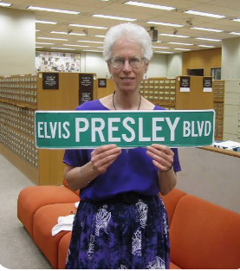
Image from Library of Congress https://blogs.loc.gov/music/2011/08/cataloger%E2%80%99s-corner-elvis-will-never-leave-our-building/
Sharon McKinley, a retired senior music cataloguing specialist at the Library of Congress and a vibrant figure in the Baltimore-DC folk dance community, passed away on July 1, 2026, at the age of 73. After graduating with a MLS from the University of Connecticut, she began her career as a library for the U.S. Army library system in Germany.
Sharon was revered by colleagues as an absolute authority on historical music scores. She was a pivotal contributor to the Library's It’s Showtime sheet music database and an expert voice on music archives for silent film.
Following her retirement in 2012, she continued to support the Library as a docent and a prolific writer for the Library’s In the Muse performing arts blog. She was active in the Music Library Association and served as a trustee of the Library of Congress staff Continuing Education Fund.
Known for her lively spirit, she was also an active English Country Dance choreographer and caller, a madrigal singer, a birder, and an avid Orioles fan who fostered community through music and dance.

Submitted by Jennifer Manning

