Helen Adams Masten - ?- 1990?

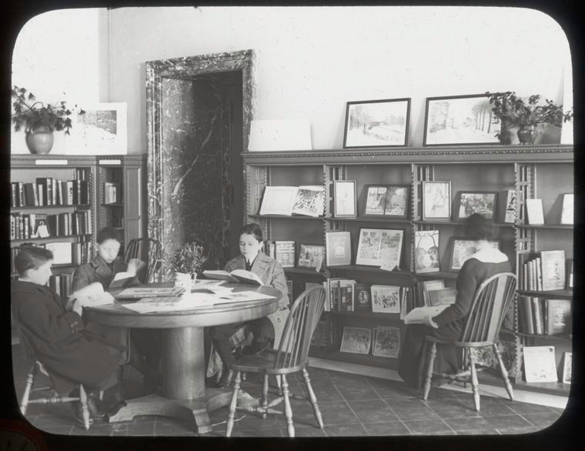

Helen Adams Masten (active ca. 1928–1961; d. ca. 1990) was a leading American children’s librarian, book critic, and influential figure in mid-20th-century children’s literature. She is best remembered for her long tenure heading the Central Children’s Room at the New York Public Library (NYPL).
Masten served as Librarian in Charge of the Central Children’s Room at the NYPL for 33 years, retiring in November 1961. In this role she oversaw one of the most important children’s collections and reading rooms in the United States, supporting generations of young readers, parents, and educators while fostering connections between the library and the broader world of children’s book publishing.
Beyond her library duties, Masten was an active book critic and contributor to The Horn Book Magazine. She also served as a judge for major children’s book awards and exhibitions, including the New York Herald Tribune Spring Book Festival and the American Institute of Graphic Arts (AIGA) Children’s Book Show. These activities placed her at the center of the professional networks that shaped American children’s literature during its “golden age” in the mid-20th century.

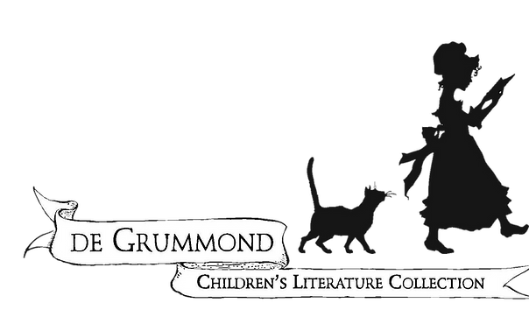

Masten maintained an extensive professional and personal correspondence with dozens of children’s authors, illustrators, editors, and critics from the 1930s through the 1970s. Her papers—containing letters from 67 correspondents, two typewritten book reviews, and a brief bibliography—are preserved in the de Grummond Children’s Literature Collection at the University of Southern Mississippi.
Masten’s career exemplifies the vital role played by mid-century children’s librarians in nurturing both young readers and the creators of children’s books. Her archival papers remain a valuable primary resource for researchers studying the history of American children’s literature and library service to youth.

Sources

de Grummond Children’s Literature Collection. The University of Southern Mississippi. Accessed July 10, 2026. https://www.degrummond.org/.

“Collection: Helen Adams Masten Papers.” University of Southern Mississippi McCain Library & Archives.
Masten, Helen Adams. Helen Adams Masten Papers, 1930–1977. de Grummond Children’s Literature Collection, University of Southern Mississippi, Hattiesburg.
“Masten, Helen Adams.” Social Networks and Archival Context (SNAC).
NYPL Digital Collections. “New York Public Library Visual Materials.” Includes historical photographs of the Central Children’s Room (e.g., from 1913). https://digitalcollections.nypl.org/.

Submitted by ALA Member

