Rosemary Allen Little – 1938-2001

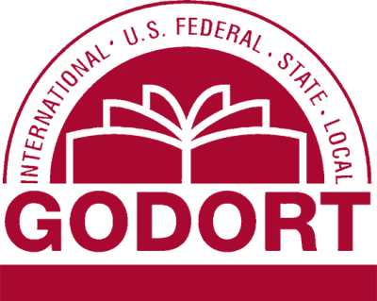

Rosemary Allen Little was a librarian and influential advocate for access to government information, with a distinguished career spanning more than four decades at Princeton University.
Born Rosemary Allen, she earned a bachelor’s degree in English from Douglass College in 1960 and a Master of Library Service (MLS) from Rutgers University’s Graduate School of Library Service (now the School of Communication and Information) in 1961.
She began her professional career in 1981 as a reference librarian at Princeton University’s Firestone Library and was promoted in 1964 to Public Administration Librarian, a position she held for the remainder of her forty-year tenure.
Colleagues remembered her as an exemplary and influential professional, particularly skilled in legal and government databases; historian Stanley Katz described her as “a marvel, a virtuoso of the legal databases, and an excellent instructor.”
Little played a foundational role in the development of government documents librarianship in the United States. She was a charter member and served as president of the Documents Association of New Jersey.
She was instrumental in the founding of the American Library Association’s Government Documents Round Table (GODORT) and remained deeply involved in its activities throughout her career.
She chaired GODORT’s Workgroup on International Documents from 1981 to 1984 and later served as liaison to the ALA International Relations Committee from 1996 to 2001.
Through these roles, she advanced awareness of international and foreign government documents and mentored numerous librarians at various stages of their careers. She was widely respected as a dedicated advocate for open government information and equitable public access to official publications in all formats.
In recognition of her contributions, the New Jersey Chapter of the Special Libraries Association established the Rosemary Allen Little Award to support students enrolled in Rutgers SC&I’s Master of Information program. Following her death, her husband, John Edwin Little (an historian and editor who worked on the Papers of Woodrow Wilson and the Papers of Thomas Jefferson), made a generous bequest to Rutgers SC&I in her memory. They are buried together at Princeton Cemetery in Princeton, New Jersey.

A memorial resolution honoring her life and work submitted by the Government Documents Round Table adopted by the American Library Association A Council in 2002.

Sources

American Library Association. Government Documents Round Table. “Memorial Resolution for Rosemary Allen Little.” June 17, 2002.
Special Libraries Association, New Jersey Chapter. “Rosemary Allen Little Award.” SLA New Jersey Chapter records and announcements.
Wilson, Woodrow. The Papers of Woodrow Wilson. Edited by Arthur S. Link, with J. E. Little as associate editor. 69 vols. Princeton: Princeton University Press, 1966–1994. (J. E. Little served as co-editor or associate editor for volumes 62–67.

Submitted by GODORT member

