Joseph Wharton Lippincott, Jr. (1914–2003)

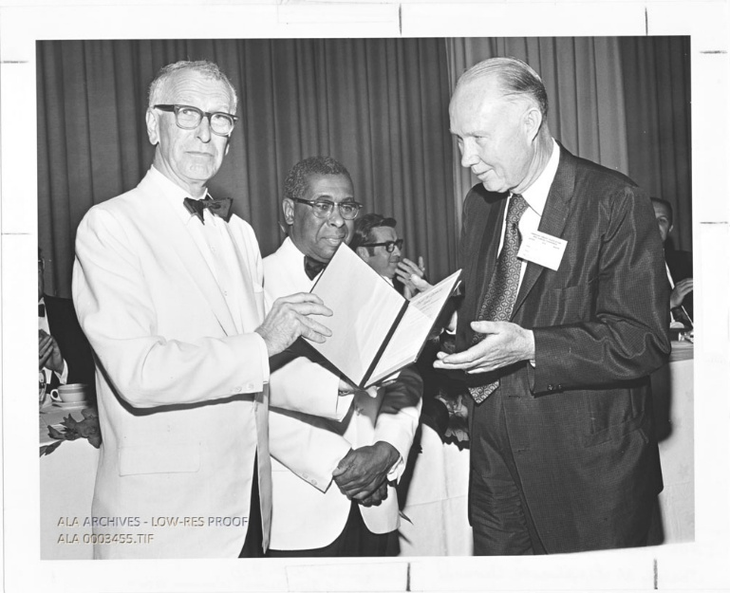
Paul Howard Accepting Joseph W. Lippincott Award in 1970

Joseph Wharton Lippincott, Jr. (1914–2003) was an American publisher who served as president and chairman of the J.B. Lippincott Company, continuing a family tradition as the fourth generation to lead the historic Philadelphia publishing house.

Joseph W. Lippincott Award
Joseph Wharton Lippincott, Jr. attended American Library Association conferences after the death of his father, Joseph W. Lippincott, to present the Joseph W. Lippincott Award for distinguished service to the profession of librarianship
The Joseph W. Lippincott Award award marked an important shift in ALA recognition. While earlier honors (such as Honorary Membership) had largely recognized bibliographers, publishers, book collectors, and library supporters, the Lippincott Award was the first to focus specifically on the work of librarians themselves.
The first recipient in 1938 was Mary Utopia Rothrock, founder of the Tennessee Valley Authority libraries and a developer of regional libraries. This represented the Association’s first formal recognition of the importance of outreach and extending library service.
The award was not given during World War II. It resumed in 1948 with Carl H. Milam (longtime ALA Executive Secretary and later United Nations Librarian), the first post-war recipient. In 1950, Joseph W. Lippincott personally presented the award to H.W. Wilson, praising his creation of essential indexing tools and the collaborative relationship between publishers and librarians.
From the 1950s onward, the award reflected the profession’s growing emphasis on serving readers and expanding access to information. Many recipients were recognized for work in adult education and extending library services.
The Lippincott Award serves as an important guidepost to the development of American librarianship. Its recipients reflect the profession’s shifting priorities over nearly nine decades — from building collections and tools of librarianship, serving readers and promoting adult education, to advancing intellectual freedom, legislative advocacy, diversity, technology, and public policy. The award consistently honors individuals whose work integrates scholarship, professional practice, and leadership in service of the ALA’s mission to enhance learning and ensure access to information for all.

After the death of Joseph Wharton Lippincott, Jr. his son, Joseph Wharton Lippincott III, represented the family to present the award at ALA Conference.

Joseph Wharton Lippincott, Jr. (1914–2003)
Joseph Wharton Lippincott, Jr. was born in Bethayres, Pennsylvania.He was the son of Joseph Wharton Lippincott (the noted publisher, author, and naturalist who led the J.B. Lippincott Company from 1926 to 1958) and Elizabeth Schuyler Mills Lippincott. He descended from Joshua Ballinger Lippincott, founder of the firm (originally established in the early nineteenth century and long known as J.B. Lippincott & Co.), and he was a great-grandson of Joseph Wharton, founder of the Wharton School of Business at the University of Pennsylvania.
Joseph Wharton Lippincott, Jr prepared at Meadowbrook School and St. Paul’s School in Concord, New Hampshire, before attending Princeton University, where he majored in English and graduated in 1937.
After graduation, he joined the family publishing business in 1937, beginning in the production department. During World War II, he served with the American Field Service, driving ambulances in Italy and Germany. He returned to the company in 1945 as a production manager. In 1951 he was named secretary of the company and advanced to executive vice president before succeeding his father as president in 1958.
Under his leadership, the J.B. Lippincott company expanded rapidly in educational publishing. The firm introduced successful series such as Basic Keys to Spelling, Lippincott’s Basic Reading, and Beginning to Read, Write and Listen. He oversaw international growth, traveling to Europe, Japan, South Korea, and the Philippines to develop markets. The company transitioned to public ownership in 1972. It was acquired by Harper & Row (later HarperCollins) in 1977–1978 and integrated into its operations; Lippincott remained on the Harper & Row board until 1987.
Lippincott was deeply committed to libraries and librarianship. He served on the boards of the Free Library of Philadelphia and Ludington Library in Bryn Mawr (now part of the Lower Merion Library System), as well as the Urban Libraries Council, the American Library Association Council, the Council for Florida Libraries, the Friends of the Princeton University Library, and the American Library Trustees Association. He chaired National Library Week and regularly presented the Joseph W. Lippincott Award (established by his father in 1938) for outstanding achievement in librarianship at ALA annual conferences.
In his personal life, Lippincott had a daughter, Elizabeth L. Mather, from a previous marriage. In 1950 he married Marie Louise (Mary Louise) Beck; the couple had a son, Joseph W. “Jay” Lippincott III (who later served as president of Lippincott Williams & Wilkins), and a daughter, Jean L. Coady. They were married for 52 years. After retirement, he volunteered at a secondhand bookstore in Vero Beach, Florida.
Joseph Wharton Lippincott, Jr. died January 25, 2003 in Bryn Mawr, Pennsylvania.
His son, Joseph Wharton Lippincott III, represents the family to present the Joseph W. Lippincott Award for distinguished service to the profession of librarianship at conferences of the American Library Association.

Sources
American Library Association, Memorial. Annual Conference 2003.
American Libraries Magazine. “2025 ALA Award Winners.” September 2, 2025. Photograph.
American Library Association Archives. “Paul Howard Accepting Joseph W. Lippincott Award.” 1970. Biographical Photographs, 1859–2006, Box 5, Folder: H [Hintz-Hutto]. University of Illinois.
“Joseph Wharton Lippincott Jr.” Wikipedia, The Free Encyclopedia.
Joseph W. Lippincott Award." Wikipedia, The Free Encyclopedia.
“Joseph Lippincott.” Publishers Weekly, February 3, 2003.
McCook, Kathleen de la Peña. “Reflections on the Heritage of Librarianship in the United States.” 2019. Working paper. [McCook reflects on the historical development of librarianship in the United States by examining two longstanding American Library Association (ALA) awards: Honorary Membership and the Joseph W. Lippincott Award. She suggests that these two awards — both of which require a formal nomination and jury process — serve as useful “guideposts” for understanding how the library profession has evolved over time. By analyzing the recipients and the values emphasized by these awards, she explores shifting perceptions of excellence, leadership, and service within the field as viewed by ALA members. The paper connects the history of these awards to broader themes in American librarianship, including professional identity, recognition of achievement, and the values the profession has chosen to celebrate].
Princeton Alumni Weekly. “Joseph Wharton Lippincott ’37.” Princeton Alumni Weekly.
Saxon, Wolfgang. “Joseph Wharton Lippincott Jr., 88, Philadelphia Publisher.” New York Times, January 29, 2003.

Submitted by ALA Member

