Kenneth James LaBudde (1920–2000)

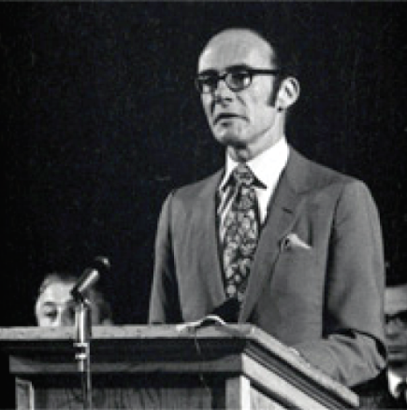

Kenneth James LaBudde (1920–2000) was an American librarian, library administrator, historian, and professor emeritus best known for his 35-year tenure as Director of Libraries at the University of Missouri–Kansas City (UMKC, formerly the University of Kansas City). He played a pivotal role in modernizing university libraries, elevating the professional status of librarians, building special collections, and advancing library networks in Missouri.
He was born January 20, 1920, in Sheboygan Falls, Wisconsin, LaBudde earned degrees from the University of Wisconsin and the University of Minnesota, where he completed a Ph.D. in American Studies in 1954. His doctoral dissertation, The Mind of Thomas Cole, examined the Hudson River School painter and reflected his deep scholarly interest in American history, art, and culture.
Early in his career, LaBudde worked briefly on the staff of the Milwaukee Public Library before enlisting in the U.S. Army during World War II.
In 1950, he was appointed Director of Libraries at the University of Kansas City--now the University of Missouri–Kansas City . He continued in this role after the institution joined the University of Missouri system in 1963, serving until his retirement in 1985, when he was named Professor Emeritus. He remained active afterward as a curator of collections.
During his long directorship, LaBudde achieved several major milestones:
- Librarians at UMKC gained faculty rank and status.
- He developed and strengthened the university’s Special Collections department.

- He oversaw the design and construction of the Miller Nichols Library (originally the General Library) at 800 E. 51st Street.

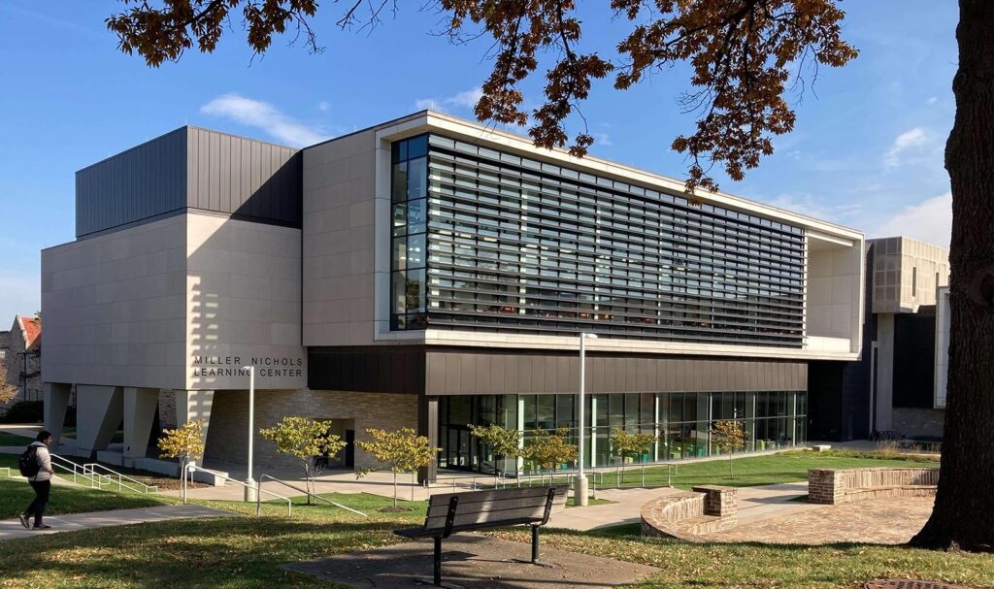
LaBudde was a strong advocate for library cooperation and professional development. He was one of the founders of the Kansas City Metropolitan Library Network, now Mid-America Library Alliance (MALA), supported networking initiatives statewide, and served as a leader in the Missouri Library Association.
He was instrumental in securing academic status for librarians across the University of Missouri system. He held life memberships in the American Library Association (ALA), the Organization of American Historians, the American Studies Association, the Society of Architectural Historians, the Missouri Library Association, and several alumni associations.
In 1988, the University of Missouri honored him with the Thomas Jefferson Award for his lifelong dedication to scholarship, knowledge, and public access to education.
Kenneth James LaBudde died on March 15, 2000, in Kansas City, Missouri.
On September 22, 2002, the Special Collections Department at the Miller Nichols Library was renamed the Kenneth J. LaBudde Department of Special Collections in recognition of his foundational contributions to the library and his expertise in Western Americana, rare books, and Kansas City history.
His personal and professional papers—spanning his education, research on Thomas Cole, extensive travels (including with the Society of Architectural Historians), correspondence on library issues and organizations, and family materials—are preserved in the Dr. Kenneth J. LaBudde Collection (MS-0139) at UMKC Libraries.

LaBudde’s legacy endures through the named special collections department, the strong research collections he helped build (particularly in Western Americana, Kansas City jazz and performing arts, and rare books), and his lasting influence on academic librarianship in Missouri.

Sources

American Library Association, Memorial Resolution. Annual Conference, 2000.
College & Research Libraries News. “Kenneth J. LaBudde.” 61, no. 6 (June 2000): 539.
University of Missouri–Kansas City Libraries. “Dr. Kenneth J. LaBudde Collection.” Finding Aids.
University of Missouri–Kansas City Libraries. “LaBudde, Kenneth James, 1920–2000.” Finding Aids.
University of Missouri–Kansas City Libraries. “LaBudde Special Collections.”
University of Missouri–Kansas City Libraries. “LaBudde Special Collections Tour.” YouTube video, 19:57. Uploaded June 10, 2021. https://www.youtube.com/watch?v=URh1wGsbOLY.
University of Missouri System. “Thomas Jefferson Award Recipients.” UM System. Accessed July 18, 2026.

Submitted by ALA Member.

