Sara Jaffarian - 1915– 2013

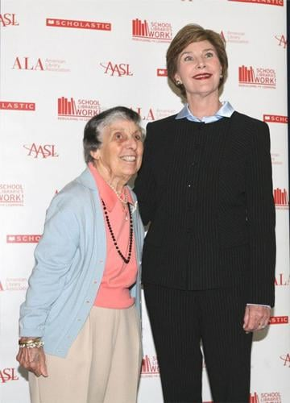

Sara Jaffarian (c. 1915–December 24, 2013) was an American school librarian, administrator, and advocate who spent her career promoting the essential role of school libraries and humanities programming in K–12 education.
Of Armenian-American heritage, she dedicated over six decades to the profession and left a lasting legacy through an award named in her honor.
She remained an active member of the American Library Association for 63 years
Sara Jaffarian was born and raised in Haverhill, Massachusetts. She earned a bachelor’s degree in social studies from Bates University, a library science degree from Simmons College and a master’s degree in education from Boston University.
Jaffarian began her career as a school librarian in the Quincy, Massachusetts, public school system. She advanced to leadership roles as director of libraries for the Greensboro Public Schools in North Carolina (1953-1960) and supervisor of libraries for the Seattle Public Schools in Washington.
In 1961, she returned to Massachusetts to design and implement a comprehensive school library program for the Lexington Public Schools, where she served as coordinator of instructional materials and services from 1961-1978. Under her leadership, the Lexington schools received the Encyclopedia Britannica Award in 1964.

Throughout her career, Jaffarian was a tireless advocate for the idea that “every school needs a library” and that excellent schools require excellent school libraries equipped with strong, curriculum-related programming. She believed such programs could engage students, involve parents, and attract the support of administrators and community leaders.
She held numerous leadership positions in the library profession, including:
- American Library Association councilor,
- Board member and recording secretary of the American Association of School Librarians (AASL)
- Member of the Newbery-Caldecott Awards Committee
- New England School Library. Association (vice president 1950-1953)
- President of the Massachusetts Association of School Librarians. (1964-1966).

Sara Jaffarian School Library Program Award for Exemplary Humanities Programming
In retirement, Jaffarian continued her advocacy by establishing the Sara Jaffarian School Library Program Award for Exemplary Humanities Programming in 2006 through a donation to the American Library Association Cultural Communities Fund.
The annual award (initially for K–8 libraries and later expanded to include high schools) recognizes outstanding humanities programming in school libraries and provides funding, recognition, and training opportunities for librarians nationwide. She expressed particular pride in the award’s focus on moving school libraries “to the next level” through programming.
Jaffarian remained active into her nineties, including humanitarian travel in 2005 (at age 90) to support library reconstruction efforts in Georgia following Hurricane Katrina.
She met First Lady Laura Bush during the event—Bush was also actively involved in post-Katrina education and library initiatives—and the two posed for photos together as part of the rebuilding projects (including library facilities supported by pledges and donations).
She also funded the Sara Jaffarian Reading Room at the Haverhill Public Library for community use.
Sara Jaffarian died on Christmas Eve, December 24, 2013. A memorial tribute highlighted her lifelong commitment to libraries, education, and preserving Armenian-American family history.

Sources

American Library Association. “About Sara Jaffarian.” Accessed July 8, 2026.
Bush, Laura. “Mrs. Bush: Rebuilding the Gulf Coast.” The White House, George W. Bush Administration.
“Jaffarian Volvo Toyota Collecting Children’s Books for Ruth’s House in Memory of Librarian in Family.” WHAV, August 10, 2021.
“Remembering the Life of Sara Jaffarian.” The Eagle Tribune, December 29, 2013.
“Remembering Sara Jaffarian.” Haverhill Gazette, January 2, 2014.
Vartabedian, Tom. “Footprints in the Snow: In Memory of Sara Jaffarian.” The Armenian Weekly, January 2, 2014.

Submitted by ALA Member

