Janice White Sikes Rogers- 1952 – 2026

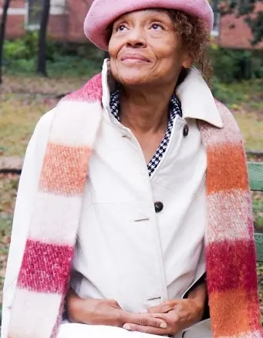

Janice White Sikes Rogers (June 5, 1952 – March 27, 2026) was an American librarian, historian, community activist, and preservationist renowned for her decades-long dedication to documenting, preserving, and promoting African American history and culture in Atlanta, Georgia, and the broader South. Often called “The Keeper of the Scrolls” for her meticulous guardianship of historical narratives, she was a foundational figure in shaping how Black history in Atlanta is archived, understood, and transmitted across generations.
She was born in Meridian, Mississippi and graduated from T.J. Harris High School in 1969. She earned a bachelor’s degree from Spelman College, majoring in English, and later completed a master’s degree in Library Science from the Atlanta University School of Library and Information Science (now part of Clark Atlanta University).
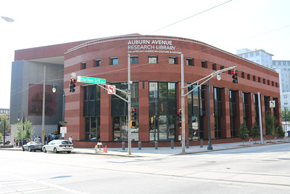

Rogers built a nearly 40-year career in the Atlanta-Fulton Public Library System, advancing through senior-level management roles. She served as head of the Samuel W. Williams Black Studies Collection and as an administrator at the Auburn Avenue Research Library on African American History and Culture, where she worked as a Senior Research Librarian for more than 20 years (in addition to earlier service with the Fulton County library system). In these positions, she facilitated access to vital resources on African American history, supported researchers and scholars, and advanced public understanding of Black heritage.
A longtime resident of Atlanta’s West End and Westview neighborhoods beginning in the 1970s, Rogers was a community advocate and historian. She researched and documented the history of West End and numerous other sites across Georgia.
Alongside her first husband, Dan Sikes, she played a key role in historic preservation efforts, including helping to establish the West End Historic District and contributing to the area’s revitalization and recognition on the historic map. She was active in the African American Family History Association and, with Dan Sikes, operated a tour company and communications business. Her work extended to photography and cultural writing that captured community life, events, and heritage sites.
Rogers also served on the Mississippi Heritage Trust Board of Trustees. She was committed to youth development through scouting leadership, higher education support, and camping and retreat ministries. At Calvary United Methodist Church in Atlanta, she led the Women’s Ministry.
She was first married to Dan Sikes and later to Rev. Dr. Willie Roy Rogers, Sr. (both of whom predeceased her).
Janice White Sikes Rogers passed away on March 27, 2026, in Atlanta.
Her legacy lives on through the historical collections she helped build, the neighborhoods she helped preserve, and the countless individuals she mentored and inspired with knowledge of their roots.

Sources
City of Atlanta. “West End.” Atlanta, GA. Accessed July 19, 2026.
“JANICE SIKES ROGERS.” Westview Community Organization. (oral history/project page).
“The Keeper of the Scrolls.” NPU-T: Southwest Atlanta United.
Mississippi Heritage Trust. “About MHT.” Accessed July 19, 2026.
“Mrs. Janice White Sikes Rogers Obituary.” The Meridian Star, April 7, 2026.
“Ms. Janice White Sikes Rogers Obituary.” Willie A. Watkins Funeral Home, April 2026.
Mason, Skip. Facebook post in “Skip Mason Black Atlanta History” group, March 31, 2026.
Mason, Skip. “Remembering the extraordinary life of my dear friend and mentor, Janice White Sikes Rogers...” Facebook post in the BCALA Members and Supporters group, March 31, 2026.
Murchison, Adrianne. “Janice White Sikes Rogers, who shaped how Atlanta preserves Black history, dead at 73.” Atlanta Journal-Constitution, April 15, 2026.

Submitted by ALA Member

