Carol Combs Hole 1940 -2007

.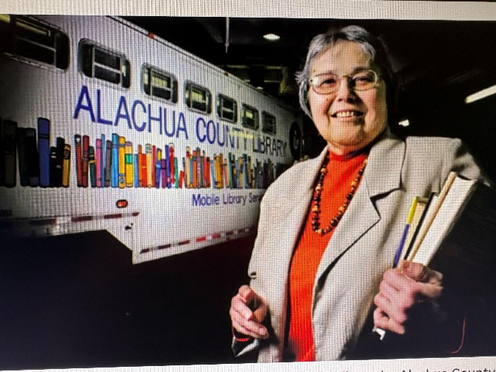

Carol Combs Hole (c. 1940 – October 1, 2007) was a public librarian whose 32-year career with the Alachua County Library District in Florida advanced bookmobile and outreach services, library facility development, and intellectual freedom. She combined practical innovation with advocacy, making libraries more accessible and inclusive while sharing her expertise widely through writing, workshops, and professional contributions.
Born around 1940, Hole moved to Gainesville with her family in 1954 and graduated from P.K. Yonge Laboratory School.
She earned a bachelor’s degree in English from Emory University in 1961 and a Masters of Library Science from Florida State University in 1979.
She worked in children’s services at Belmont Public Library near Boston and later in East Rochester near Pittsford, New York, and as a public school librarian in St. Croix, U.S. Virgin Islands.

Career at Alachua County Library District, Florida
Upon returning to Gainesville, Hole joined the Alachua County Library (later District) in the children’s department, drawing on her artistic background. In 1978 she was promoted to Librarian II in Outreach Services, overseeing bookmobiles, talking books for the blind, and the jail library. Many rural areas relied on the bookmobile as their primary (or only) library access.

She played a pivotal role in major expansions and innovations:
- Helped secure a voter-approved library taxing district in 1985.
- Supported a $19 million bond referendum in 1987 that funded a new headquarters (completed 1991) and additional branches.
- Obtained a federal grant for a step-van bookmobile to serve smaller communities and wrote about the project for Florida Libraries magazine.
- Conducted workshops (including for the South Carolina State Library) and became a recognized expert on bookmobiles and outreach.
- Supervised three bookmobiles and nine branches, contributing to practical facility designs.
- Advocated for inclusive collections, successfully adding popular titles such as Harlequin romances and Nancy Drew books.
Hole viewed librarianship as essential to democracy and free speech, describing the public library as “the only agency that has no agenda for people.”
Hole was a prolific writer who promoted libraries through humor and practical guidance. She authored a weekly column, “Off the Shelf,” in the Gainesville Sun beginning October 15, 1985, which highlighted books and used humor to make libraries approachable.
Hole retired on March 1, 2006, after more than 31½ years. Library Director Sol Hirsch credited her with much of the district’s statewide stature. She remained a dedicated reader throughout her life.
Her legacy endures through awards named in her honor: the national Carol Hole Conference Attendance Award given by the Association of Bookmobile and Outreach Services (ABOS) supporting outreach and bookmobile staff, and the local Carol Combs Hole Award (Alachua County Library District) recognizing innovative projects.
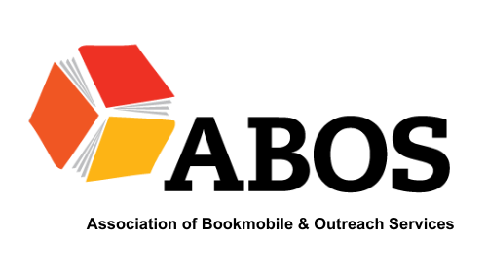
She died on October 1, 2007.

Sources

Alachua County Library District. “History.” Accessed July 12, 2026.
Alloway, Catherine Suyak, ed. The Book Stops Here: New Directions for Bookmobile Service. Metuchen, NJ: Scarecrow Press, 1990.
American Library Association Institutional Repository. Memorial. Carol Combs Hole. Council of the American Library Association Wednesday, July 2, 2008. Anaheim, California.
Association of Bookmobile and Outreach Services. “Carol Hole Conference Attendance Award.”
Blomberg, Marina. “Bringing Books to the Masses.” Gainesville Sun, March 6, 2006.
“Carol Hole Obituary.” Legacy.com
Find a Grave. “Carol Hole.” Memorial no. 160323903.
Hole, Carol. “Essay on rural bookmobile stops.” In The Book Stops Here: New Directions for Bookmobile Service, edited by Catherine Suyak Alloway. Metuchen, NJ: Scarecrow Press, 1990.
Hole, C. C. (1990). Click! The feminization of the public library; policies and attitudes make men the great unserved. American Libraries, 21, 1076–107.
Hole, Carol. “Who Me, Censor?” Top of the News (Winter/Fall 1984).
———. “Yeah, Me Censor: A Response to Various Critics.” Top of the News 41, no. 3 (Spring 1985): 236–47.
Topping, R., & Hole, C. C. (1992). How to buy a bookmobile. Wilson Library Bulletin, 66, 38.

Submitted by Florida Library Association Member.

