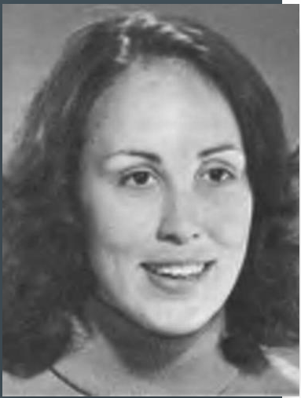

SUSANA HINOJOSA "Presente!" - Jan 24, 1949 - June 21, 2023

OBITUARY
https://www.legacy.com/us/obituaries/ivpressonline/name/susana-hinojosa-obituary?id=52419438

ALA MEMORIAL RESOLUTION HONORING SUSANA HINOJOSA - June 26, 2023
https://www.ala.org/sites/default/files/aboutala/content/Memorial%20Resolution%20Honoring%20Susana%20Hinojosa.pdf

AMERICAN LIBRARIES MAGAZINE. JANUARY/FEBRUARY 2024, p. 3
https://americanlibrariesmagazine.org/currents/hinojosa-susana/

REFORMA Library of the Year winners
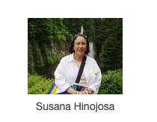
https://www.reforma.org/content.asp?contentid=108#:~:text=Oralia%20Garza%20de%20Cort%C3%A9s%2C%20of,Librarians%20of%20the%20Year%20(LOTY)

PERSONAL TRIBUTES:

Lily Castillo Speed and Lupe Gallegos:

Susana Hinojosa, mentor and friend to many generations, passed away on June 21, 2023.
She was a reference librarian and also worked with government documents over her long career. She was hired in 1971 in the Doe Library and retired in 2009. She promoted mentorship and was a wonderful mentor and role model to many librarians. She was also a strong union leader. Through consistent and persistent committee work she worked for "diversity" in librarianship as that term developed over the years.

Here is the notice that was sent out about her receiving the Librarian of the Year Award from REFORMA in 2010.

"Susana Hinojosa has been selected as one of the two Arnulfo D. Trejo Librarians of the Year by REFORMA, the ALA-affiliated organization that promotes library and information services to Latinos and the Spanish-speaking. Susana is a recently retired government documents, social sciences, and outreach librarian at Doe Library, where she was employed for over thirty-eight years. She is also a past president of REFORMA. Susana has distinguished herself through her involvement with the Racial and Ethnic Diversity and the Intellectual Freedom Committees of the ACRL division of the ALA. The National Association for Chicana and Chicano Studies and the California Library Association's Minority Concerns Committee have also benefited from her many years of involvement. Susana was a lecturer for many years at UCB's school of library and information science, where she inspired generations of librarians in her multicultural studies and outreach librarianship classes. Her steadfast dedication to equity, fairness, teaching and mentorship and her long term service to organizations focusing on Chicanos, Chicanas, Latinos and Latinas is recognized by this award."
Susana was also honored by the 150 Years of Women at Berkeley project,
p. 11
https://escholarship.org/content/qt2083k53h/qt2083k53h.pdf

Susana was always fighting the tough fights, never shrinking from issues of diversity and fairness or power inequities.
- Lillian Castillo-Speed and Lupe Gallegos
UC Berkeley Ethnic Studies Library
June 23, 2023

https://www.facebook.com/eslibrary/posts/susana-hinojosa-mentor-and-friend-to-many-generations-passed-away-on-june-21-202/606045961700063/

Toni Bissessar:
"When I think of Susana, I remember her sense of justice, especially for Chicanos, Latinos and other people of color. She had a wonderful sense of humor, she was passionate about familia, our community and her students. She was extremely organized, supportive and brilliant! I loved her laugh!"
- Toni Bissessar, Arlington Public Library, Retired and former President REFORMA (1999-2000)

Rhonda Rios Kravitz:
Salute to Rafaela Castro, Susana Hinojosa, Wei Chi Poon, Satia Orange:
“They were true powerhouses in the library movement, an inspiration to everyone who had the privilege of knowing them. Their lifelong commitment to justice and equity shaped every space they entered as strong women of color. Through their service on local and national library committees, they worked to influence policy, expand access, and insist on equity as a core professional value.
Their work was never simply procedural; it was a deliberate challenge to the systemic inequities that continue to disproportionately affect marginalized communities. Their contributions are not relics of the past. Their legacy actively shapes our present and future as librarians, both current and retired, dedicated to social justice, to building bridges across generations, and to transforming our institutions.
Our responsibility now is to carry their work forward with intention, ensuring that diverse voices are not only heard, but uplifted, centered, and shared.""
- Rhonda Rios Kravitz, MSLS, DPA, Dean Emerita, Sacramento City College

Sandra Rios Balderrama:
I met Susana in 1982 or so. She was a reference librarian at Moffitt Library at UC Berkeley and I was, in the then named, MLIS program. To meet a Chicana academic librarian, off of the bat, who was originally from the Calexico/Mexicali area that my Grandfather Rios was from, was AMAZING to me! And further excited my interest in librarianship. She welcomed me to ALA involvement and guided me through the conference, pointing me in the direction of public library committees and programs. There is so much to remember but in essence, her essence contained a beautiful ferocity for justice, equity, representation, and inclusion within the ALA and in all types of libraries. She had a dedication to the labor rights of librarians and library workers. She always encouraged me to stand up, to speak out, and to go forward.
Her insights and organizational skills were impeccable. You would not walk away from Susana without gaining some new way of looking at things or without inspiration to return to your library and give it your all for equity!
I knew she loved her sons so much. She spoke of them with a beautiful smile and yes! - Her laugh was engaging. There was kindness, joy, accomplishments and victories to be celebrated with treasured colleagues and shared meals.
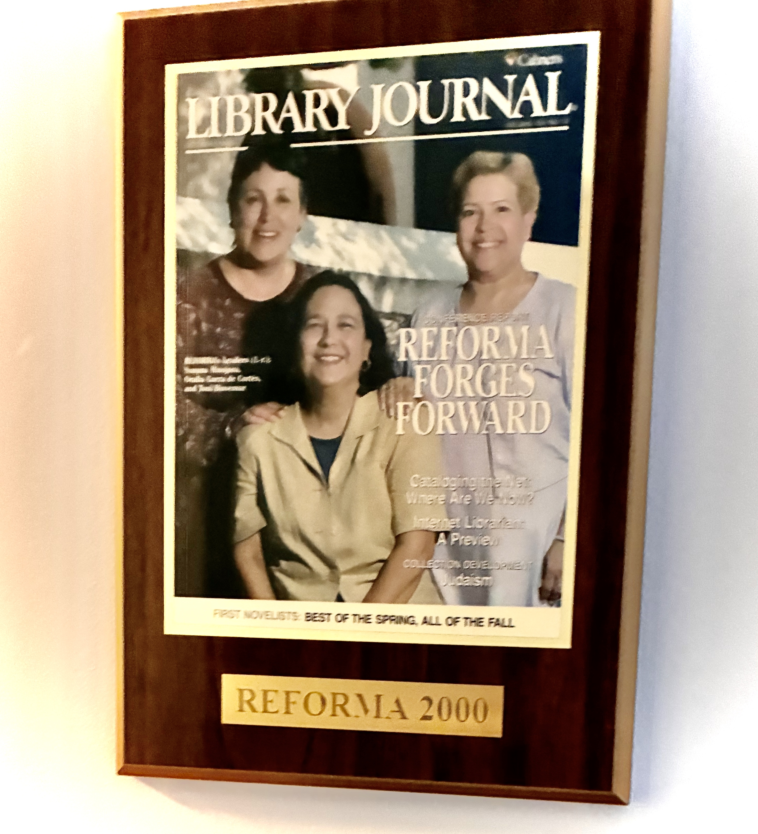
- Sandra Rios Balderrama, retired from public libraries and the ALA; former REFORMA President (1997-1998), Co-founder of the Pura Belpré Award for Children’s Literature by Latinx/Latine authors and illustrators.

(Susana is on the left as you look at this photo, with Oralia Garza de Cortés and Toni Bissessar, from the Personal Collection of Toni Bissessar)

PUBLICATIONS (There are more than listed here!)
Hinojosa, Susana. "Racial and ethnic diversity: Information Exchange" College & Research Libraries News Online, 52.6 (1991)
https://crln.acrl.org/index.php/crlnews/article/view/19412/22735

Hinojosa, S. (1996). Re-Thinking Reference - A True Change? The Reference Librarian, 25(54), 95-102
https://www.tandfonline.com/doi/abs/10.1300/J120v25n54_09

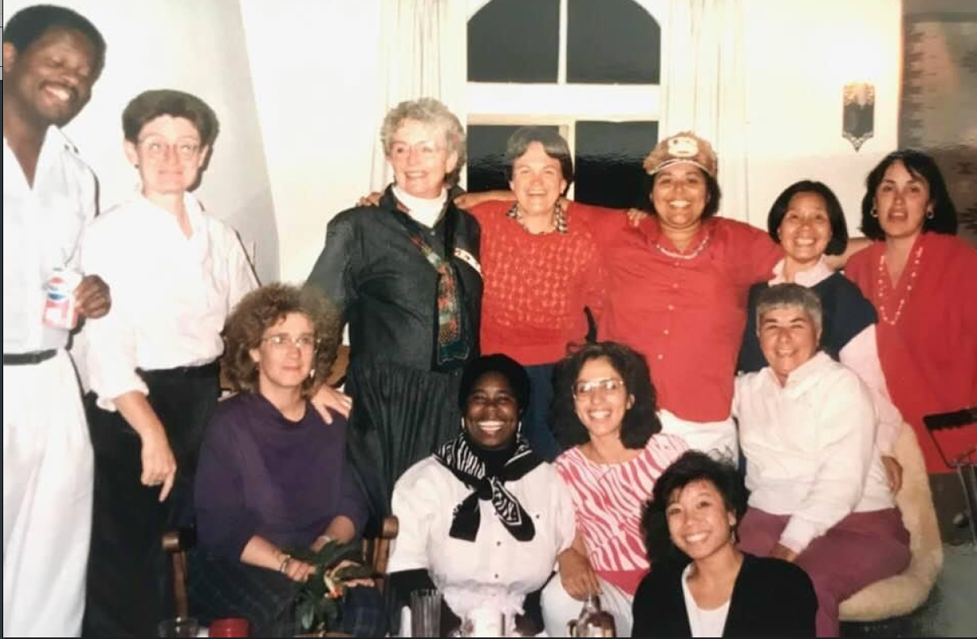

(Susana is standing up, in red, on the far right as you look at this photo, from the personal collection of Sandra Rios Balderrama. Circa, late 80's)

Submitted with Love and Respect,
Sandra Rios Balderrama
July 25, 2026

